**MINISTRY OF EDUCATION AND TRAINING**



**FPT UNIVERSITY**

Capstone Project Document

Designing and making a two wheel inverted balancing robot

|  |  |
| --- | --- |
| **Group 1 – Embedded System** | |
| **Group Members** | Nguyễn Thanh Hòa – Team leader - SE60768  Trần Lữ Sinh – Team Member – SE60799  Nguyễn Lý Thanh Huy – Team Member – SE60759  Phạm Nguyễn Tân Bình – Team Member – 60096 |
| **Supervisor** | Mr. Trần Khánh Ninh |
| **Ext Supervisor** | N/A |
| **Capstone Project Code** | 2WR |

Ho Chi Minh City, January 2014

*This page is intentionally left blank*

**ACKNOWLEDGEMENTS**

We couldn’t have finished this project without the help and technical assistance of many people. In particular, we would like to thank our family .The amount of time and effort that goes into this project is hard to measure.

Especially, we truly had a fantastic person helping us - Mr. Tran Khanh Ninh, his professional guidance and his experience help us to overcome the obstacles, even the hardest time when we think we can’t continue with this project anymore. He has truly had a significant impact on the success of this project.

We would like to extend a special thank you to our teachers; friends who have support us throughout 4 months of this project.

## Table of Contents

Table of Contents 2

List of Tables 5

List of Figures 6

Definitions, Acronyms, and Abbreviations 9

1. INTRODUCTION 10

1.1 Project Information 10

1.2 Introduction 10

1.3 Existing Solutions 11

1.3.1 Four-Wheeled Robot 11

1.3.2 Three-Wheeled Robot 12

1.4 Proposed Solution 13

1.5 Feature Functions 14

1.6 Project Team 14

2. SYSTEM PROJECT MANAGEMENT PLAN (SPMP) 15

2.1 Problem Definition 15

2.1.1 Name and Main Points of Capstone Project 15

2.1.2 Problem Abstract 15

2.1.3 Project Overview 15

2.2 Overview 16

2.2.1 System Process Model 16

2.2.2 Roles and Responsibilities 17

2.2.3 Tools and Techniques 18

2.3 Project Management Plan 20

2.3.1 Iteration 20

2.3.2 Iteration detail 21

2.3.3 Task Sheet: Assignments and Timetable 23

2.4 Convention Rules 23

3. SYSTEM REQUIREMENTS SPECIFICATIONS (SRS) 24

3.1 User Requirement Specification 24

3.2 System Requirement Specification 24

3.2.1 External Interface Requirements 24

3.2.2 Functional Requirements 25

3.2.3 Non-functional Requirements 62

4. SOFTWARE DESIGN DESCRIPTION (SDD) 63

4.1 Design Overview 63

4.2 System Architecture Design 63

4.2.1 Architecture 63

4.3 Component Diagram 65

4.4 Detailed Design of Components 65

4.4.1 Hardware 65

4.4.2 Software 73

4.5 Sequence Diagram 84

4.5.1 Handle Resend Request 84

4.5.2 Handle Sending Exception 85

4.5.3 Connect Bluetooth 86

4.5.4 Get PID values 87

4.5.5 Set PID values 88

4.5.6 Start Free Moving Sequence Diagram 89

4.5.7 Stop Free Moving Sequence Diagram 90

4.5.8 Precise Moving Control Sequence Diagram 91

4.5.9 Execute Sequence Movement Control Sequence Diagram 92

4.6 User Interface Design/Hardware Interface Design 93

4.6.1 Welcome Window 93

4.6.2 Settings Panel 94

4.6.3 Beginner Tab 95

4.6.4 Advanced Tab 96

4.7 Algorithms & Mechanisms 98

4.7.1 Balancing mechanism 98

4.7.2 Angle calculation process 99

4.7.3 PID (Proportional-Integral-Derivative) Algorithms 104

4.7.4 PWM Motor Control 109

4.7.5 Quadrature Encoder Interface (QEI) 112

5. SYSTEM IMPLEMENTATION & TEST (SIT) 114

5.1 Introduction 114

5.1.1 System Overview 114

5.1.2 Test Approach 114

5.1.3 Features to be tested 114

5.1.4 Test environment 114

5.2 Test Case 115

5.2.1 Two wheeled inverted balancing robot (TWIBR) Test Cases 115

5.2.2 TWIBR Monitor windows application Test Cases 119

6. SYSTEM USER’S MANUAL (SUM) 128

6.1 System Requirement 128

6.2 Install/Uninstall Control Program 128

6.2.1 Install 128

6.2.2 Uninstall 132

6.3 Configuration 134

6.3.1 Settings Bluetooth 134

6.4 Normal Control 142

6.4.1 Beginner Tab 142

6.4.2 Advanced Tab 144

6.5 Sequence Movement Control 145

6.5.1 Add new movement 145

6.5.2 Edit movement command 147

6.5.3 Delete movement command 148

6.5.4 Export all movement command to file 149

6.5.5 Import all movement command from file 150

6.5.6 Execute/Continue 152

6.5.7 Pause 152

6.5.8 Stop 153

7. REFERENCES 154

## List of Tables

Table 1 – Project team 14

Table 2 – Roles and Responsibilities 18

Table 3 – Project Iterations 20

Table 4 – Phase 1- Preliminary study and planning 21

Table 5 – Phase 2 - Design, prepare hardware 21

Table 6 – Phase 3 - Develop hardware 22

Table 7 – Phase 4 - Develop robot’s firmware 22

Table 8 – Phase 5 - Develop window application 22

Table 9 – Phase 6 - Integration and system test for the behavior in System 23

Table 10 – Connect Bluetooth Use case Description 28

Table 11 – Import Sequence File Use Case Description 30

Table 12 – Export Sequence To File Use Case Description 32

Table 13 – Add Movement Use Case Description 34

Table 14 – Update Movement Use Case Description 36

Table 15 – Remove Movement Use Case Description 38

Table 16 – Execute Sequence Movement Use Case Description 40

Table 17 – Free Move Forward Use Case Description 43

Table 18 – Free Move Backward Use Case Description 45

Table 19 – Free Turn Left Use Case Description 47

Table 20 – Free Turn Right Use Case Description 49

Table 21 – Precise Move Forward Use Case Description 51

Table 22 – Precise Move Backward Use Case Description 54

Table 23 – Precise Turn Left Use Case Description 55

Table 24 – Precise Turn Right Use Case Description 58

Table 25 – Get PID values Use Case Description 59

Table 26 – Set PID values Use Case Description 61

Table 27 – Welcome window GUI description 93

Table 28 – Settings Panel GUI description 94

Table 29 – Beginner Tab GUI Description 95

Table 30 – Advanced Tab Description 97

Table 31 – Test case for TWIBR 119

Table 32 – TWIBR Monitor Test Cases 127

Table 33 – System Requirement Description 128

## List of Figures

Figure 1 – Applications of Two-wheeled inverted Balancing Robot 10

Figure 2 – Non-inverted (left) and inverted (right) pendulum 10

Figure 3 – Four Wheeled Robot (left) and its driving mechanism (right) 11

Figure 4 – 3 Wheeled Robot (left) and its driving mechanism (right) 12

Figure 5 – Two-Wheeled Inverted Balancing Robot 13

Figure 6 – Boundaries of the System 16

Figure 7 – Iterative and Incremental development model 17

Figure 8 – Use case Diagram 25

Figure 9 – Connect Bluetooth Use case Diagram 26

Figure 10 – Sequence Movement Control Use case Diagram 28

Figure 11 – Import Sequence File Use case Diagram 28

Figure 12 – Export Sequence To File Use Case Diagram 30

Figure 13 – Add Movement Use Case Diagram 32

Figure 14 – Update Movement Use Case Diagram 34

Figure 15 – Remove Movement Use Case Diagram 36

Figure 16 – Execute Sequence Movement Use Case Diagram 38

Figure 17 – Free Mode Movement Control Use Case Diagram 40

Figure 18 – Free Move Forward Use Case Diagram 41

Figure 19 – Free Move Backward Use Case Diagram 43

Figure 20 – Free Turn Left Use Case Diagram 45

Figure 21 – Free Turn Right Use Case Diagram 47

Figure 22 – Precise Mode Movement Control Use Case Diagram 49

Figure 23 – Precise Move Forward Use Case Diagram 50

Figure 24 – Precise Move Backward Use Case Diagram 52

Figure 25 – Precise Turn Left Use Case Diagram 54

Figure 26 – Precise Turn Right Use Case Diagram 56

Figure 27 – Settings PID values Use Case Diagram 58

Figure 28 – Get PID values Use Case Diagram 58

Figure 29 – Set PID values Use Case Diagram 60

Figure 30 – System Architecture Diagram 63

Figure 31 – Component Diagram 65

Figure 32 – Mainboard circuit diagram (power supply part) 65

Figure 33 – Mainboard circuit diagram (power supply part) 66

Figure 34 – Bottom Layer circuit 67

Figure 35 – Top Layer circuit 67

Figure 36 – Printed Circuit 68

Figure 37 – dsPIC33FJ128MC802-I/SP 68

Figure 38 – MPU-6050 communication mechanism 69

Figure 39 – MPU-6050 schematic 69

Figure 40 – MPU-6050 printed circuit 70

Figure 41 – Bluetooth HC-05 breakout 70

Figure 42 – Bluetooth HC-05 Schematic 70

Figure 43 – IC L298N H-Bridge 71

Figure 44 – H-Bidge operation principles 71

Figure 45 – H-Bridge operation summary 72

Figure 46 – DC Planet Motor 72

Figure 47 – DC Planet Motor appearance size and motor data 73

Figure 48 – Class Diagram 74

Figure 49 – Handle Resend Request Sequence diagram 84

Figure 50 – Handle Sending Exception sequence diagram 85

Figure 51 – Connect Bluetooth Sequence diagram 86

Figure 52 – Get PID value sequence diagram 87

Figure 53 – Set PID value sequence diagram 88

Figure 54 – Start Free Moving Sequence Diagram 89

Figure 55 – Stop Free Moving Sequence Diagram 90

Figure 56 – Precise Moving Control Sequence Diagram 91

Figure 57 – Execute Sequence Movement Control Sequence 92

Figure 58 – Welcome Window GUI 93

Figure 59 – Settings Panel GUI 94

Figure 60 – Beginner Tab GUI 95

Figure 61 – Advanced Tab GUI (1) 96

Figure 62 – Advanced Tab GUI (2) 96

Figure 63 - Three different modes of two wheeled inverted balancing robot 98

Figure 64 – Accelerator value of 3 axes correspondant to IMU rotation. 99

Figure 65 – Yaw, pitch roll values 99

Figure 66 – Balancing robot and its dependency to roll value 100

Figure 67 – Projection of 3 axes to gravity axis 101

Figure 68 – Complementary Filter Diagram 103

Figure 69 – Angle by time Graph 104

Figure 70 – Closed-loop system 105

Figure 71 – PID for angle measurement 106

Figure 72 – Proportional term with balancing robot 107

Figure 73 – Integral term with balancing robot 107

Figure 74 – Derivative term with balancing robot 108

Figure 75 – PWM signal correspondant to duty cycle 109

Figure 76 – Deadtime in Motor Control PWM 111

Figure 77 – Dead Time Insertion Diagram 111

Figure 78 – Quadrature encoder interface signals 113

Figure 79 – Install folder 128

Figure 80 – Installation - Step 1 129

Figure 81 – Installation - Step 2 129

Figure 82 – Installation - Step 3 130

Figure 83 – Installation - Step 4 131

Figure 84 – Installation - Step 5 131

Figure 85 – Finish Installation 132

Figure 86 – Programs and Features Dialog 132

Figure 87 – Uninstall TWIBR Monitor application 133

Figure 88 – Bluetooth is required 134

Figure 89 – Bluetooth Icon on Tray bar 135

Figure 90 – Add a Device option 135

Figure 91 – Add a device dialog (1) 136

Figure 92 – Add a device dialog (2) 137

Figure 93 – Add a device dialog (3) – Successfully added a device 138

Figure 94 – Enter pairing code for the first time. 139

Figure 95 – Bluetooth icon on Tray Bar 139

Figure 96 – Open Settings option 140

Figure 97 –Port name of the robot 140

Figure 98 – Beginner Tab GUI 142

Figure 99 – Robot Movement Control section 143

Figure 100 – Precise Mode Movement Control 143

Figure 101 – Activites Log 144

Figure 102 – Advanced Tab GUI 144

Figure 103 – PID Value section 145

Figure 104 – Get PID values button 145

Figure 105 – New Movement Row 146

Figure 106 – Add new Movement to Sequence List 146

Figure 107 – Update a Movement 147

Figure 108 – Direction combo box 147

Figure 109 – Select direction 147

Figure 110 – Amount combo box 148

Figure 111 – Edit amount 148

Figure 112 – Remove button of Movement 149

Figure 113 – Click on “X” button Remove a movement 149

Figure 114 – Export Movement button 150

Figure 115 – Save File Dialog 150

Figure 116 – Import Sequence File button 151

Figure 117 – Open File Dialog 151

Figure 118 – Execute button 152

Figure 119 – Pause button 153

Figure 120 – Stop button 153

## Definitions, Acronyms, and Abbreviations

|  |  |  |
| --- | --- | --- |
| **2WR** | Two Wheeled Robot |  |
| **HMI** | Human Machine Interface |  |
| **PID** | Proportional, Integral, Derivative | PID  is a control loop feedback mechanism widely used in industrial control systems. |
| **GUI** | Graphical user interface |  |
| **QEI** | Quadrature Encoder Interface | Quadrature encoders Interface (also known as incremental encoders or optical encoders) are used for position and speed detection of rotating motion systems. |
| **WPF** | Windows Presentation Foundation |  |
| **I2C** | Inter-Integrated Circuit | I2C is a multi-master serial single-ended computer bus invented by the Philips semiconductor division. |
| **UART** | Universal asynchronous receiver/transmitter | UART is a piece of computer hardware that translates data between parallel and serial forms. |
| **PWM** | Pulse-width modulation | PWM is a modulation technique that conforms the width of the pulse, formally the pulse duration, based on modulator signal information. |
| **MCU** | Microcontroller unit |  |
| **PC** | Personal Computer |  |
| **DSP** | Digital Signal Processor | **DSP** is a specialized microprocessor with an architecture optimized for the operational needs of digital signal processing. |
| **SPP** | Serial Port Protocol | SPP is a serial communication physical interface through which information transfers in or out one bit at a time. |
| **TTL** | Transistor–transistor logic | TTL is a class of digital circuits built from bipolar junction transistors and resistors. |
| **DC Motor** | Direct Current Motor |  |
| **MCPWM** | Motor Control PWM |  |
| **MV** | Manipulated Variable |  |
| **TWIBR, Robot, The robot** | Two-wheeled Inverted Balancing Robot | The robot which is intended to design and implement |
| **TWIBR Monitor** | Two-wheeled Inverted Balancing Robot Monitor | The windows application to monitor and control the robot. |

## INTRODUCTION

### Project Information

* Project name: **Designing and making a two wheel inverted balancing robot**
* Project Code: **2WR**
* Product Type: **Robot, Embedded System, Windows Application**
* Start Date: **January, 2014**
* End Date: **April, 2014**

### Introduction

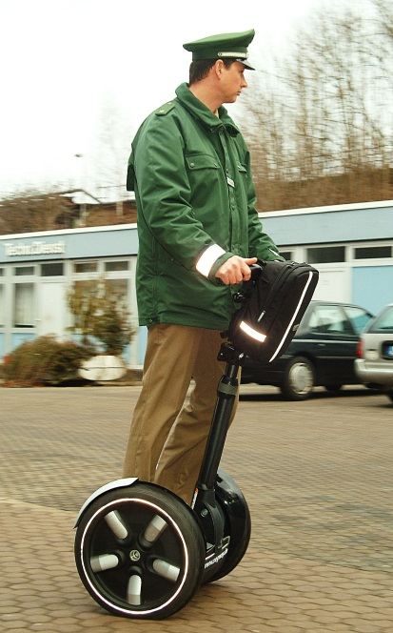 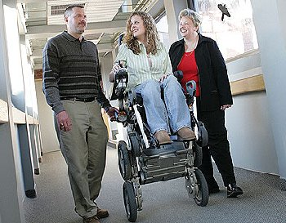

Figure 1 – Applications of Two-wheeled inverted Balancing Robot

Nowadays robots can be seen in our daily life. Robots are employed on production lines in factories, appeared as intelligent machines to do a specific task or used as commercial products. Recently, robotic applications and their wide range of functionalities have drawn many engineers’ attentions. In robotic researching field, two wheeled inverted balancing robot takes a lot of attentions as its outcome can be applied to various domains: transportation, industry, health care…



Figure 2 – Non-inverted (left) and inverted (right) pendulum

Two wheeled inverted balancing robots are based on inverted pendulum configuration which rely upon dynamic balancing systems for balancing and maneuvering. These robot bases provide exceptional robustness and capability due to their smaller size and power requirements. Outcome of research in this field had led to the birth of robots such as Segway, Murata boy etc. Such robots find their applications in surveillance & transportation purpose.

This project is based on development of a two wheeled inverted balancing robot. In particular, the focus is on the **electro-mechanical mechanisms** & **control algorithms** required to enable the robot to perceive and act in real time for a dynamically changing world.

Two-wheeled balancing robots can be used in several applications with different perspectives such as an intelligent gardener in agricultural fields (e.g. vineyards), an autonomous trolley in hospitals, shopping malls, offices, airports, healthcare applications or an intelligent robot to guide blind or disable people.

### Existing Solutions

#### Four-Wheeled Robot

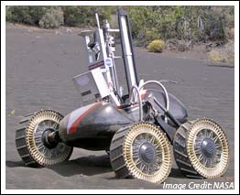 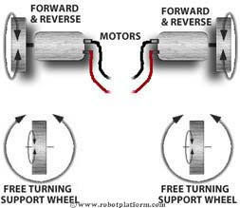

Figure 3 – Four Wheeled Robot (left) and its driving mechanism (right)

Four wheeled robot is the most stable robot comparing to 2, 3 wheeled one. That reason result in the rapid development of four wheeled vehicle for transportation (car, truck…). Balancing a four wheeled robot is never an issue. But it’s also has some disadvantages

* Requires lots of space
* Steering in limited amount.

#### Three-Wheeled Robot

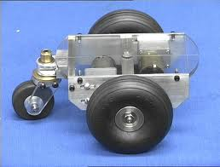 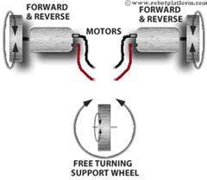

Figure 4 – 3 Wheeled Robot (left) and its driving mechanism (right)

3-wheeled robot has simpler design and construction; these robots do not require any specialized balancing algorithms and the reason are the most favorable choice for a beginner. The wheels are normally arranged in a triangular manner and are hence balanced.

**Disadvantages:**

* Cannot spin or have a 90° turn due to their limited radius of curvature.
* Cannot navigate well when move on the hard terrain
* Difficulty of moving irregular surfaces. When the robot goes over uneven surfaces, its orientation might change abruptly if one of the active wheels loses contact to the ground.

### Proposed Solution

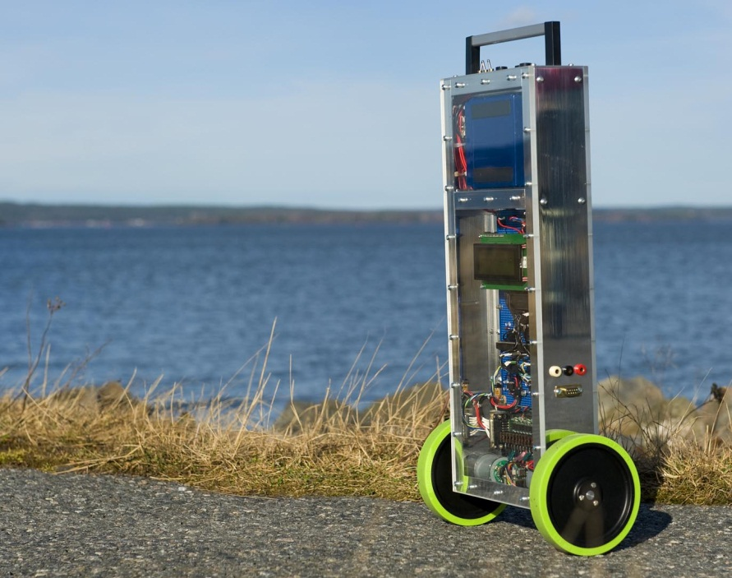

Figure 5 – Two-Wheeled Inverted Balancing Robot

The proposed solution is a **2 wheeled robot**, with self-balancing ability which provides higher level of mobility and maneuverability. Due to its high maneuverability, the two wheeled balancing robot has deeply and widely observed to solve some robotic tasks.

Comparing to 3, 4 wheeled robot, it’s has many advantages:

* Uses less track space as compared to any other vehicle.
* It is more flexible and easy to steer as compared to any other vehicle.
* It can cut through obstacles easier than a four wheeled bot.
* Due to its low weight and greater steer ability, it can be made faster
* This robot might be useful for transportation in research areas or mines where man or four wheeled robots cannot reach.
* Is believed to be the best robot design platform which is able to make flexible movements among human environment.

**Disadvantages:**

* Hard to balance and keep it upright.
* Balancing platform is not an easy structure.

### Feature Functions

The system is intended to build contains two parts: **Two-wheeled inverted balancing Robot** and **Two-wheeled inverted balancing Robot** **Monitor Windows Application**

* The robot has its ability to balance itself even when it received disturbances
* The robot can move in inclined surface and tough terrain without falling.
* The robot can be monitored by user using windows application
* Using monitor windows application, user can observe the current status of robot, setting robot values, send movement command, freely, precisely, or in sequence.

### Project Team

|  |  |  |  |
| --- | --- | --- | --- |
| **No.** | **Name** | **Role** | **Contact** |
| 1 | Trần Khánh Ninh | Supervisor | **Phone**: 0909503464  **Email**: NinhTK@fpt.edu.vn |
| 2 | Nguyễn Thanh Hòa | Leader | **Phone**: 0906111548  **Email**: hoantse60768@fpt.edu.vn |
| 3 | Trần Lữ Sinh | Member | **Phone**: 01235557228  **Email**: sinhtlse60799@fpt.edu.vn |
| 4 | Nguyễn Lý Thanh Huy | Member | **Phone**: 0945148468  **Email**: huynltse60759@fpt.edu.vn |
| 5 | Phạm Nguyễn Tân Bình | Member | **Phone**: 0973456565  **Email**: binhpnt60096@fpt.edu.vn |

Table 1 – Project team

## SYSTEM PROJECT MANAGEMENT PLAN (SPMP)

### Problem Definition

#### Name and Main Points of Capstone Project

**English:** Designing and making a two wheel inverted balancing robot.

**Vietnamese:** Thiết kế và thi công hệ thống xe 2 bánh cân bằng.

The system requires design the controller using Microcontroller, software using HMI; program on hardware; PID, FUZZY algorithms, sensor.

#### Problem Abstract

Two wheeled balancing robots are based on inverted pendulum configurations which rely upon dynamic balancing systems for balancing and maneuvering. As the name suggest the robot would be make itself balanced, controlled through a wireless remote, and at the same time autonomously balancing itself and avoid falling.

#### Project Overview

##### The current System

Wheeled robots are robots that navigate around the ground using motorized wheels to propel themselves. This design is simpler than using treads or legs and by using wheels they are easier to design, build, and program for movement in flat, not-so-rugged terrain. They are also better controlled than other types of robots. Nowadays, there are so many types of wheeled-robots, depending on how many wheels it has. 3, 4 wheeled robots are widely using, but it has many problems:

* Requires lots of space
* Hard to steer
* Cannot navigate well over obstacles, move on the hard terrain

##### The proposed System

There is the need of invention of a new vehicle that is more agile and flexible for transportation which has many advantages:

* Higher level of mobility and manoeuvrability.
* Uses less track space as compared to any other vehicle.
* It is more flexible and easy to steer as compared to any other vehicle.
* It can cut through obstacles easier than a four wheeled bot.
* This robot might be useful for transportation in research areas or mines where man or four wheeled robots cannot reach.

In particular, the focus is on the **electro-mechanical mechanisms & control algorithms** required to enable the robot to perceive and act in real time for a dynamically changing world. The construction of sensors, filters and actuator system is a learning experience.

We design the system with good hardware and platform. The robot has a compact design and high mobility.

##### Boundaries of the System

The system which is intended to build contains **2 parts:**

* **Two-wheeled Inverted Balancing Robot (TWIBR)**: The robot gathers sensor value and users PID algorithm to keep balancing itself.
* **Two-wheeled Inverted Balancing Robot Monitor (TWIBR Monitor):** A windows application for users to monitor the robot through Bluetooth connection (Serial Port Protocol)

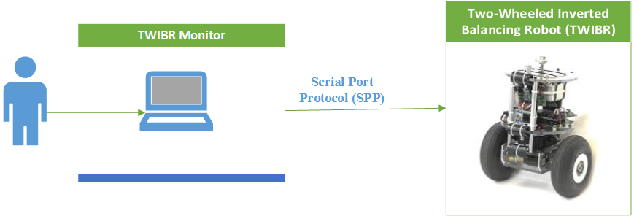

Figure 6 – Boundaries of the System

### Overview

#### System Process Model

Project is developed under Iterative and Incremental development model.

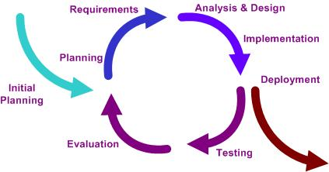

Figure 7 – Iterative and Incremental development model

Iterative and incremental software development is a method of software development that is modeled around a gradual increase in feature additions and a cyclical release and upgrade pattern.

Iterative and incremental software development begins with planning and continues through iterative development cycles involving continuous user feedback and the incremental addition of features concluding with the deployment of completed software at the end of each cycle.

#### Roles and Responsibilities

|  |  |  |  |
| --- | --- | --- | --- |
| **No.** | **Name** | **Role** | **Responsibilities** |
| 1 | Trần Khánh Ninh | Supervisor | * Support technical issue * Specify requirement * Control the development process |
| 2 | Nguyễn Thanh Hòa | Team Leader, Developer | * Managing process * Designing hardware * GUI design * Create test case * Coding * Clarifying requirements * Support technique * Prepare documents |
| 3 | Trần Lữ Sinh | Team Member, Developer, Tester | * Assign tasks * GUI Design * Coding * Clarifying requirements * Support technique * Testing * Prepare documents |
| 4 | Nguyễn Lý Thanh Huy | Team Member, Developer, Tester | * GUI Design * Prepare hardware * Designing hardware * Coding * Clarifying requirements * Prepare documents |
| 5 | Phạm Nguyễn Tân Bình | Team Member, Developer, Tester | * Coding * Prepare hardware * Clarifying requirements * Create test case * Testing * Prepare documents |

Table 2 – Roles and Responsibilities

#### Tools and Techniques

##### Robot development

###### **Hardware**

The robot hardware can be classified into the following parts:

* **Mechanical Model**
* **Custom Mainboard**
* **Inertial sensors** : combine gyroscopes and accelerometers
* **Logical processing unit**
* **Actuators** (DC Motor with QEI Encoder)
* **Wireless Communication** : Bluetooth module
* **Addition hardware**:
  + Program/Debug Device

###### **Software**

* **Operating System:** Windows 7 Professional
* **Hardware Simulation Software**: ISIS Proteus 7 Professional
* **Circuit Board Layout Tool**: Orcad Layout 9.2
* **Schematic Design for develop PCB:** Orcad Capture 9.2
* **IDE :** Mplab IDE 8.86 with C30 Compiler

##### Windows application development

* **Wireless** **Communication** : Bluetooth module
* **Technologies** : WPF with MVVM pattern, Mahapps.Metro UI library
* **IDE** : Microsoft Visual Studio 2012

##### Communication



By Facebook, Gmail, Skype and in class with Supervisor

### Project Management Plan

#### Iteration

|  |  |  |  |  |  |
| --- | --- | --- | --- | --- | --- |
| **Phase**  **/Iteration** | **Description** | **Deliverables** | **Resource needed** | **Dependencies and Constraints** | **Risks** |
| Preliminary study and planning | - Study how to program specific microcontroller  - Identify and research algorithm and devices  - Make project’s plan | - Notes about dsPic33F  - Project’s plan | 20 man-days | N/A | - Can be misunderstand about dsPIC33F |
| Design, prepare hardware | - Design main board circuit  - Find and buy material for create devices | - Devices circuit design  - Printed circuit  - Component devices | 30 man-days | N/A | - The supplier not supply the material on time  - Materials can be broken due to inappropriate uses.  - Lack of money |
| Develop hardware | - Assemble component into the board circuit  - Design the chassis | - Completed main board with components on it.  - Chassis design | 40 man-days | Depend on **“Develop hardware”** | - The quality of device that supply in Vietnam sometimes not good enough the requirement |
| Develop robot’s firmware | - Implement robot firmware including balancing algorithms | - Completed robot firmware code | 75 man-days | Depend on **“Develop hardware”** | - Components can be broken due to wrong settings code |
| Develop window application | - Implement an window application for users to view and control robot via Bluetooth module | - Window application | 30 man-days | - N/A | - Lack of experience in WPF technology for developing window application. |
| Integration and system test for the behavior in system | - Create test plan, test cases and expected result  - Execute test cases and collect test result | - Integrated system  - Test plan, test cases and test result | 20 man-days | Depend on **“Develop window application”** and **“Develop robot’s firmware”** | - Lack of experience in creating test plan, test cases |

Table 3 – Project Iterations

#### Iteration detail

##### Phase 1: Preliminary study and planning

|  |  |  |
| --- | --- | --- |
| **Task** | **Description** | **Author** |
| - Study about dsPIC33F | - Study about dsPIC33F | SinhTL, BinhPNT, HoaNT, HuyNLT |
| - Research current system in our life | - Segway operating mechanism  - PID algorithms for balancing robot | SinhTL, BinhPNT, HoaNT, HuyNLT |
| - Identify and research about robot | - Choose which end devices should be made  - Research about needed circuits | BinhPNT, HuyNLT |
| - Planning | - Make plan, schedule and assign task  - Identify risk and how to manage | SinhTL |
| - Document | - Make team’s report: Introduction, SRS | SinhTL, BinhPNT, HoaNT, HuyNLT |

Table 4 – Phase 1- Preliminary study and planning

##### Phase 2: Design, prepare hardware

|  |  |  |
| --- | --- | --- |
| **Task** | **Description** | **Author** |
| Identify requirement and planning | - Which devices should be made  - What materials are needed | HoaNT, SinhTL |
| Design Main board | - Design circuit  - Design schematic of circuit  - Print circuit | HoaNT |
| Buy material | - Microcontroller  - Motors  - MPU6050 sensor  - Bluetooth module  - H-Bridge | HuyNLT, BinhPNT |
| Design robot chassis | - Design chassis | HoaNT, SinhTL |
| Document | - Make team’s report: SRS, SDD | SinhTL, BinhPNT, HoaNT, HuyNLT |

Table 5 – Phase 2 - Design, prepare hardware

##### Phase 3: Develop hardware

|  |  |  |
| --- | --- | --- |
| **Task** | **Description** | **Author** |
| Assemble robot | - Implement chassis design  - Solder components to printed circuit  - Make main board and motor fixed on chassis | SinhTL, HuyNLT, BinhPNT |
| Implement robot firmware parts | - Implement I2C communication  - Implement UART communication  - Implement PWM motor control | HoaNT, SinhTL |
| - Testing | - Test each part work correctly | HuyNLT, BinhPNT |
| - Document | - Make team’s report: SRS, SDD | SinhTL, BinhPNT, HoaNT, HuyNLT |

Table 6 – Phase 3 - Develop hardware

##### Phase 4: Develop robot’s firmware

|  |  |  |
| --- | --- | --- |
| **Task** | **Description** | **Author** |
| Implement algorithms in robot firmware | - Implement angle calculation  - Implement complementary filter  - Implement PID algorithms | HoaNT |
| Implement robot feature | - Implement moving function | SinhTL |
| Testing | - Test if all devices work correctly | HuyNLT, BinhPNT |
| Document | - Update SRS, SDD | SinhTL, BinhPNT, HoaNT, HuyNLT |

Table 7 – Phase 4 - Develop robot’s firmware

##### Phase 5: Develop window application

|  |  |  |
| --- | --- | --- |
| **Task** | **Description** | **Author** |
| - Identify requirement | - Which feature/services the application should provide | HuyNLT, BinhPNT |
| - Implement communication | - Implement how application communicates with robot | HoaNT, HuyNLT |
| - Implement GUI and Interaction | - Implement application on windows to help users control robot | SinhTL, HuyNLT |
| -Testing | - Test system behavior and  performance | HuyNLT, BinhPNT |
| - Document | - Update SRS, SDD; | SinhTL, BinhPNT, HoaNT, HuyNLT |

Table 8 – Phase 5 - Develop window application

##### Phase 6: Integration and system test for the behavior in system

|  |  |  |
| --- | --- | --- |
| **Task** | **Description** | **Author** |
| - Identify requirement and planning | - Which feature the system can be improved | SinhTL, BinhPNT, HoaNT, HuyNLT |
| - Test performance | - Check the performance of system | HoaNT, HuyNLT |
| - Create test case | - Check the behavior of system when risk occurred | HuyNLT, SinhTL |
| - Execute test case | - Create test cases to cover | SinhTL, BinhPNT |
| - Check the result and fix bug | - Collect test result  - If any bug occurred, fixed them | HoaNT, BinhPNT |
| - Document | - Add test plan and test result  - Create User Manual | SinhTL, BinhPNT, HoaNT, HuyNLT |

Table 9 – Phase 6 - Integration and system test for the behavior in System

#### Task Sheet: Assignments and Timetable

See the Task sheet hard-copy.

### Convention Rules

The following rules follow:

* + The standard rules for developing application using C/C++ (<http://users.ece.cmu.edu/~eno/coding/CCodingStandard.html>)
  + MSDN’s C# Coding Conventions (C# Programming Guide) (<http://msdn.microsoft.com/en-us/library/vstudio/ff926074%28v=vs.110%29.aspx>)

## SYSTEM REQUIREMENTS SPECIFICATIONS (SRS)

### User Requirement Specification

The purpose of the windows application is to monitor and control Two-wheeled inverted balancing Robot via Bluetooth connection. There are 5 functions:

* **Free Mode Moving Control:** User can control moving of robot such as move forward, backward, turn left, turn right, without specific amount.
* **Precise Mode Moving Control:** User can control moving of robot such as move forward, backward, turn left, turn right with specific amount.
* **Monitor inclined value of robot** : User can observe the stability of robot by watching the robot simulation and angle by time graph
* **Configure robot PID values:** User can see the current PID values, and can set the robot PID values.
* **Sequence Movement Control:** User can make the robot move in planned sequence. User can edit the sequence moves and observe the path robot is moving via the sequence map.

### System Requirement Specification

#### External Interface Requirements

##### User Interface

The interface must be designed to be satisfied the following requirement:

* The interface is divided by tabs, which will allow users to easily switch between different parts of the program.
* Be simple and user-friendly.
* Meet all the main functions and easily to identify each of functions.
* Use obvious icons to avoiding misunderstanding.

##### Hardware Interface

The hardware interface the robot using must be designed to be satisfied the following requirement:

* Low-cost hardware module.
* Easy to consume.
* Easy to replace for maintenance.

##### Communication Protocols

The robot and the windows application must use **Serial Port Protocol** (SPP) to connect each other, via Bluetooth Module of PC and HC-05 Bluetooth Module on the robot

#### Functional Requirements

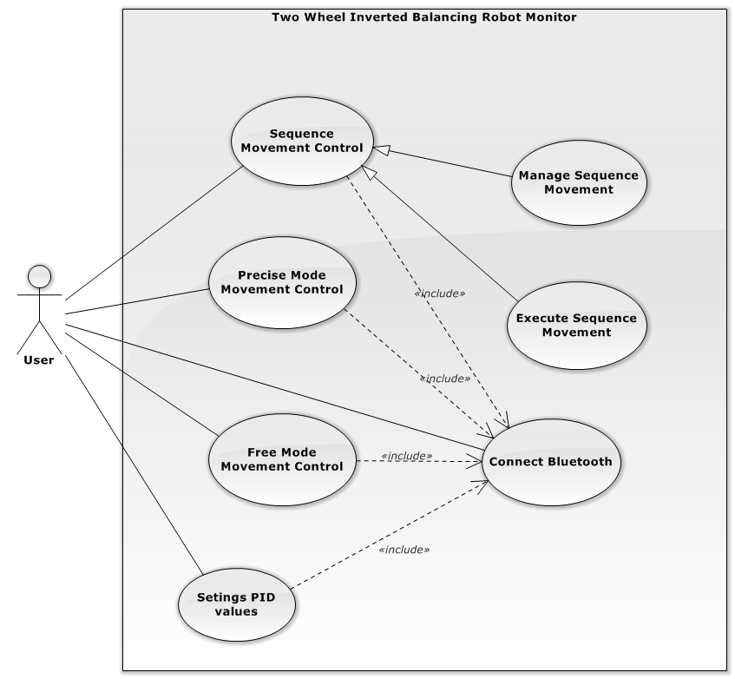

Figure 8 – Use case Diagram

##### Connect Bluetooth Function

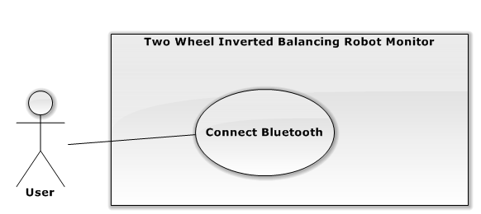

Figure 9 – Connect Bluetooth Use case Diagram

|  |  |  |  |  |
| --- | --- | --- | --- | --- |
| USE CASE - UC001 – Connect Bluetooth Functional | | | | |
| Use-case No. | UC001 | **Use-case Version** | | 1.0 |
| Use-case Name | Connect Bluetooth | | | |
| Author | Nguyễn Thanh Hòa | | | |
| Date | 2014/02/14 | **Priority** | Normal | |
| Actor:  User  Summary:   * + This use case allow user setting appropriate Port name and Baud rate and connect to the robot through Bluetooth   Goal:   * + The windows application successfully connect to robot via Bluetooth   Triggers:   * + User click on Connect button on setting panel.   Preconditions:   * + Robot is ON   + Windows application is not connected to robot   Post Conditions:   * + Windows application is connected to robot   + Windows application changes connection status from *disconnected* to *connected*   Main Success Scenario:   |  |  |  | | --- | --- | --- | | Step | Actor Action | System Response | | 1a | User open the application | Application is appeared. The welcome page is shown. | | 2a | User click on “Start Now” button | Settings panel is opened, port name list and baud rate list is shown | | 3a | User click Connect button | Windows application connect to selecting port name and baud rate |   Alternative Scenario:  N/A  Exceptions:   |  |  |  | | --- | --- | --- | | No | Actor Action | System Response | | 1 | 1. Choose other port name (not the robot Bluetooth port name) 2. Click Connect button | Appear message *“Cannot establish the connection! Please check then try again!”* under Connect button | | 2 | 1. Turn off the robot, 2. Click Connect button | Appear message *“Cannot establish the connection! Please check then try again!”* under Connect button | | 3 | The PC does not have any available COM port | Appear message “*There are no port in your PC, Please Add a Bluetooth device and try again*” |   Relationship:  Free Mode Movement Control, Precise Mode Movement Control, Setting PID values, Execute Sequence Movement | | | | |

Table 10 – Connect Bluetooth Use case Description

##### Sequence Movement Control

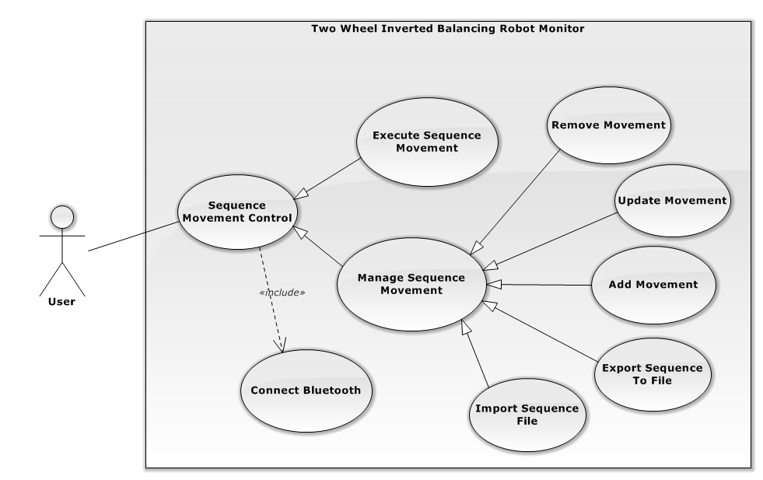

Figure 10 – Sequence Movement Control Use case Diagram

###### Import Sequence File

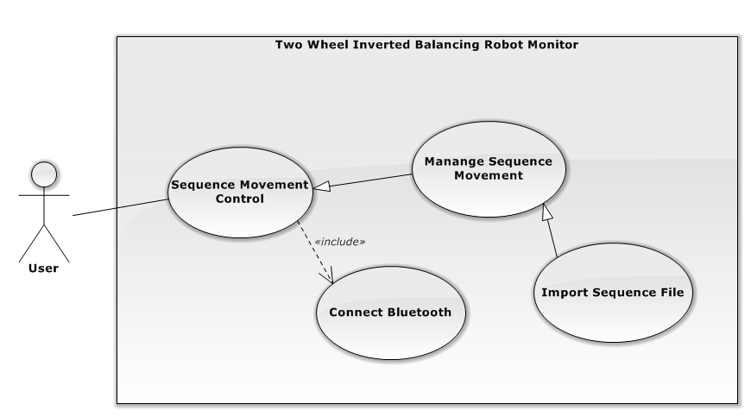

Figure 11 – Import Sequence File Use case Diagram

|  |  |  |  |  |
| --- | --- | --- | --- | --- |
| USE CASE - UC002– Import Sequence File | | | | |
| Use-case No. | UC002 | **Use-case Version** | | 1.0 |
| Use-case Name | Import Sequence File | | | |
| Author | Nguyễn Thanh Hòa | | | |
| Date | 2014/02/14 | **Priority** | Normal | |
| Actor:  User  Summary:   * + This use case allow user to import a text file which contains set of movements to the sequence control.   Goal:   * + The application loaded all of movements defined in the text file.   Triggers:   * + User click on Import File () button on “Sequence Movement Control” section of “Advanced” tab   Preconditions:   * + Robot is ON   + Windows application is connected to robot   + The sequence movement is not currently executing.   Post Conditions:   * + Success: The movements defined in the text file is loaded in the sequence movement list   + Fail: No movement is added. Failure message is shown.   Main Success Scenario:   |  |  |  | | --- | --- | --- | | Step | Actor Action | System Response | | 1 | Clicks Advanced Tab item | Advanced Tab content is shown, including “Sequence Movement Control” section | | 2 | Click Import File ( ) button | The Open File dialog is opened. | | 3 | - Choose a text file  - Click “Open” button of Open File Dialog | - Validate the file successfully  - The movements defined in the chosen text file are loaded to the sequence list. |   Alternative Scenario:   |  |  |  | | --- | --- | --- | | No | Actor Action | System Response | | 3a | - Enter the existed file name  - Press “**Enter**” button | - Validate the file successfully  - The movements defined in the chosen text file are loaded to the sequence list. |   Exceptions:   |  |  |  | | --- | --- | --- | | No | Actor Action | System Response | | 1 | Click “Cancel” or “X” button as the top right corner of the Open File dialog | Cancel the import request, close Open File dialog | | 2 | Choose the file which is not in text format | Display error message: “Cannot import the file. Please choose a valid text message” | | 3 | Choose the file which has invalid movement format | Display error message: “Cannot import the file. Please choose a valid format text file” | | 4 | Choose the file which has more than 10,000 movements | Display error message: “The file is too large. Please choose the file less than 10,000 movements” |   Relationship:  Sequence Movement Control, Manage Sequence Movement  Business Rules:   * + The sequence file must be a text format file   + Each line of the sequence file must match ”^[FBLRfblr][0-9]{1,4}$” regular expression   Ex: Valid Movement: F291, L1234 …  Invalid Movement: U221, B21341 … | | | | |

Table 11 – Import Sequence File Use Case Description

###### Export Sequence File

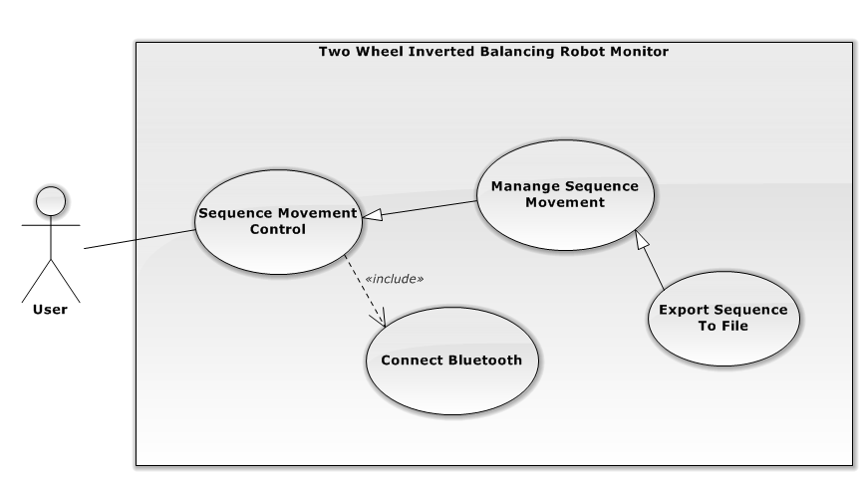

Figure 12 – Export Sequence To File Use Case Diagram

|  |  |  |  |  |
| --- | --- | --- | --- | --- |
| USE CASE - UC003 – Export Sequence To File | | | | |
| Use-case No. | UC003 | **Use-case Version** | | 1.0 |
| Use-case Name | Export Sequence To File | | | |
| Author | Nguyễn Thanh Hòa | | | |
| Date | 2014/02/14 | **Priority** | Normal | |
| Actor:  User  Summary:   * + This use case allow user to export current sequence movements to the text file for later use.   Goal:   * + Store sequence movements into text file   Triggers:   * + User click on Export File () button on “Sequence Movement Control” section of “Advanced” tab   Preconditions:   * + Robot is ON   + Windows application is connected to robot   + The sequence movement is not currently executing.   Post Conditions:   * + Success: Sequence movement list is stored in the chosen file.   + Fail: No movement is stored. Failure message is shown.   Main Success Scenario:   |  |  |  | | --- | --- | --- | | Step | Actor Action | System Response | | 1 | Clicks Advanced Tab item | Advanced Tab content is shown, including “Sequence Movement Control” section | | 2 | Click Export File ( ) button | The Save File dialog is opened. | | 3 | - Enter the file name  - Click “Save” button of Open File Dialog | Sequence movement list is stored in the chosen file. |   Alternative Scenario:   |  |  |  | | --- | --- | --- | | Step | Actor Action | System Response | | 3a | - Enter the file name  - Press **Enter** button | Sequence movement list is stored in the chosen file. |   Exceptions:   |  |  |  | | --- | --- | --- | | No | Actor Action | System Response | | 1 | Save to the file which being opened by another application | Display error message: “Cannot export to file. It is currently in use.” | | 2 | Click “Cancel” or “X” button as the top right corner of the Save File dialog | Cancel the export request, close Save File dialog |   Relationship:  Sequence Movement Control, Manage Sequence Movement  Business Rules:  N/A | | | | |

Table 12 – Export Sequence To File Use Case Description

###### Add Movement

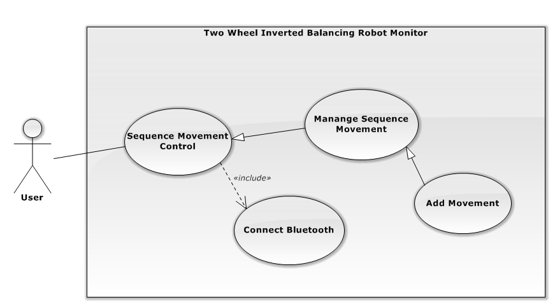

Figure 13 – Add Movement Use Case Diagram

|  |  |  |  |  |
| --- | --- | --- | --- | --- |
| USE CASE - UC004 Add Movement | | | | |
| Use-case No. | UC004 | **Use-case Version** | | 1.0 |
| Use-case Name | Add Movement | | | |
| Author | Nguyen Thanh Hoa | | | |
| Date | 2014/02/14 | **Priority** | Normal | |
| Actor:  User  Summary:   * + This use case allow user to add a new movement to the current sequence list for execution.   Goal:   * + A new movement is added to the sequence list   Triggers:   * + User click on Add () button at the bottom of the Sequence List, on “Sequence Movement Control” section of “Advanced” tab   Preconditions:   * + Robot is ON   + Windows application is connected to robot   + The sequence movement is not currently executing.   Post Conditions:   * + A new movement is added and displayed at the bottom of the Sequence List   + The Movement Map is refreshed with correspondent movement.   Main Success Scenario:   |  |  |  | | --- | --- | --- | | Step | Actor Action | System Response | | 1 | Clicks Advanced Tab item | Advanced Tab content is shown, including “Sequence Movement Control” section | | 2 | Click Add ( ) button at the bottom of the Sequence List | Display the Direction combobox and Amount textbox for user | | 3 | - User choose 1 in 4 direction of the combo box  - User enter the amount numeric textbox  - Press Enter | The new movement is added and displayed at the bottom of the Sequence List |   Alternative Scenario:   |  |  |  | | --- | --- | --- | | Step | Actor Action | System Response | | 3a | User click on the position which is outside of the current adding row | The new movement is added and displayed at the bottom of the Sequence List |   Exceptions:  N/A  Relationship:  Sequence Movement Control, Manage Sequence Movement  Business Rules:  N/A | | | | |

Table 13 – Add Movement Use Case Description

###### **Update Movement**

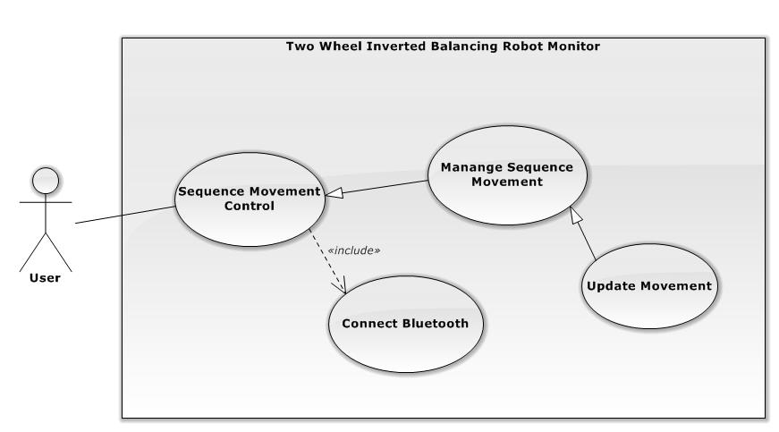

Figure 14 – Update Movement Use Case Diagram

|  |  |  |  |  |
| --- | --- | --- | --- | --- |
| USE CASE - UC005 Update Movement | | | | |
| Use-case No. | UC005 | **Use-case Version** | | 1.0 |
| Use-case Name | Update Movement | | | |
| Author | Nguyen Thanh Hoa | | | |
| Date | 2014/02/14 | **Priority** | Normal | |
| Actor:  User  Summary:   * + This use case allow user to update Direction or Amount of an existing movement to the current sequence list for execution.   Goal:   * + Update Direction or Amount of an existing movement   Triggers:   * + User double-click a row of Sequence List, on “Sequence Movement Control” section of “Advanced” tab   Preconditions:   * + Robot is turned on   + Windows application is connected to robot   + The sequence movement is not currently executing.   Post Conditions:   * + An existing movement is updated   + The Movement Map is refreshed with correspondent updated movement.   Main Success Scenario:   |  |  |  | | --- | --- | --- | | Step | Actor Action | System Response | | 1 | Clicks Advanced Tab item | Advanced Tab content is shown, including “Sequence Movement Control” section | | 2 | Double-click a existing row of Sequence List | Display the Direction combo box and Amount numeric box for user to change. | | 3 | - Choose 1 in 4 direction of the combo box  - Enter the amount numeric textbox  - Press Enter | - The movement is updated  - The Movement Map is refreshed with correspondent updated movement |   Alternative Scenario:   |  |  |  | | --- | --- | --- | | Step | Actor Action | System Response | | 3a | User click on the position which is outside of the current updating row | - The movement is updated  - The Movement Map is refreshed with correspondent updated movement |   Exceptions:  N/A  Relationship:  Sequence Movement Control, Manage Sequence Movement  Business Rules:  N/A | | | | |

Table 14 – Update Movement Use Case Description

###### **Remove Movement**

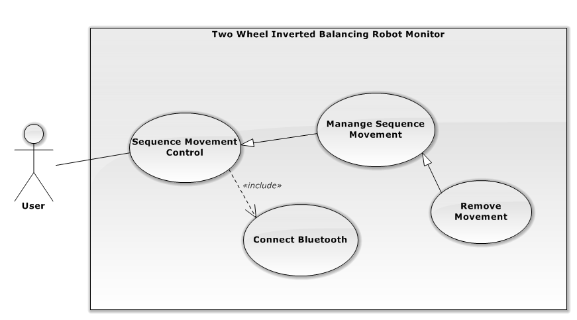

Figure 15 – Remove Movement Use Case Diagram

|  |  |  |  |  |
| --- | --- | --- | --- | --- |
| USE CASE - UC006 Remove Movement Function | | | | |
| Use-case No. | UC006 | **Use-case Version** | | 1.0 |
| Use-case Name | Remove Movement | | | |
| Author | Nguyen Thanh Hoa | | | |
| Date | 2014/02/14 | **Priority** | Normal | |
| Actor:  User  Summary:   * + This use case allow user to remove an existing movement from current sequence list.   Goal:   * + Remove an existing movement from current sequence list   Triggers:   * + User click on “x” button on the right of a row in Sequence List, on “Sequence Movement Control” section of “Advanced” tab   Preconditions:   * + Robot is turned on   + Windows application is connected to robot   + The sequence movement is not currently executing.   Post Conditions:   * + The movement is removed from the sequence list   + The Movement Map is refreshed with correspondent removed movement.   Main Success Scenario:   |  |  |  | | --- | --- | --- | | Step | Actor Action | System Response | | 1 | Clicks Advanced Tab item | Advanced Tab content is shown, including “Sequence Movement Control” section | | 2 | Double-click “x” button on the right of a row in Sequence List | The confirmation message is shown. | | 3 | Click “Yes” button on the confirmation message | - The movement is removed from the sequence list  - The Movement Map is refreshed with correspondent removed movement. |   Alternative Scenario:   |  |  |  | | --- | --- | --- | | Step | Actor Action | System Response | | 2a | - User moves mouse to hover the row  - Press **Delete** on the keyboard | - The movement is removed from the sequence list  - The Movement Map is refreshed with correspondent removed movement. |   Exceptions:  N/A  Relationship:  Sequence Movement Control, Manage Sequence Movement  Business Rules:  N/A | | | | |

Table 15 – Remove Movement Use Case Description

###### **Execute Sequence Movement**

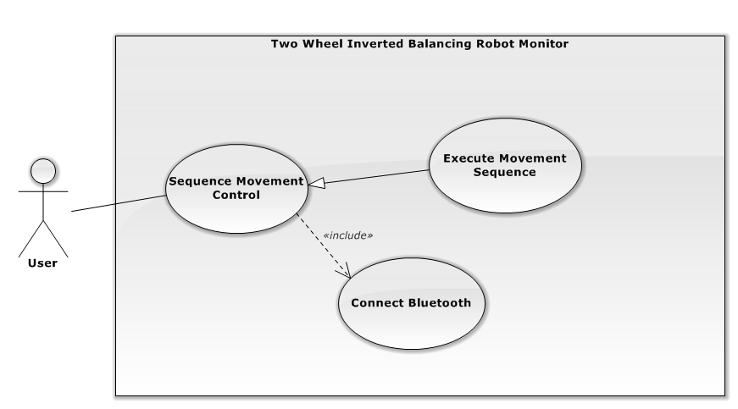

Figure 16 – Execute Sequence Movement Use Case Diagram

|  |  |  |  |  |
| --- | --- | --- | --- | --- |
| USE CASE - UC007 Execute Sequence Movement | | | | |
| Use-case No. | UC007 | **Use-case Version** | | 1.0 |
| Use-case Name | Execute Sequence Movement | | | |
| Author | Nguyễn Thanh Hòa | | | |
| Date | 2014/02/14 | **Priority** | Normal | |
| Actor:  User  Summary:   * + This use case allow user to start execute sequence movement which is defined in Sequence List   Goal:   * + Robot step by step executes defined movements with specific amount and direction.   Triggers:   * + User click Execute() button on “Sequence Movement Control” section of “Advanced” tab   Preconditions:   * + Robot is turned on   + Windows application is connected to robot   + The sequence movement is not currently executing.   + At least 1 move in the Sequence List has pending or executing status   + No other function is executing.   Post Conditions:   * + Execute button is hidden,   + Pause button appears   + The robot executes the sequence list until all of the moves are done if user does not click Pause button   Main Success Scenario:   |  |  |  | | --- | --- | --- | | Step | Actor Action | System Response | | 1 | Clicks Advanced Tab item | Advanced Tab content is shown, including “Sequence Movement Control” section | | 2 | Click Execute() button | While sequence list has any pending move  - The next move changes status from Pending to Executing  - The Robot moves with specific direction to the specific distance defined in the current executing move  - The currnet executing movement changes status from Executing to Done.  End Loop |   Alternative Scenario:  N/A  Exceptions:   |  |  |  | | --- | --- | --- | | No | Actor Action | System Response | | 1 | Cannot send data to robot due to Bluetooth connection problem | -Stop the sequence.  Display error message “Cannot send data to robot. Please try again” |   Relationship:  Sequence Movement Control  Business Rules:  N/A | | | | |

Table 16 – Execute Sequence Movement Use Case Description

##### Free Mode Movement Control Function

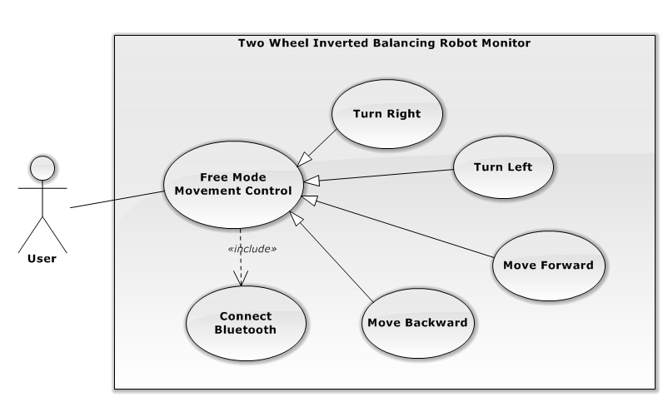

Figure 17 – Free Mode Movement Control Use Case Diagram

###### **Free Move Forward Function**

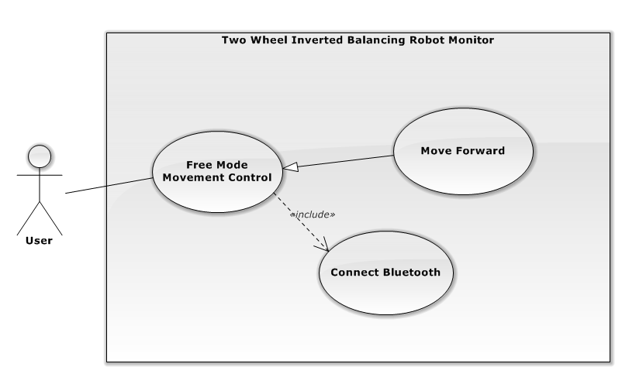

Figure 18 – Free Move Forward Use Case Diagram

|  |  |  |  |  |
| --- | --- | --- | --- | --- |
| USE CASE - UC008 - Free Move Forward | | | | |
| Use-case No. | UC008 | **Use-case Version** | | 1.0 |
| Use-case Name | Free Move Backward | | | |
| Author | Trần Lữ Sinh | | | |
| Date | 2014/02/14 | **Priority** | Normal | |
| Actor:  User  Summary:   * + This use case allow user control robot moving forward without specific amount   Goal:   * + Robot moves backward as long as user holds  (Forward)   Triggers:   * + User clicks on  (Forward) button.   Preconditions:   * + Robot is ON   + Windows application and robot are paired.   + No other function is executing.   Post Conditions:   * + Robot stop when user release  (Forward) button   Main Success Scenario:   |  |  |  | | --- | --- | --- | | Step | Actor Action | System Response | | 1 | User go to “Beginner” tab | Windows app shows all content of “Beginner” tab | | 2 | User holds  (Forward) button | Robot is moving backward | | 3 | User release  (Forward) button | - Robot stop moving and soon stands upright  - Application logs “Robot has move forward {0}mm” format with the distance the robot has moved |   Alternative Scenario:   |  |  |  | | --- | --- | --- | | Step | Actor Action | System Response | | 2a | User hold Up arrow on keyboard. | Robot is moving forward | | 3a | User release Up arrow on keyboard. | - Robot stop moving and quickly stands upright  - Application logs “Robot has move forward {0}mm” format with the distance the robot has moved |   Exceptions:   |  |  |  | | --- | --- | --- | | No | Actor Action | System Response | | 1 | - User holds  (Forward) button  - User turns off the robot | -Application return to **disconnected** status  -Display error message “Lost connection with the robot. Please check the connection and try again.” |   Relationship:  Connect Bluetooth, Free Mode Movement Control | | | | |

Table 17 – Free Move Forward Use Case Description

###### **Free Move Backward Function**

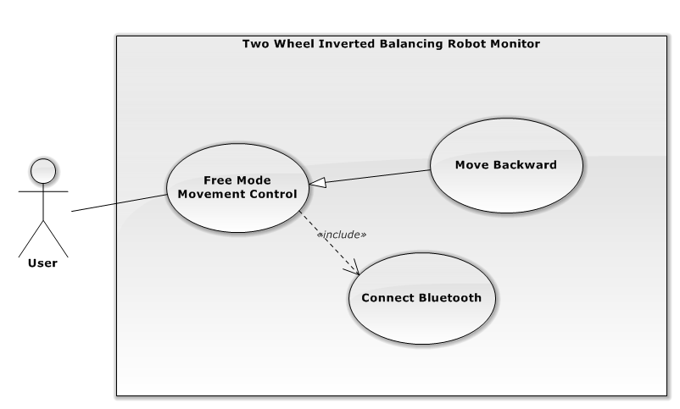

Figure 19 – Free Move Backward Use Case Diagram

|  |  |  |  |  |
| --- | --- | --- | --- | --- |
| USE CASE - UC009 - Free Move Backward | | | | |
| Use-case No. | UC009 | **Use-case Version** | | 1.0 |
| Use-case Name | Free Move Backward | | | |
| Author | Trần Lữ Sinh | | | |
| Date | 2014/02/14 | **Priority** | Normal | |
| Actor:  User  Summary:   * + This use case allow user control robot moving backward without specific amount   Goal:   * + Robot moves backward as long as user holds (Backward) button   Triggers:   * + User clicks on  (Backward) button.   Preconditions:   * + Robot is ON   + Windows application and robot are paired.   + No other function is executing.   Post Conditions:   * + Robot stop moving when user release  (Backward) button.   Main Success Scenario:   |  |  |  | | --- | --- | --- | | Step | Actor Action | System Response | | 1 | User go to “Beginner” tab | Windows app shows all content of “Beginner” tab | | 2 | User holds  (Backward) button | Robot is moving backward | | 3 | User release  (Backward) button | - Robot stop moving and quickly stands upright  - Application logs “Robot has move backward {0}mm” format with the distance the robot has moved |   Alternative Scenario:   |  |  |  | | --- | --- | --- | | Step | Actor Action | System Response | | 2a | User holds Down arrow on the keyboard | Robot is moving backward | | 3a | User release Down arrow on computer. | - Robot stop moving and quickly stands upright  - Application logs “Robot has move backward {0}mm” format with the distance the robot has moved |   Exceptions:   |  |  |  | | --- | --- | --- | | No | Actor Action | System Response | | 1 | - User holds  (Backward) button  - User turns off the robot | -Application return to **disconnected** status  -Display error message “Lost connection with the robot. Please check the connection and try again.” |   Relationship:  Connect Bluetooth, Free Mode Movement Control | | | | |

Table 18 – Free Move Backward Use Case Description

###### **Free Turn Left Function**

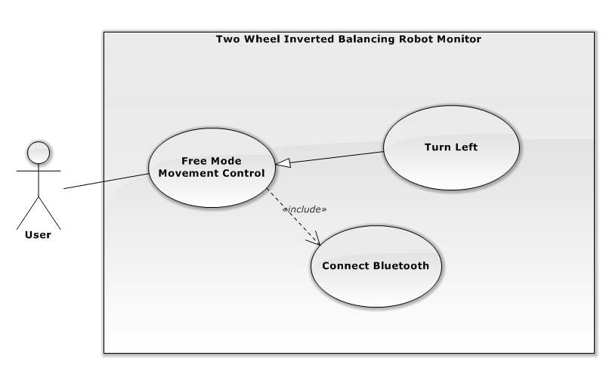

Figure 20 – Free Turn Left Use Case Diagram

|  |  |  |  |  |
| --- | --- | --- | --- | --- |
| USE CASE - UC010 - Free Turn Left | | | | |
| Use-case No. | UC010 | **Use-case Version** | | 1.0 |
| Use-case Name | Free Turn Left | | | |
| Author | Trần Lữ Sinh | | | |
| Date | 2014/02/14 | **Priority** | Normal | |
| Actor:  User  Summary:   * + This use case allow user control robot turning left without specific amount   Goal:   * + Robot turns left as long as user holds  (Left) button   Triggers:   * + User clicks on  (Left) button or press Left arrow on keyboard.   Preconditions:   * + Robot is ON   + Windows application and robot are paired.   + No other function is executing.   Post Conditions:   * + Robot stop when user release  (Left) button   Main Success Scenario:   |  |  |  | | --- | --- | --- | | Step | Actor Action | System Response | | 1 | User go to “Beginner” tab | Windows app shows all content of “Beginner” tab | | 2 | User holds  (Left) button | Robot is turning left | | 3 | User releases  (Left) button | - Robot stop turning and quickly stands upright  - Application logs “Robot has turned left {0} degrees” format with amount the robot has turned |   Alternative Scenario:   |  |  |  | | --- | --- | --- | | Step | Actor Action | System Response | | 2a | User holds Leftarrow on keyboard. | Robot is turning left | | 3a | User releases Left arrow on keyboard. | - Robot stop turning and quickly stands upright  - Application logs “Robot has turned left {0} degrees” format with amount the robot has turned |   Exceptions:   |  |  |  | | --- | --- | --- | | No | Actor Action | System Response | | 1 | - User holds  (Left) button  - User turns off the robot | -Application return to **disconnected** status  -Display error message “Lost connection with the robot. Please check the connection and try again.” |   Relationship:  Connect Bluetooth, Free Mode Movement Control | | | | |

Table 19 – Free Turn Left Use Case Description

###### **Free Turn Right Function**

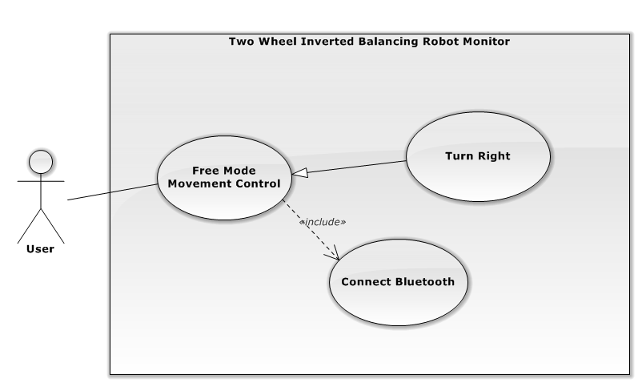

Figure 21 – Free Turn Right Use Case Diagram

|  |  |  |  |  |
| --- | --- | --- | --- | --- |
| USE CASE - UC011 - Free Turn Right | | | | |
| Use-case No. | UC011 | **Use-case Version** | | 1.0 |
| Use-case Name | Free Turn Right | | | |
| Author | Trần Lữ Sinh | | | |
| Date | 2014/02/14 | **Priority** | Normal | |
| Actor:  User  Summary:   * + This use case allow user control robot turning right without specific amount   Goal:   * + Robot turns right as long as user holds  (Right) button.   Triggers:   * + User clicks on  (Right) button.   Preconditions:   * + Robot is ON   + Windows application and robot are paired.   + No other function is executing.   Post Conditions:   * + Robot stops when user releases  (Right) button.   Main Success Scenario:   |  |  |  | | --- | --- | --- | | Step | Actor Action | System Response | | 1 | User go to “Beginner” tab | Windows app shows all content of “Beginner” tab | | 2 | User holds  (Right) button | Robot is turning right | | 3 | User releases  (Right) button | - Robot stop turning and quickly stands upright  - Application logs “Robot has turned right {0} degrees” format with amount the robot has turned |   Alternative Scenario:   |  |  |  | | --- | --- | --- | | Step | Actor Action | System Response | | 2a | User holds Right arrow on keyboard | Robot is turning right | | 3a | User releases Right arrow on keyboard. | - Robot stop turning and quickly stands upright  - Application logs “Robot has turned right {0} degrees” format with amount the robot has turned |   Exceptions:   |  |  |  | | --- | --- | --- | | No | Actor Action | System Response | | 1 | - User holds (Right) button  - User turns off the robot | -Application return to **disconnected** status  -Display error message “Lost connection with the robot. Please check the connection and try again.” |   Relationship:  Connect Bluetooth, Free Mode Movement Control | | | | |

Table 20 – Free Turn Right Use Case Description

##### Precise Mode Movement Control Function

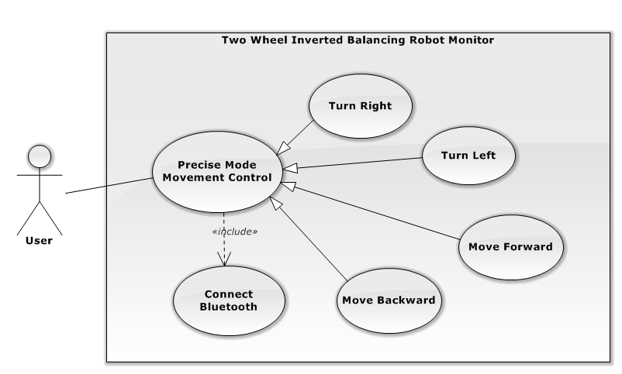

Figure 22 – Precise Mode Movement Control Use Case Diagram

###### **Precise Move Forward Function**

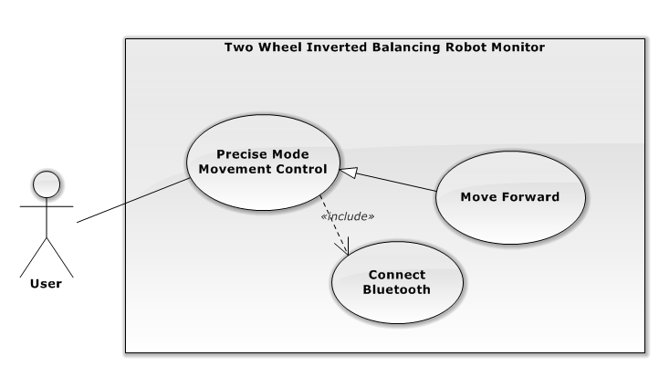

Figure 23 – Precise Move Forward Use Case Diagram

|  |  |  |  |  |
| --- | --- | --- | --- | --- |
| USE CASE - UC012 - Precise Move Forward | | | | |
| Use-case No. | UC012 | **Use-case Version** | | 1.0 |
| Use-case Name | Precise Move Forward | | | |
| Author | Phạm Nguyễn Tân Bình | | | |
| Date | 2014/02/14 | **Priority** | Normal | |
| Actor:  User  Summary:   * + This use case allow user control robot moving forward with specific amount   Goal:   * + After clicking Forward button, Robot moves forward with defined amount.   Triggers:   * + User clicks on Forward button   Preconditions:   * + Robot is ON   + Windows application and robot are paired.   + Forward amount textbox are filled.   + No other function is executing.   Post Conditions:   * + Robot stops when it finishes moving with defined amount.   Main Success Scenario:   |  |  |  | | --- | --- | --- | | Step | Actor Action | System Response | | 1 | User go to “Beginner” tab | Windows app shows all content of “Beginner” tab | | 2 | User input valid value to **Forward amount** textbox | The Forward button is enabled | | 3 | User click Forward button | - Robot moves forward until it reaches the defined amount  - Application logs “Robot has moved forward {x}mm” with defined amount |   Alternative Scenario:   |  |  |  | | --- | --- | --- | | Step | Actor Action | System Response | | 2a | User input valid amount to Forward amount textbox, then press “Enter” | - The Forward button is enabled.  - Robot moves forward until it reaches the defined amount  - Application logs “Robot has moved forward {x}mm” with defined amount |   Exceptions:   |  |  |  | | --- | --- | --- | | No | Actor Action | System Response | | 1 | User input invalid amount to **Forward** **amount** textbox | The **Forward** button is disabled | | 2 | User leaves **Forward** **amount** textbox empty | The **Forward** button is disabled |   Relationship:  Connect Bluetooth, Precise Mode Movement Control | | | | |

Table 21 – Precise Move Forward Use Case Description

###### **Precise Move Backward Function**

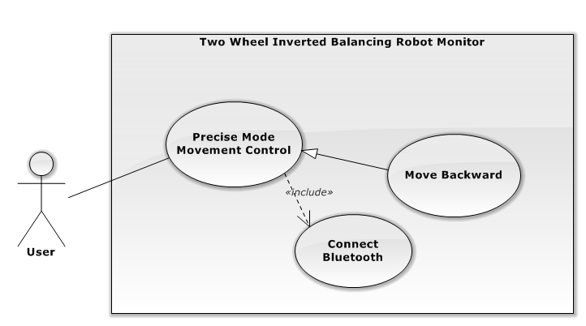

Figure 24 – Precise Move Backward Use Case Diagram

|  |  |  |  |  |
| --- | --- | --- | --- | --- |
| USE CASE - UC013- Precise Move Backward Functional | | | | |
| Use-case No. | UC013 | **Use-case Version** | | 1.0 |
| Use-case Name | Precise Move Backward | | | |
| Author | Phạm Nguyễn Tân Bình | | | |
| Date | 2014/02/14 | **Priority** | Normal | |
| Actor:  User  Summary:   * + This use case allow user control robot moving backward with specific amount   Goal:   * + After clicking Backward button, Robot moves backward with defined amount.   Triggers:   * + User clicks on Backward button   Preconditions:   * + Robot is ON   + Windows application and robot are paired.   + Backward amount textbox are filled.   + No other function is executing.   Post Conditions:   * + Robot stops when it finishes moving with defined amount.   Main Success Scenario:   |  |  |  | | --- | --- | --- | | Step | Actor Action | System Response | | 1 | User go to “**Beginner**” tab | Windows app shows all content of “Beginner” tab | | 2 | User input valid value to **Backward amount** textbox | - The Backward button is enabled | | 3 | User click Backward button | - Robot moves backward until it reaches the defined amount  - Application logs “Robot has moved backward {x}mm” with defined amount |   Alternative Scenario:   |  |  |  | | --- | --- | --- | | Step | Actor Action | System Response | | 2a | User input valid amount to Backward amount textbox, then press “Enter” | - The Backward button is enabled.  - Robot moves backward until it reaches the defined amount  - Application logs “Robot has moved backward {x}mm” with defined amount |   Exceptions:   |  |  |  | | --- | --- | --- | | No | Actor Action | System Response | | 1 | User input invalid amount to **Backward** **amount** textbox | The **Backward** button is disabled | | 2 | User leaves **Backward** **amount** textbox empty | The **Backward** button is disabled |   Relationship:  Connect Bluetooth, Precise Mode Movement Control | | | | |

Table 22 – Precise Move Backward Use Case Description

###### **Precise Turn Left Function**

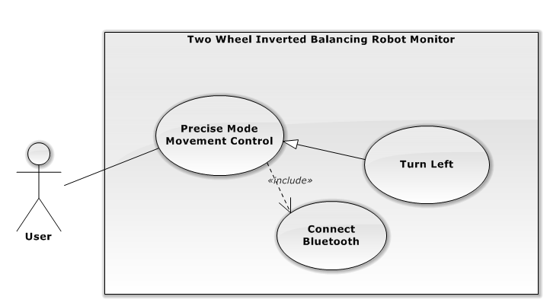

Figure 25 – Precise Turn Left Use Case Diagram

|  |  |  |  |  |
| --- | --- | --- | --- | --- |
| USE CASE - UC014 - Precise Turn Left | | | | |
| Use-case No. | UC014 | **Use-case Version** | | 1.0 |
| Use-case Name | Precise Turn Left | | | |
| Author | Phạm Nguyễn Tân Bình | | | |
| Date | 2014/02/14 | **Priority** | Normal | |
| Actor:  User  Summary:   * + This use case allow user control robot turning left with specific amount   Goal:   * + After clicking Left button, Robot turns left with defined amount.   Triggers:   * + User clicks on Left button   Preconditions:   * + Robot is ON   + Windows application and robot are paired.   + Backward amount textbox are filled.   + No other function is executing.   Post Conditions:   * + Robot stops when it finishes turning with defined amount.   Main Success Scenario:   |  |  |  | | --- | --- | --- | | Step | Actor Action | System Response | | 1 | User go to “**Beginner**” tab | Windows app shows all content of “Beginner” tab | | 2 | User input valid value to **Left** **amount** textbox | The Left button is enabled | | 3 | User click Left button | - Robot turns left until it reaches the defined amount  - Application logs “Robot has turned left {x} degrees” with defined amount |   Alternative Scenario:   |  |  |  | | --- | --- | --- | | Step | Actor Action | System Response | | 2a | User input valid amount to Left amount textbox, then press “Enter” | - The Left button is enabled.  - Robot turns left until it reaches the defined amount  - Application logs “Robot has turned left {x} degrees” with defined amount |   Exceptions:   |  |  |  | | --- | --- | --- | | No | Actor Action | System Response | | 1 | User input invalid amount to **Left** **amount** textbox | The **Left** button is disabled | | 2 | User leaves **Left** **amount** textbox empty | The **Left** button is disabled |   Relationship:  Connect Bluetooth, Precise Mode Movement Control | | | | |

Table 23 – Precise Turn Left Use Case Description

###### **Precise Turn Right Function**

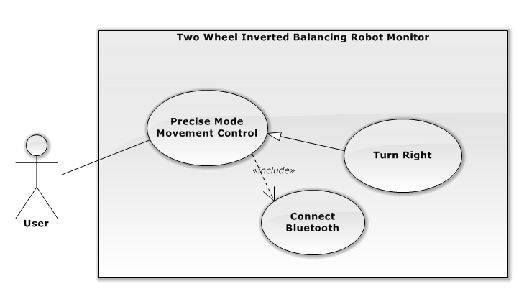

Figure 26 – Precise Turn Right Use Case Diagram

|  |  |  |  |  |
| --- | --- | --- | --- | --- |
| USE CASE - UC015 - Precise Turn Left Functional | | | | |
| Use-case No. | UC015 | **Use-case Version** | | 1.0 |
| Use-case Name | Precise Turn Right | | | |
| Author | Phạm Nguyễn Tân Bình | | | |
| Date | 2014/02/14 | **Priority** | Normal | |
| Actor:  User  Summary:   * + This use case allow user control robot turning right with specific amount   Goal:   * + After clicking Right button, Robot turns right with defined amount.   Triggers:   * + User clicks on Right button   Preconditions:   * + Robot is ON   + Windows application and robot are paired.   + Backward amount textbox are filled.   + No other function is executing   Post Conditions:   * + Robot stops when it finishes turning with defined amount.   Main Success Scenario:   |  |  |  | | --- | --- | --- | | Step | Actor Action | System Response | | 1 | User go to “**Beginner**” tab | Windows app shows all content of “Beginner” tab | | 2 | User input valid value to **Right** **amount** textbox | The Right button is enabled | | 3 | User click Right button | - Robot turns right until it reaches the defined amount  - Application logs “Robot has turned right {x} degrees” with defined amount |   Alternative Scenario:   |  |  |  | | --- | --- | --- | | Step | Actor Action | System Response | | 2a | User input valid amount to Right amount textbox, then press “Enter” | - The Right button is enabled.  - Robot turns right until it reaches the defined amount  - Application logs “Robot has turned left {x} degrees” with defined amount |   Exceptions:   |  |  |  | | --- | --- | --- | | No | Actor Action | System Response | | 1 | User input invalid amount to **Right** **amount** textbox | The **Right** button is disabled | | 2 | User leaves **Right** **amount** textbox empty | The **Right** button is disabled |   Relationship:  Connect Bluetooth, Precise Mode Movement Control | | | | |

Table 24 – Precise Turn Right Use Case Description

##### Settings PID values

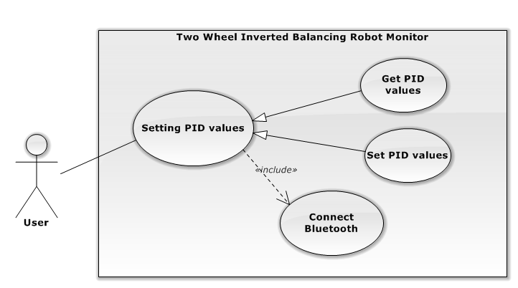

Figure 27 – Settings PID values Use Case Diagram

###### **Get PID values**

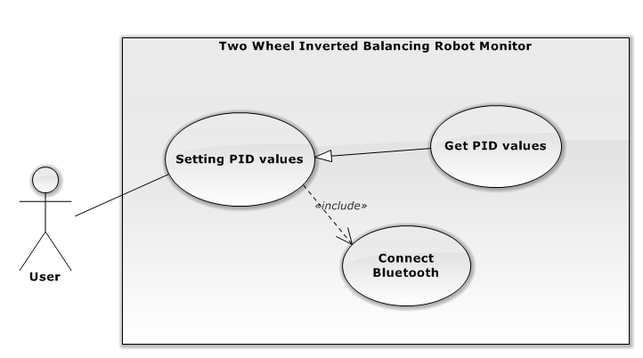

Figure 28 – Get PID values Use Case Diagram

|  |  |  |  |  |
| --- | --- | --- | --- | --- |
| USE CASE - UC016 – Get PID values | | | | |
| Use-case No. | UC016 | **Use-case Version** | | 1.0 |
| Use-case Name | Get PID values | | | |
| Author | Nguyen Ly Thanh Huy | | | |
| Date | 2014/02/14 | **Priority** | Normal | |
| Actor:  User  Summary:   * + This use case allow user getting current Proportional, Integral, Derivative (PID) values of the robot   Goal:   * + Getting current PID values of the robot   Triggers:   * + User click on Get PID () button on “PID Values” section of “Advanced” tab   Preconditions:   * + Robot is ON   + Windows application is connected to robot   + No other function is executing   Post Conditions:   * + PID values are returned to the application to display.   Main Success Scenario:   |  |  |  | | --- | --- | --- | | Step | Actor Action | System Response | | 1 | User clicks **Advanced** Tab | Advanced Tab content is shown, including “PID Values” section | | 2 | User clicks on Get PID () button | Proportional, Integral, Derivative textboxes is updated with current robot PID values |   Alternative Scenario:  N/A  Exceptions:   |  |  |  | | --- | --- | --- | | No | Actor Action | System Response | | 1 | Application is disconnected to the robot | -Application return to **disconnected** status  -Display error message “Lost connection with the robot. Please check the connection and try again.” |   Relationship:  Settings PID values, Connect Bluetooth | | | | |

Table 25 – Get PID values Use Case Description

###### **Set PID values**

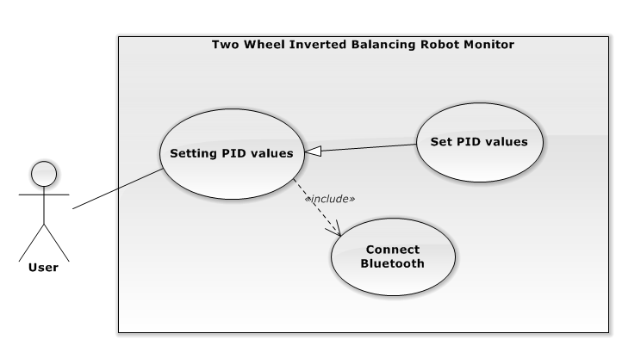

Figure 29 – Set PID values Use Case Diagram

|  |  |  |  |  |
| --- | --- | --- | --- | --- |
| USE CASE - UC017 – Set PID values | | | | |
| Use-case No. | UC017 | **Use-case Version** | | 1.0 |
| Use-case Name | Set PID values | | | |
| Author | Nguyen Ly Thanh Huy | | | |
| Date | 2014/02/14 | **Priority** | Normal | |
| Actor:  User  Summary:   * + This use case allow user to set Proportional, Integral, Derivative (PID) values to the robot   Goal:   * + Change PID values to the robot   Triggers:   * + User click on Set PID () button on “PID Values” section of “Advanced” tab   Preconditions:   * + Robot is ON   + Windows application is connected to robot   + No other function is executing   Post Conditions:   * + Success: The confirm notification is shown to notice the success of setting PID values   + Fail: Failure message is shown.   Main Success Scenario:   |  |  |  | | --- | --- | --- | | Step | Actor Action | System Response | | 1 | User clicks **Advanced** Tab | Advanced Tab content is shown, including “PID Values” section | | 2 | User fills valid values to Proportional, Integral, Derivative textboxes | The Set PID () button is enabled | | 3 | User clicked Set PID () button | The confirm notification( Changing “PID Value” section background color to Green in 2 seconds) is shown to notice the success of setting PID values |   Alternative Scenario:  N/A  Exceptions:   |  |  |  | | --- | --- | --- | | No | Actor Action | System Response | | 1 | Application is disconnected to the robot | -Application return to **disconnected** status  -Display error message “Lost connection with the robot. Please check the connection and try again.” | | 2 | User leaves Proportional, Integral, Derivative textboxes blank or fills invalid values in it | The Set PID () button is disabled. |   Relationship:  Settings PID values | | | | |

Table 26 – Set PID values Use Case Description

#### Non-functional Requirements

##### Reliability

* + There is at least 99.9% of user command that will be successfully sent to the robot.
  + The robot has to stay balance when it does not receive any disturbance.
  + Balancing accuracy of PID algorithms is at least 99 % (The balancing angle is $0±1$ degree) when it does not receive any external disturbance.
  + The robot must be able to return to balance state when it receives any external forces.

##### Availability

* + User can operate the robot successfully using two wheeled inverted balancing robot monitor whenever the robot is on and available to connect through Bluetooth

##### Security

* + N/A

##### Maintainability

* + Flexible mechanical designing to make it easy to replace any robot components.
  + The hardware components are all available, and easy to purchase in Viet Nam.
  + The system is divided into separate modules (TWIBR, TWIBR Monitor)
  + The firmware code and software code is easy to maintain and upgrade.

##### Portability

* + N/A

##### Performance

* + Robot has to response one user command in less than 0.5 second.
  + Robot has to reach balance state in less than 3 seconds after it received an external force.

## SOFTWARE DESIGN DESCRIPTION (SDD)

### Design Overview

This document describes a general view of system which includes:

* System architectural design which describes system’s model, system’s layers, layer’s component and the function of each layer.
* The detailed description of components and the relationship between each component.
* Sequence diagram to know how to the system run.
* User Interface design which describes system’s screens and how users interact to systems. Each screen includes functions, types of input/ output and event handling.

### System Architecture Design

#### Architecture

##### Overview

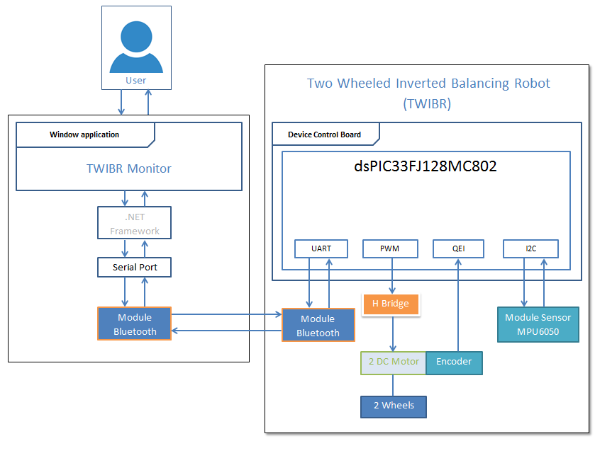

Figure 30 – System Architecture Diagram

##### TWIBR

**TWIBR**

**HC-05 Bluetooth Module**

**2 DC Motors with Gearbox**

**2 H-Bridge**

**2 Quadruple Encoders**

**Gyroscopes & Accelerators (MPU6050)**

**Microchip dsPIC33FJ128MC802**

##### TWIBR Monitor

**TWIBR Monitor**

**Serial Port**

**.NET Framework**

**Serial Connector**

**Robot Services**

**Sequence Movement Manager**

**ViewModel**

**View (XAML)**

### Component Diagram

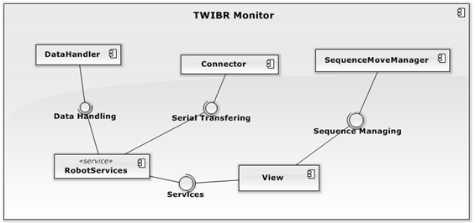

Figure 31 – Component Diagram

### Detailed Design of Components

#### Hardware

##### Mainboard

* Circuit Diagram

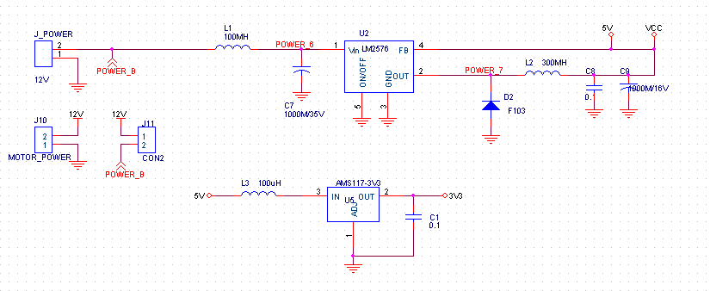

Figure 32 – Mainboard circuit diagram (power supply part)

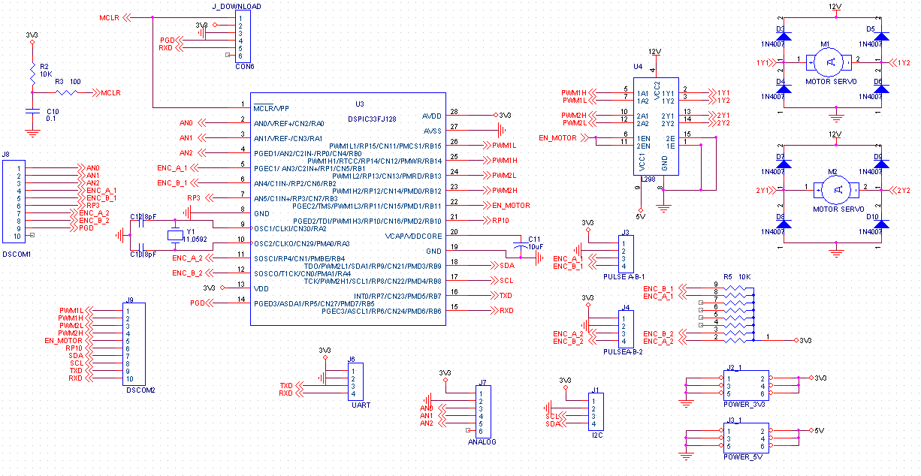

Figure 33 – Mainboard circuit diagram (controller part)

* Printed Circuit

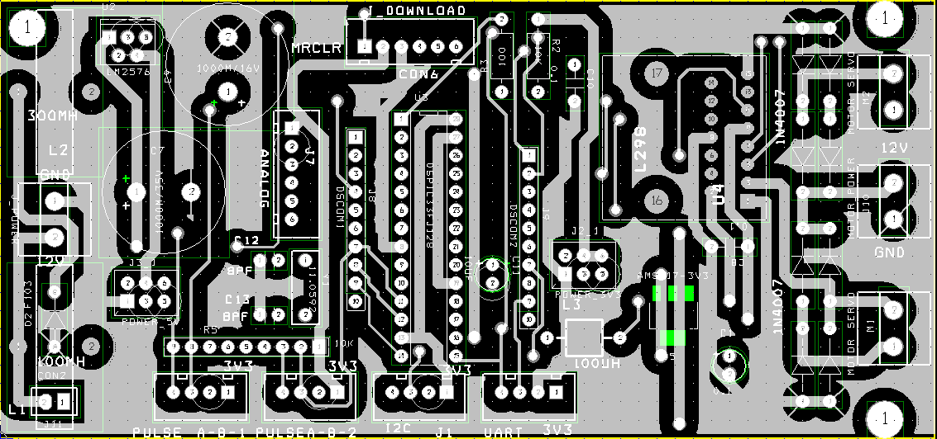

Figure 34 – Bottom Layer circuit

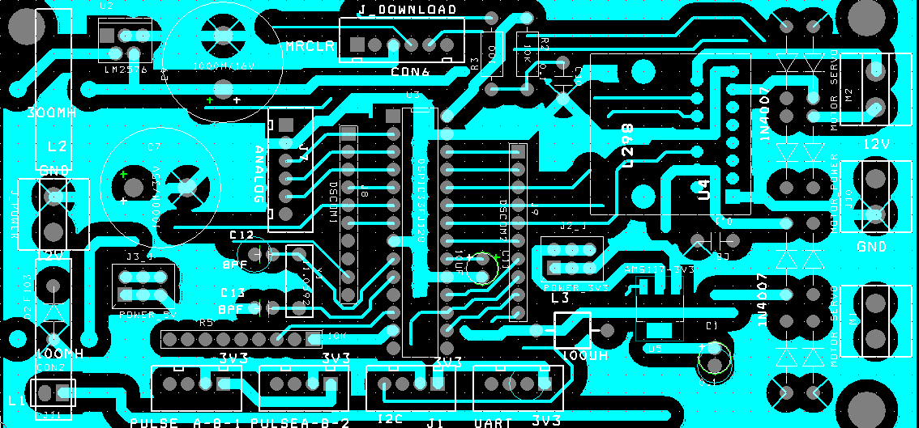

Figure 35 – Top Layer circuit

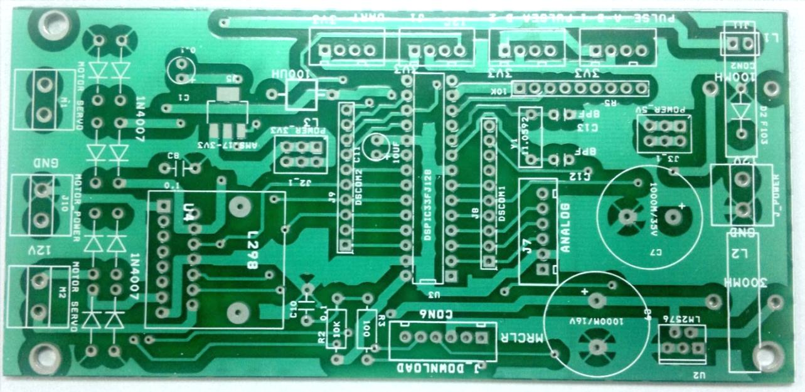

Figure 36 – Printed Circuit

##### Microcontroller

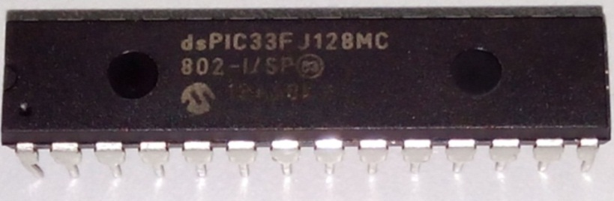

Figure 37 – dsPIC33FJ128MC802-I/SP

dsPIC33FJ128MC802 is a single-chip, embedded controller that seamlessly integrates the control attributes of a Microcontroller (MCU) with the computation and throughput capabilities of a Digital Signal Processor (DSP) in a single core.

The important features that it provides to robot system:

* **Motor Control**

The dsPIC33F devices are ideal for motors requiring more than a basic microcontroller. DC, AC induction or switched reluctance motors are ideal candidates for dsPIC33F:

* 6 channel motor PWM output.
* Complementary or independent PWM.
* Up to 2 programmable dead time settings.
* 2 On-chip Quadrature Encoder Interface (QEI).
* **Connectivity**

With dsPIC33F, we can easily connect to the sensor device (MPU6050) and Bluetooth module, using I²C™ and UART communication.

##### MPU-6050 Breakout

MPU-6050 contains a microelectromechanical systems accelerometer and a microelectromechanical systems gyro in a single chip. It is very accurate, as it contains 16-bits analog to digital conversion hardware for each channel. Therefor it captures the x, y, and z channel at the same time.

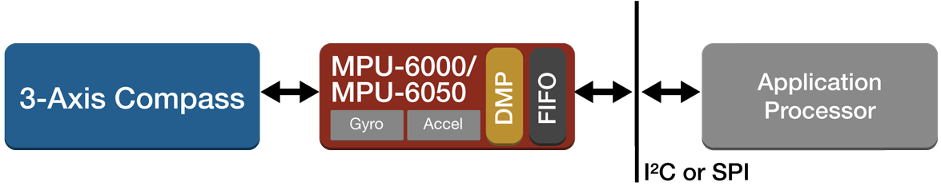

Figure 38 – MPU-6050 communication mechanism

* Schematic

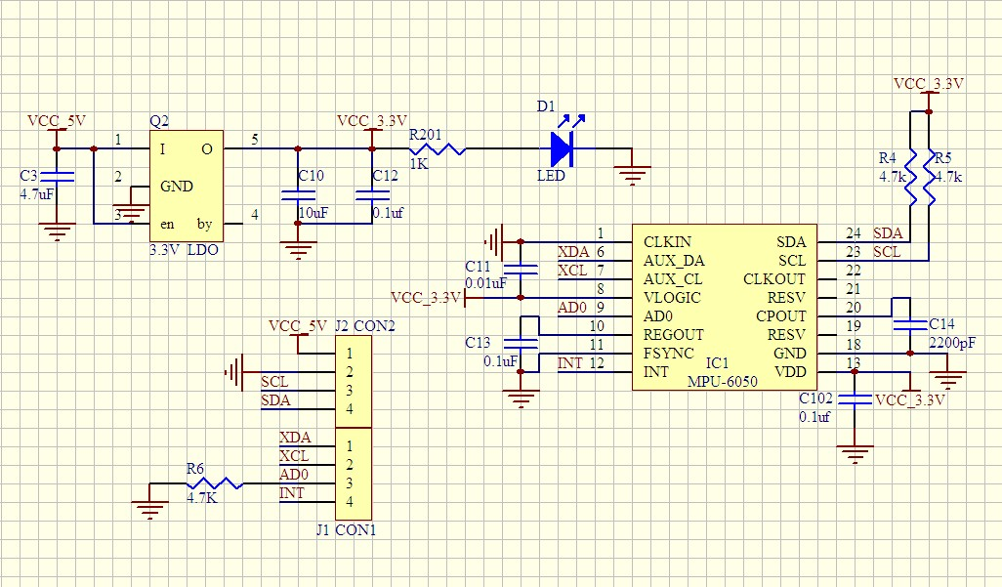

Figure 39 – MPU-6050 schematic

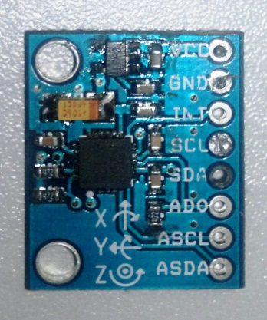

Figure 40 – MPU-6050 printed circuit

##### Bluetooth HC-05 Module

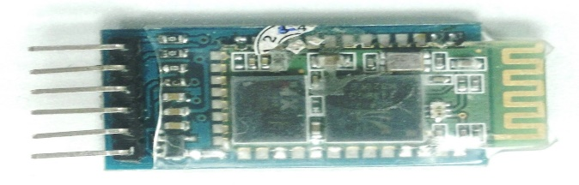

Figure 41 – Bluetooth HC-05 breakout

HC-05 module is an easy to use Bluetooth SPP (Serial Port Protocol) module, designed for transparent wireless serial connection setup. This is used to make communication between the robot and the controller application.

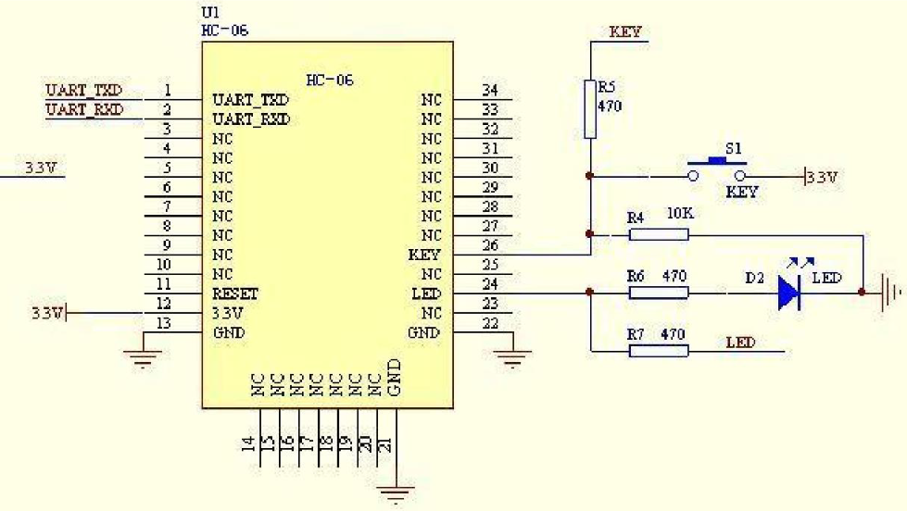

Figure 42 – Bluetooth HC-05 Schematic

##### L298N H-Bridge

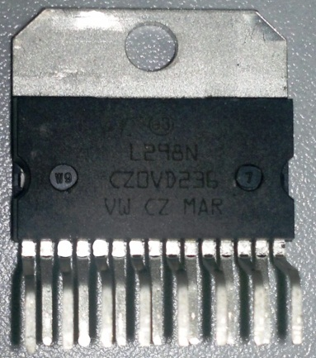

Figure 43 – IC L298N H-Bridge

The L298 is an integrated monolithic circuit in a 15-lead Multiwatt and PowerSO20 packages. It is a high voltage, high current dual full-bridge driver designed to accept standard TTL logic levels and drive inductive loads such as relays, solenoids, DC and stepping motors.

Operating principles:

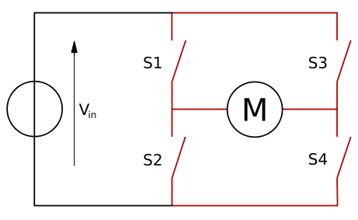

Figure 44 – H-Bidge operation principles

An H bridge is built with four switches (solid-state or mechanical). When the switches S1 and S4 (according to the first figure) are closed (and S2 and S3 are open) a positive voltage will be applied across the motor. By opening S1 and S4 switches and closing S2 and S3 switches, this voltage is reversed, allowing reverse operation of the motor.

Using the nomenclature above, the switches S1 and S2 should never be closed at the same time, as this would cause a short circuit on the input voltage source. The same applies to the switches S3 and S4. This condition is known as shoot-through.

The H-bridge arrangement is generally used to reverse the polarity of the motor, but can also be used to 'brake' the motor, where the motor comes to a sudden stop, as the motor's terminals are shorted, or to let the motor 'free run' to a stop, as the motor is effectively disconnected from the circuit. The following table summarizes operation, with S1-S4 corresponding to the diagram above:

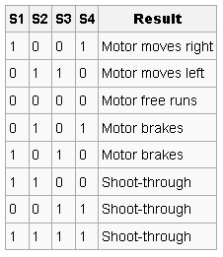

Figure 45 – H-Bridge operation summary

##### DC Motor with Encoder & Planetary Gearbox

Planet motor 24V – DC 30W, 469 RPM, encoder 13ppr, weight 400g.

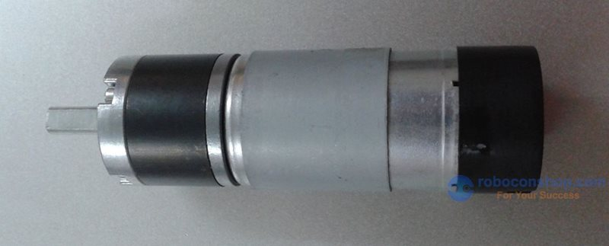

Figure 46 – DC Planet Motor

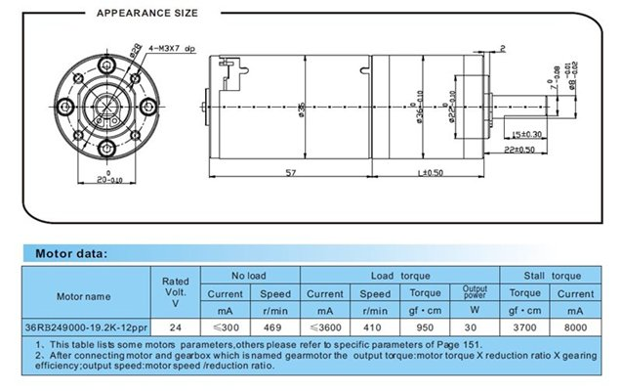

Figure 47 – DC Planet Motor appearance size and motor data

#### Software

##### Class Diagram

##### C:\Users\Genik\Desktop\cs.png

Figure 48 – Class Diagram

##### Class Diagram Explanation

##### TWRobotMonitor.Models namespace

###### **BaseDto** class

* Attribute

|  |  |  |  |
| --- | --- | --- | --- |
| **Attribute** | **Type** | **Visibility** | **Description** |

* Method

|  |  |  |  |
| --- | --- | --- | --- |
| **Method** | **Return Type** | **Visibility** | **Description** |
| GetMode | Mode enum | Public | Get operation mode of the dto |

###### **PwmValueDto** class

* Attribute

|  |  |  |  |
| --- | --- | --- | --- |
| **Attribute** | **Type** | **Visibility** | **Description** |
| PwmValue | Int | Public | Robot ‘s pwm value |

* Method

|  |  |  |  |
| --- | --- | --- | --- |
| **Method** | **Return Type** | **Visibility** | **Description** |
| GetMode | Mode enum | Public | Get operation mode of the dto |

###### **MovementDto** class

* Attribute

|  |  |  |  |
| --- | --- | --- | --- |
| **Attribute** | **Type** | **Visibility** | **Description** |
| Direction | Direction enum | Public | Robot ‘s moving direction |
| Amount | Int | Public | Robot moving amount |
| MovingType | Byte | Public | Moving type (Free Mode, Precise Mode, or Sequence Mode) |
| ExecuteStatus | ExecuteStatus | Public | Execute status of movement (Pending, Executing, or Done) |

* Method

|  |  |  |  |
| --- | --- | --- | --- |
| **Method** | **Return Type** | **Visibility** | **Description** |
| GetMode | Mode enum | Public | Get operation mode of the dto |

###### **AngleDto** class

* Attribute

|  |  |  |  |
| --- | --- | --- | --- |
| **Attribute** | **Type** | **Visibility** | **Description** |
| Angle | float | Public | Robot ‘s angle value (in degree) |

* Method

|  |  |  |  |
| --- | --- | --- | --- |
| **Method** | **Return Type** | **Visibility** | **Description** |
| GetMode | Mode enum | Public | Get operation mode of the dto |

###### **PidValueDto** class

* Attribute

|  |  |  |  |
| --- | --- | --- | --- |
| **Attribute** | **Type** | **Visibility** | **Description** |
| PidMode | Byte | Public | Mode of operation(Get or Set Pid value) |

* Method

|  |  |  |  |
| --- | --- | --- | --- |
| **Method** | **Return Type** | **Visibility** | **Description** |
| GetMode | Mode enum | Public | Get operation mode of the dto |

###### **IDataHandler** interface

* Method

|  |  |  |  |
| --- | --- | --- | --- |
| **Method** | **Return Type** | **Visibility** | **Description** |
| ToObject | BaseDto | Public | Convert Bluetooth data from byte array to BaseDto object |
| ToByteArray | Byte[] | Public | Convert data from BaseDto object to byte array for Bluetooth data transferring |

###### **Mode** enum

* Attribute

|  |  |  |  |
| --- | --- | --- | --- |
| **Attribute** | **Value** | **Visibility** | **Description** |
| Pid | 1 | Public | Pid mode |
| Angle | 2 | Public | Angle mode |
| Pwm | 3 | Public | Pwm mode |
| Move | 4 | Public | Move mode |
| Encoder | 5 | Public | Encoder mode |

###### **Direction** enum

* Attribute

|  |  |  |  |
| --- | --- | --- | --- |
| **Attribute** | **Value** | **Visibility** | **Description** |
| Forward | 1 | Public | Move Forward |
| Backward | 2 | Public | Move Backward |
| Left | 3 | Public | Turn Left |
| Right | 4 | Public | Turn Right |

###### **ExecuteStatus** enum

* Attribute

|  |  |  |  |
| --- | --- | --- | --- |
| **Attribute** | **Value** | **Visibility** | **Description** |
| Pending | 1 | Public | The Movement is not executed |
| Executing | 2 | Public | The Movement is executing |
| Done | 3 | Public | The Movement is |
| Right | 4 | Public |  |

##### TWRobotMonitor.Connector namespace

###### **BluetoothSettingInfo** class

* Attribute

|  |  |  |  |
| --- | --- | --- | --- |
| **Attribute** | **Type** | **Visibility** | **Description** |
| PortName | String | Public | Bluetooth port name |
| Baudrate | Integer | Public | Bluetooth connection baudrate |

* Method

|  |  |  |  |
| --- | --- | --- | --- |
| **Method** | **Return Type** | **Visibility** | **Description** |

###### **BluetoothConnector** class

* Attribute

|  |  |  |  |
| --- | --- | --- | --- |
| **Attribute** | **Type** | **Visibility** | **Description** |
| serialPort | System.IO.Ports.SerialPort | Private | Serial Port object responses for low-level data transfer |
| messageBuffer | byte[] | Private | Data received buffer |
| byteRxCount | Integer | Private | Current received byte counter |
| messageReceived | EventHandler<byte[]> | Private | Event Handler for registering message received event |
| lastSendingMessage | byte[] | Private | Most recently sending message for resending. |

* Method

|  |  |  |  |
| --- | --- | --- | --- |
| **Method** | **Return Type** | **Visibility** | **Description** |
| DataReceived | Void | Private | Event handler of serialPort’s DataReceived event |
| Connect | Boolean | Public | Connect to bluetooth port |
| AddRxEventHandler | Void | Public | Register message received event handler |
| SendData | Void | Public | Send low-level data to bluetooth |
| Disconnect | Void | Public | Disconnect current connection to bluetooth |
| Resend | Void | Public | Resend most recently message |

##### TWRobotMonitor.Services namespace

###### **RobotServices** class

* Attribute

|  |  |  |  |
| --- | --- | --- | --- |
| **Attribute** | **Type** | **Visibility** | **Description** |
| angleDataReceived | System.EventHandler<AngleDto> | Private | Event Handler for registering angle message received event |
| movementReceived | System.EventHandler<MovementDto> | Private | Event Handler for registering movement message received event |
| pidDataReceived | System.EventHandler<PidValueDto> | Private | Event Handler for registering PID data message received event |
| pwmDataReceived | System.EventHandler<PwmValueDto> | Private | Event Handler for registering pwm data message received event |

* Method

|  |  |  |  |
| --- | --- | --- | --- |
| **Method** | **Return Type** | **Visibility** | **Description** |
| DispatchRxMessage | Void | Private | Dispatch received message to correspondent event handler |
| RegisterDataReceived<T> | Void | Public | Register method to handle specific event |
| AddRxEventHandler | Void | Public | Register message received event handler |
| SendTxMessage | Void | Public | Send BaseDto object to bluetooth |
| RxMessageReceived | Void | Private | Event handler of BluetoothConnector Message received event |

###### **Logger** class

* Attribute

|  |  |  |  |
| --- | --- | --- | --- |
| **Attribute** | **Type** | **Visibility** | **Description** |
| Log | String | Public | Contain activities description |

* Method

|  |  |  |  |
| --- | --- | --- | --- |
| **Method** | **Return Type** | **Visibility** | **Description** |
| AddLog | Void | Public | Add content to Log |
| AddLogWithFormat | Void | Public | Add content to Log, with format |
| Clear | Void | Public | Clear the Log |

###### **ActivityLogger** class

* Attribute

|  |  |  |  |
| --- | --- | --- | --- |
| **Attribute** | **Type** | **Visibility** | **Description** |

* Method

|  |  |  |  |
| --- | --- | --- | --- |
| **Method** | **Return Type** | **Visibility** | **Description** |
| AddMovementResult | Void | Public | Add content to Log, correspondent to a free mode or precise mode movement |

###### **SequenceMoveManager** class

* Attribute

|  |  |  |  |
| --- | --- | --- | --- |
| **Attribute** | **Type** | **Visibility** | **Description** |
| Movements | System.Collections.ObjectModel. ObservableCollection<Movement> | Public | Contain activities description |

* Method

|  |  |  |  |
| --- | --- | --- | --- |
| **Method** | **Return Type** | **Visibility** | **Description** |
| FromFile | Void | Public | Import movements from file |
| ToFile | Void | Public | Export movements to file |
| GetNextMovement | MovementDto | Public | Get the next Pending movement |
| HasPendingMovement | Boolean | Public | Return if the list has any Pending Movement |
| ToCommands | Void | Private | Convert from string to Movement Command |
| GetMapElements | System.Windows.Data.CompositionCollection | Public | Get Map component from movement to render to Sequence Map |

##### TWRobotMonitor.Wpf namespace

###### **MainWindow** class

* Attribute

|  |  |  |  |
| --- | --- | --- | --- |
| **Attribute** | **Type** | **Visibility** | **Description** |

* Method

|  |  |  |  |
| --- | --- | --- | --- |
| **Method** | **Return Type** | **Visibility** | **Description** |
| BtnMoveMouseDown | Void | Private | Fire start free mode move event of arrow keys |
| BtnMoveMouseUp | Void | Private | Fire stop free mode move event of arrow keys |
| TextBoxBase_OnTextChanged | Void | Private | Fire text change event for Logger textboxes |

##### TWRobotMonitor.ViewModel namespace

###### **MainViewModel** class

* Attribute

|  |  |  |  |
| --- | --- | --- | --- |
| **Attribute** | **Type** | **Visibility** | **Description** |
| IsConnected | Boolean | Public | Bluetooth connecting status |
| IsWelcome | Boolean | Public | Use to manage Welcome tab |
| CurrrentPid | PidValueDto | Public | Current Pid value |
| CurrentAngle | Float | Public | Current robot angle |
| IsPlaying | Boolean | Public | Status of playing sequence movement |
| IsSequenceMovementLoaded | Boolean | Public | Status of loading sequence file |
| PlotModel | OxyPlot.PlotModel | Public | Plot Model for the angle graph |
| SequenceLogContent | String | Public | Store log content of sequence movement mode |
| BeginnerLogContent | String | Public | Store log content of free mode and precise mode |
| OpenSettingCommand | System.Windows.Input.ICommand | Public | Command for Setting button |
| PauseSequenceCommand | System.Windows.Input.ICommand | Public | Command for Sequence pause button |
| PlaySequenceCommand | System.Windows.Input.ICommand | Public | Command for Sequence play button |
| PreciseMovingCommand | System.Windows.Input.ICommand | Public | Command for precise moving buttons |
| SetPidCommand | System.Windows.Input.ICommand | Public | Command for Set Pid button |
| StartFreeMovingCommand | System.Windows.Input.ICommand | Public | Command for Mouse down free mode moving buttons |
| StopFreeMovingCommand | System.Windows.Input.ICommand | Public | Command for Mouse up free mode moving buttons |
| FileOpenCommand | System.Windows.Input.ICommand | Public | Command for open sequence file button |
| GetPidCommand | System.Windows.Input.ICommand | Public | Command for Get Pid button |

* Method

|  |  |  |  |
| --- | --- | --- | --- |
| **Method** | **Return Type** | **Visibility** | **Description** |
| AngleDataReceived | Void | Private | Handle received robot angle |
| BluetoothConnected | Void | Private | Handle Bluetooth connected event |
| BluetoothDisconnected | Void | Private | Handle Bluetooth disconnected event |
| MovementReceived | Void | Private | Handle received robot movement |
| PidValueReceived | Void | Private | Handle received robot PID value |
| SendGetPidValue | Void | Private | Send “Get PID” request to robot |
| SendSetPidValue | Void | Private | Send “Set PID” request to robot |
| StartFreeMoving | Void | Private | Send “Start Free Moving” request to robot |
| StopFreeMoving | Void | Private | Send “Stop Free Moving” request to robot |
| PlaySequenceMovement | Void | Private | Start doing the movement in sequence mode |
| PauseSequenceMovement | Void | Private | Pause doing the movement in sequence mode |
| OpenSequenceFile | Void | Private | Open Sequence file |
| PreciseMove | Void | Private | Send “Start Precise mode moving” request to robot |
| UpdatePlot | Void | Public | Update Plot model for graph |
| ChangeLinear | Void | Public | Increase Time-axis value |
| CreateNewPoint | Void | Private | Add new angle point to graph |

###### **SettingsViewModel** class

* Attribute

|  |  |  |  |
| --- | --- | --- | --- |
| **Attribute** | **Type** | **Visibility** | **Description** |
| IsConnected | Boolean | Public | Bluetooth connecting status |
| IsConnectError | Boolean | Public | Status connecting error |
| IsOpen | Boolean | Public | Opening status of setting panel |
| SelectedPort | String | Public | Current selecting port name |
| BaudrateList | System.Collections.ObjectModel.ObservableCollection<int> | Public | List of Bluetooth baudrate |
| ComPortList | System.Collections.ObjectModel.ObservableCollection<string> | Public | List of available COM ports |
| BluetoothSetting | BluetoothSettingInfo | Public | Bluetooth setting information |
| ConnectCommand | System.Windows.Input.ICommand | Public | Command for Connect button |
| DisconnectCommand | System.Windows.Input.ICommand | Public | Command for Disconnect button |
| CloseFlyoutCommand | System.Windows.Input.ICommand | Public | Command for close setting panel button |

* Method

|  |  |  |  |
| --- | --- | --- | --- |
| **Method** | **Return Type** | **Visibility** | **Description** |
| ConnectBluetooth | Void | Private | Connect Bluetooth |
| DisconnectBluetooth | Void | Private | Disconnect Bluetooth |
| Initialize | Void | Private | Initialize states and commands |
| OpenSetting | Void | Private | Open setting panel |
| ChangeAccent | Void | Private | Change Metro theme color |

### Sequence Diagram

#### Handle Resend Request

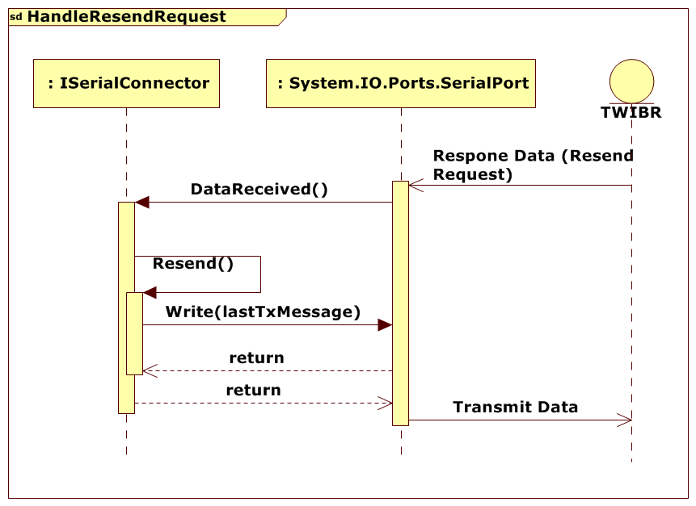

Figure 49 – Handle Resend Request Sequence diagram

#### Handle Sending Exception

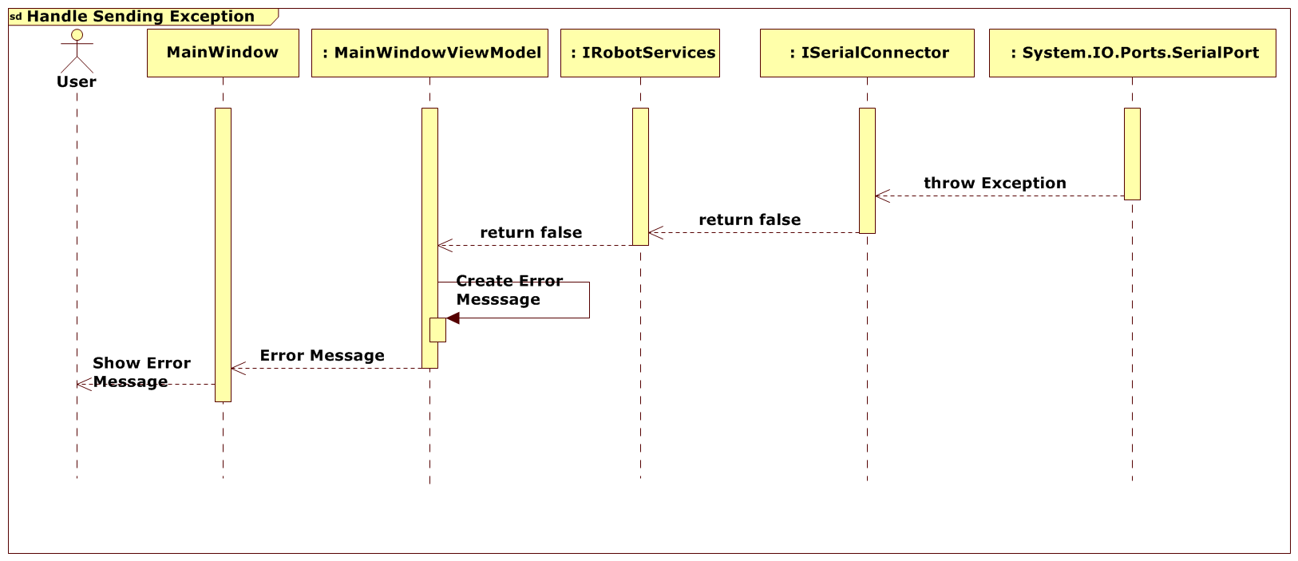

Figure 50 – Handle Sending Exception sequence diagram

#### Connect Bluetooth

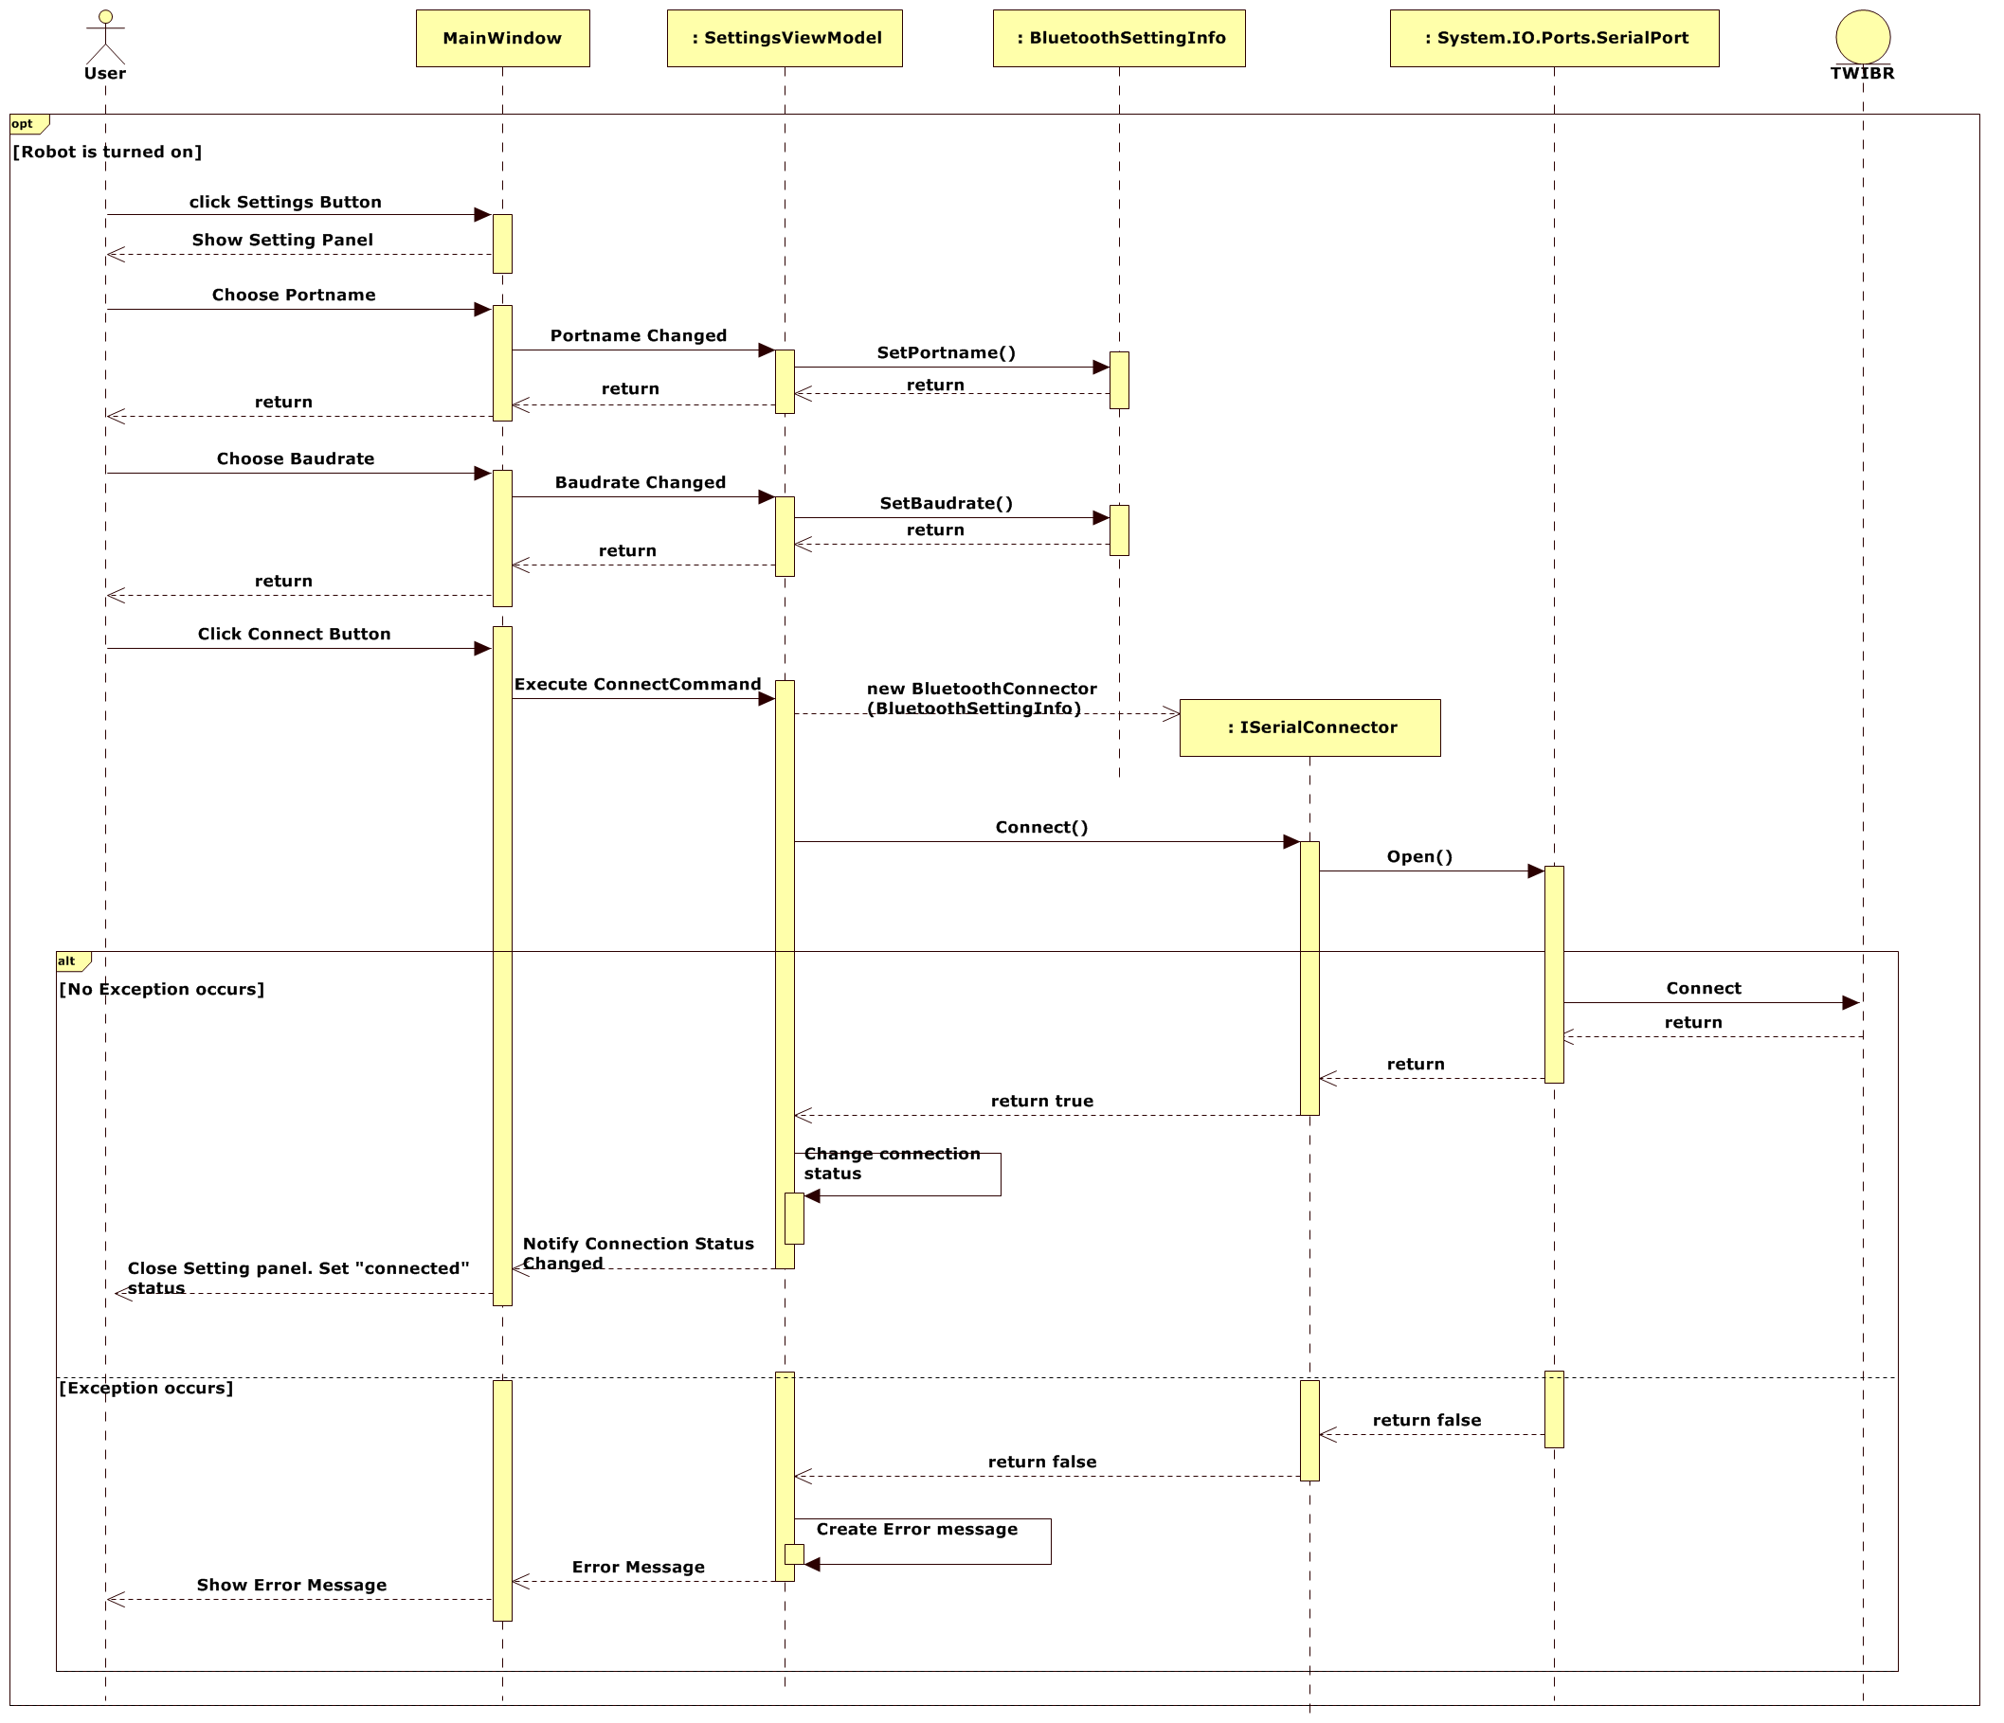

Figure 51 – Connect Bluetooth Sequence diagram

#### Get PID values

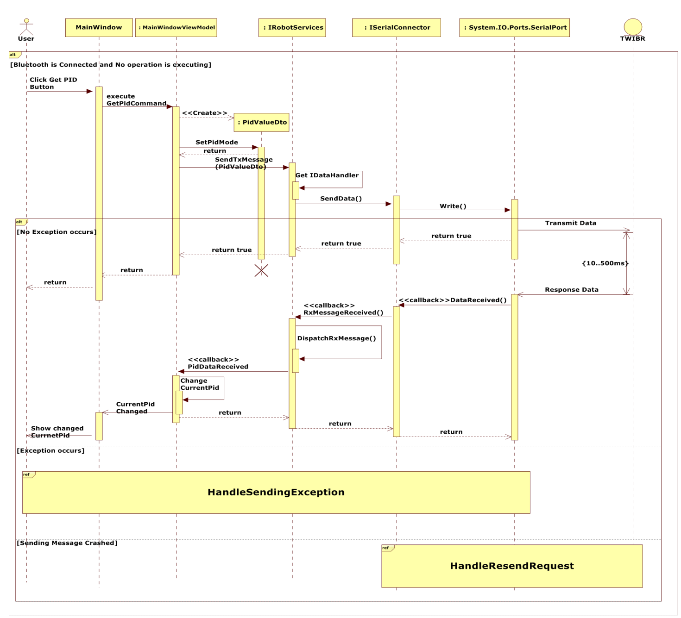

Figure 52 – Get PID value sequence diagram

#### Set PID values

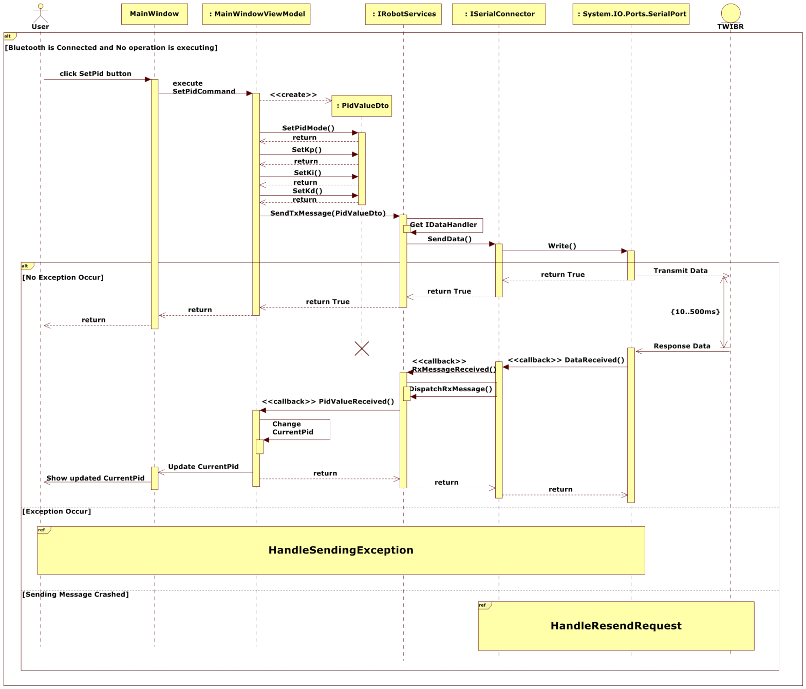

Figure 53 – Set PID value sequence diagram

#### Start Free Moving Sequence Diagram

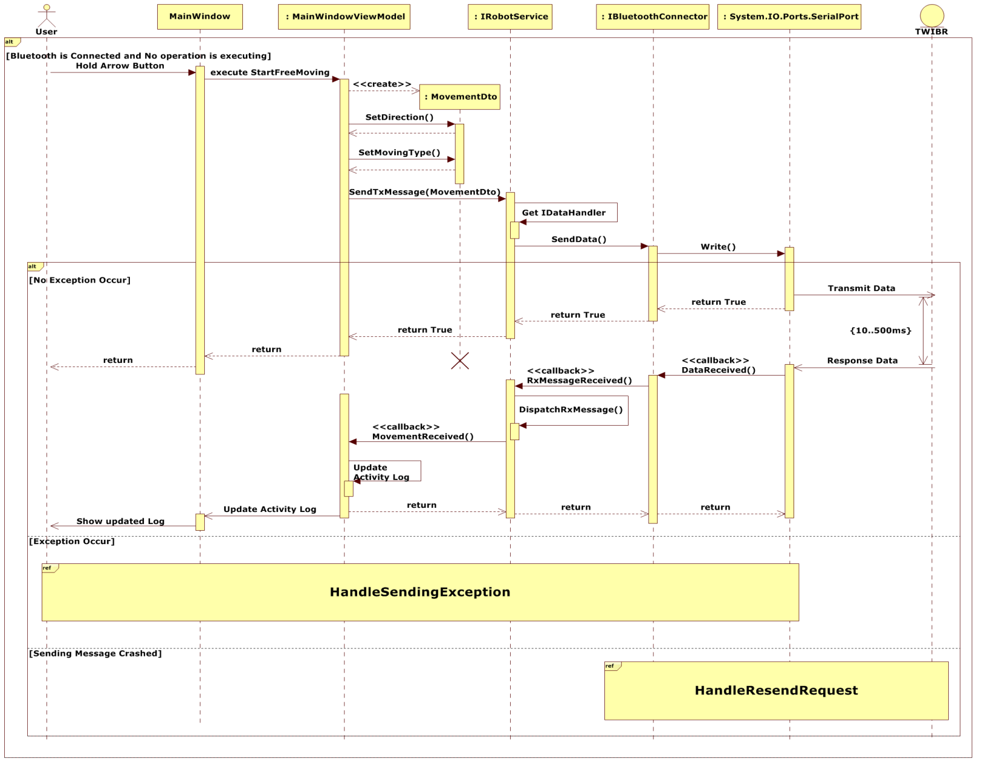

Figure 54 – Start Free Moving Sequence Diagram

#### Stop Free Moving Sequence Diagram

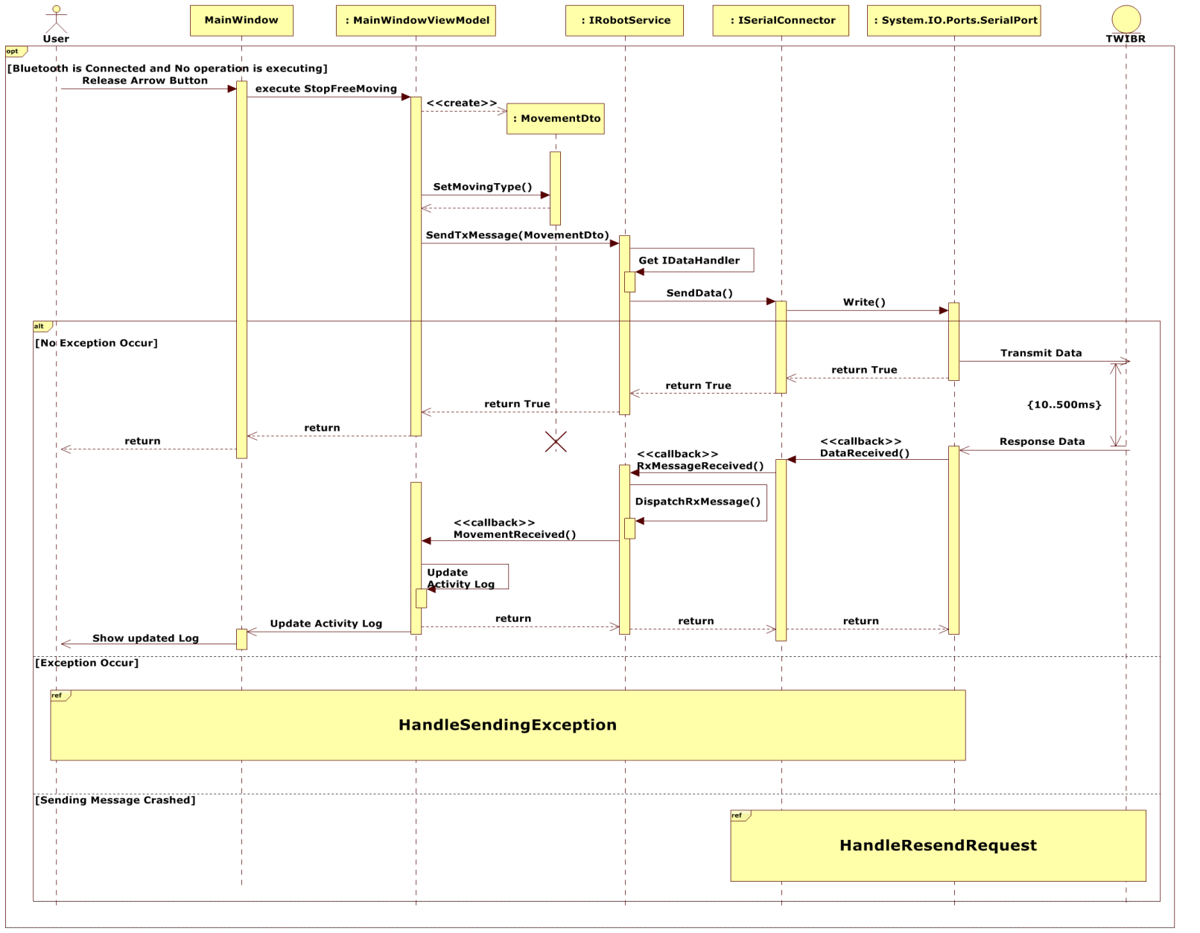

Figure 55 – Stop Free Moving Sequence Diagram

#### Precise Moving Control Sequence Diagram

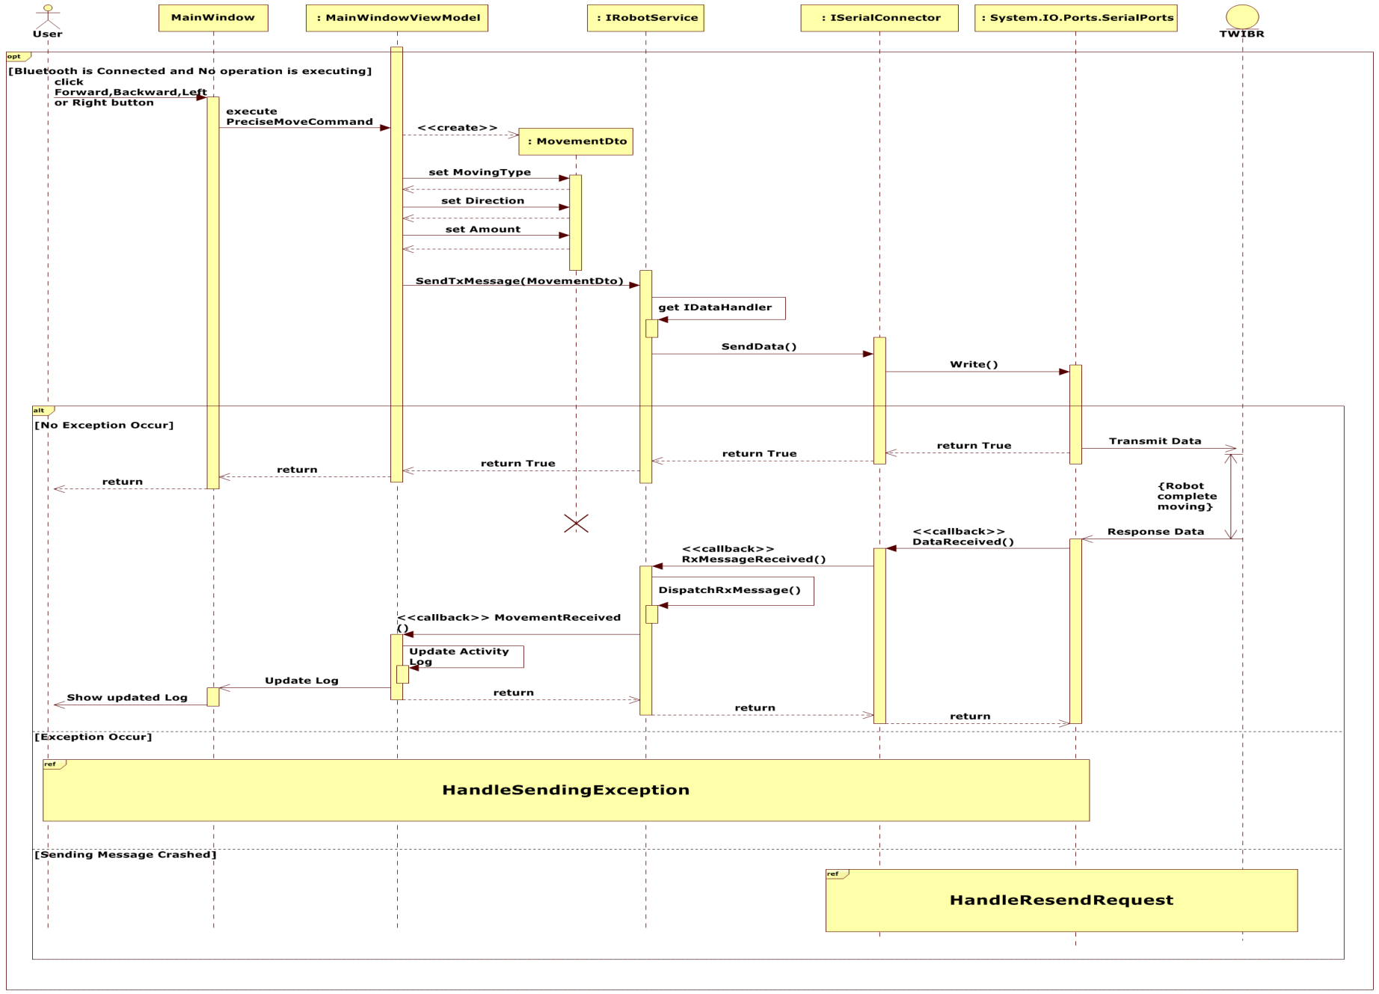

Figure 56 – Precise Moving Control Sequence Diagram

#### Execute Sequence Movement Control Sequence Diagram C:\Users\Genik\Desktop\6.png

Figure 57 – Execute Sequence Movement Control Sequence

### User Interface Design/Hardware Interface Design

#### Welcome Window

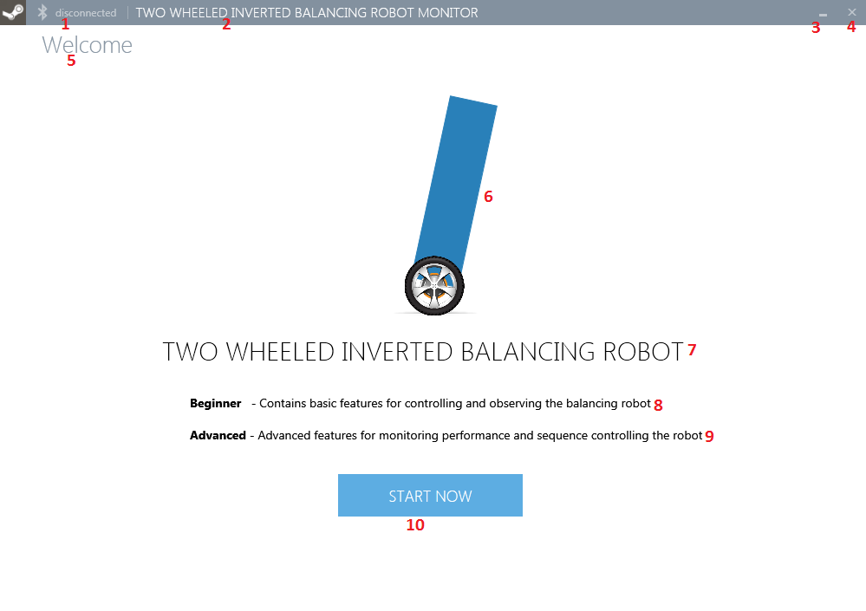

Figure 58 – Welcome Window GUI

|  |  |  |
| --- | --- | --- |
| **No** | **Item** | **Description** |
| 1 | Label | Status: “disconnected” or “connected” |
| 2 | Label | Title "TWO WHEELED INVERTED BALANCING ROBOT MONITOR” |
| 3 | Button | Minimize |
| 4 | Button | Close |
| 5 | Label | Welcome |
| 6 | Image | Image of two wheeled inverted balancing robot. |
| 7 | Label | Show label: “TWO WHEELED INVERTED BALANCING ROBOT” |
| 8 | Label | Description of “Beginner” tab |
| 9 | Label | Description of “Advance” tab |
| 10 | Button | Show Settings panel when clicked |

Table 27 – Welcome window GUI description

#### Settings Panel

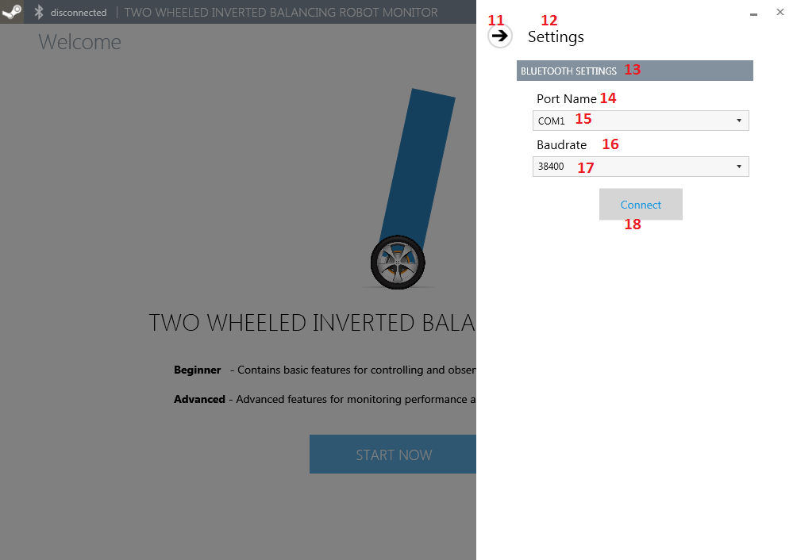

Figure 59 – Settings Panel GUI

|  |  |  |
| --- | --- | --- |
| **No** | **Item** | **Description** |
| 11 | Button | Close Settings panel |
| 15 | ComboBox | Choose COM port name |
| 17 | ComboBox | Choose Baud rate |
| 18 | Button | Connect to specific port |

Table 28 – Settings Panel GUI description

#### Beginner Tab

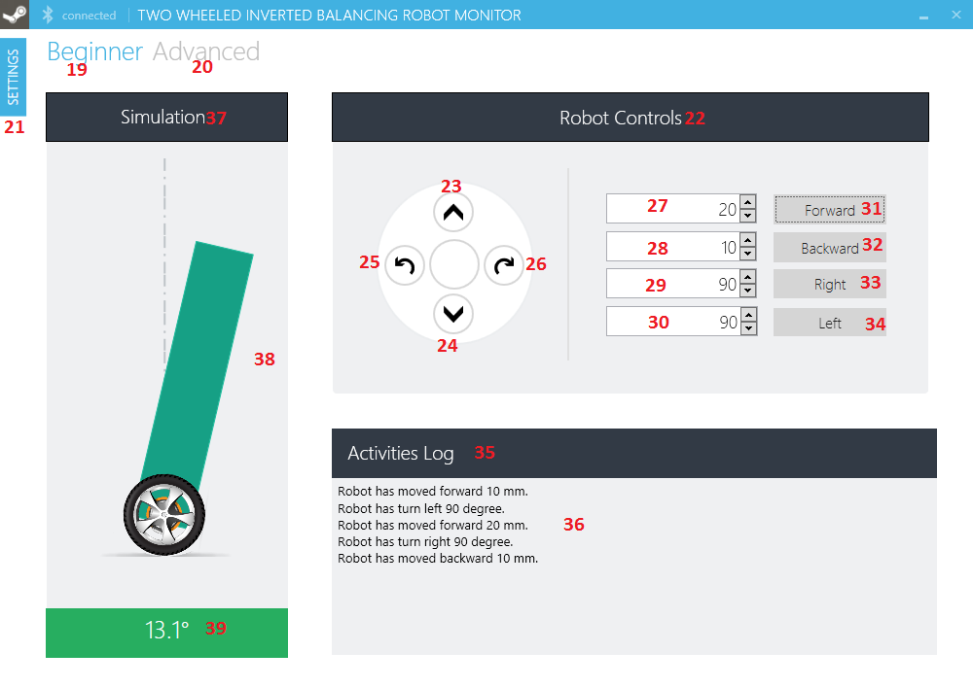

Figure 60 – Beginner Tab GUI

|  |  |  |
| --- | --- | --- |
| **No** | **Item** | **Description** |
| 19 | TabItem | Link to “Beginer” tab |
| 20 | TabItem | Link to “Advanced” tab |
| 21 | Button | Click to open Settings panel |
| 23 | Button | Free Mode Go forward |
| 24 | Button | Free Mode Go backward |
| 25 | Button | Free Mode Go left |
| 26 | Button | Free Mode Go right |
| 27 | TextBox | Set distance to move forward |
| 28 | TextBox | Set distance to move backward |
| 29 | TextBox | Set angle to turn left |
| 30 | TextBox | Set angle to turn right |
| 31 | Button | Accept go forward command with specific distance |
| 32 | Button | Accept go backward command with specific distance |
| 33 | Button | Accept go left command with specific angle |
| 34 | Button | Accept go right command with specific angle |
| 36 | TextBox | Logging activies of robot responding to user commands |
| 38 | Grid | Current robot’s simulation. |
| 39 | Label | Current Robot angle |

Table 29 – Beginner Tab GUI Description

#### Advanced Tab

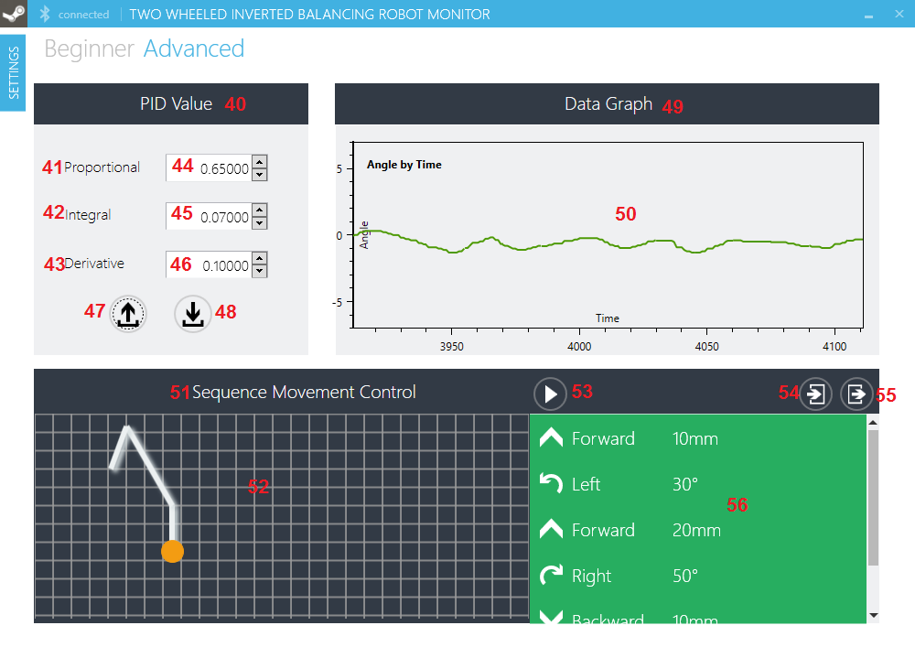

Figure 61 – Advanced Tab GUI (1)

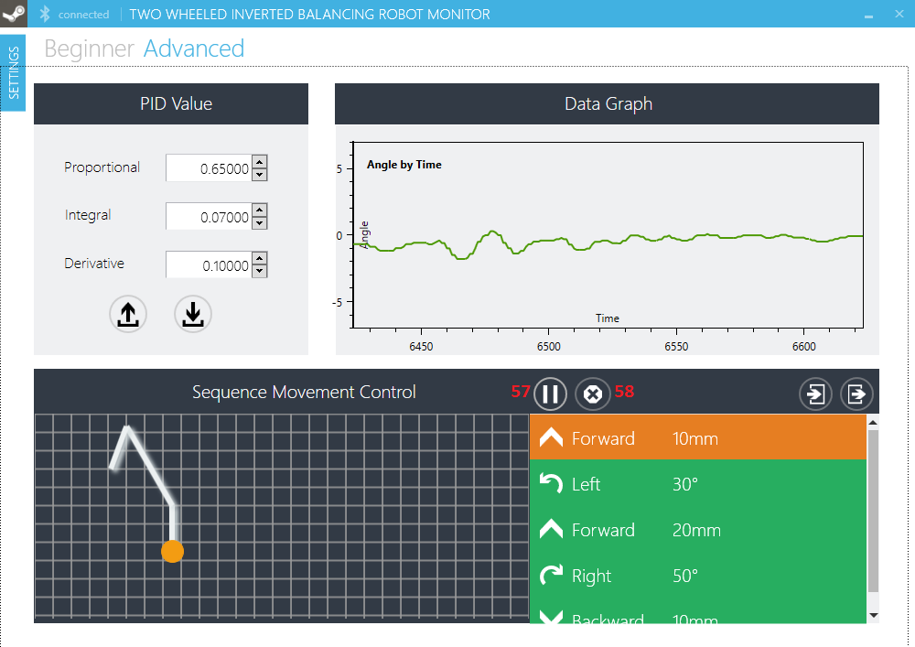

Figure 62 – Advanced Tab GUI (2)

|  |  |  |
| --- | --- | --- |
| **No** | **Item** | **Description** |
| 44 | TextBox | Robot’s Proportional value |
| 45 | TextBox | Robot’s Integral value |
| 46 | TextBox | Robot’s Derivative value |
| 47 | Button | Get PID Values |
| 48 | Button | Update PID Values |
| 50 | Plot | Plot of angular deviation |
| 52 | Grid | Sequence Map correspondent to Sequence List |
| 53 | Button | Execute Sequence |
| 54 | Button | Import File |
| 55 | Button | Export File |
| 56 | DataRow | Sequence List (When click “Execute” button, movement with black color : **Done**, Movement with orange color : **Executing**, Movement with green color : **Pending**). |
| 57 | Button | Click to Pause Sequence |
| 58 | Button | Click to Stop Sequence |

Table 30 – Advanced Tab Description

### Algorithms & Mechanisms

#### Balancing mechanism

Two-wheeled inverted balancing robot is an unstable dynamic system. It means that robot is free to fall forward or backward without any applied forces. Robot is balance when its center of gravity and wheel are located on a identical imaginary vertical line. Otherwise, wheels should follow the robot’s falls until robot balance itself. Using two wheel only for two-wheeled inverted balancing robot provide lighter weight and smoother maneuver

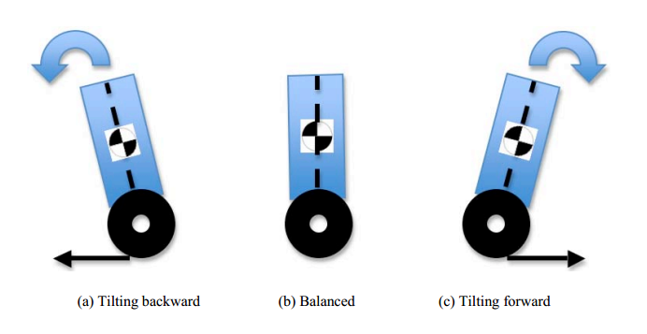

Figure 63 - Three different modes of two wheeled inverted balancing robot

In practice this requires 3 steps

* **Gathering input: *Angle calculation process*** by using tilt angle and angle velocity
* **PID algorithms**
* **Output:** Actuator response.

#### Angle calculation process

##### Accelerator reading

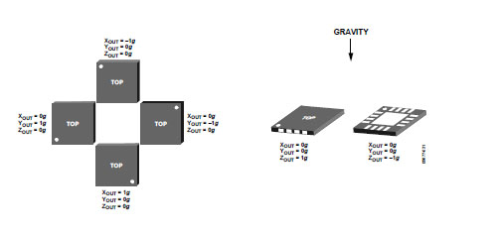

Figure 64 – Accelerator value of 3 axes correspondant to IMU rotation.

Using MPU6050 output data, we are able to know robot’s inclined value (yaw, pitch, and roll) in *g (gravity)* unit. To compute orientation from the accelerometer, we rely on the fact that there is a constant gravitational pull of 1g (9.8 m/s^2) downwards. If no additional forces are acting on the accelerometer, the magnitude of the acceleration detected will always measure 1g, and the sensor’s rotation can be computed from the apparent position of the acceleration vector.

##### Yaw, pitch, and roll values:

The accelerometer read and return value following roll, pitch, and yaw in radian unit. The picture below will present roll, pitch, and yaw in 3d space:

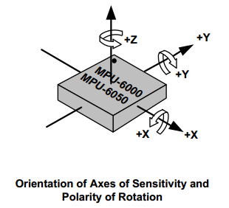

Figure 65 – Yaw, pitch roll values

The MPU-6050’s 3-Axis accelerometer uses separate proof masses for each axis. Acceleration along a particular axis induces displacement on the corresponding proof mass, and capacitive sensors detect the displacement differentially. The MPU-6050’s architecture reduces the accelerometers’ susceptibility to fabrication variations as well as to thermal drift. When the device is placed on a flat surface, it will measure 0g on the X- and Y-axes and +1g on the Z-axis. The accelerometers’ scale factor is calibrated at the factory and is nominally independent of supply voltage.

##### Calculate X-axis rotation (roll) value

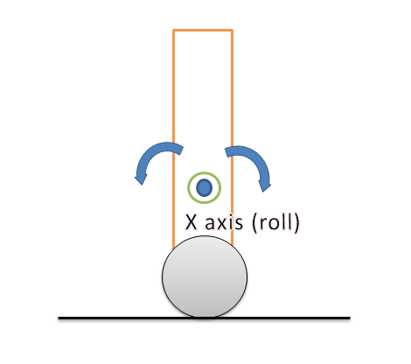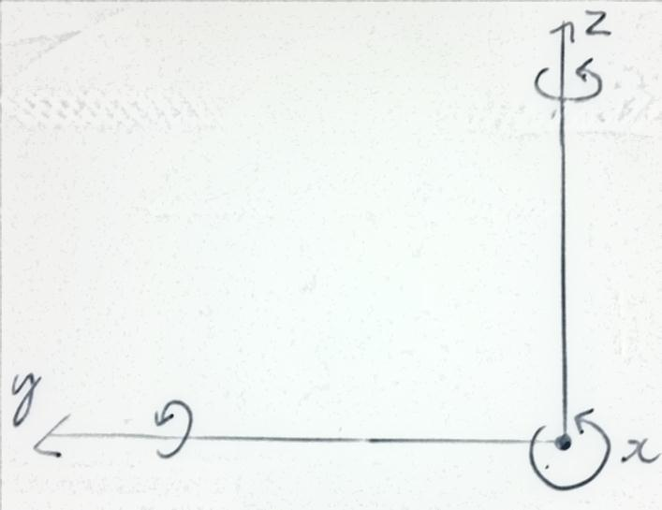

Figure 66 – Balancing robot and its dependency to roll value

The robot falling orientation is following the X-axis rotation. Thus, we only have to maintain the roll value to handle the robot’s falling behavior.

When the robot falls we receive value from Y- and Z- axes. The accelerometer will return data based on their projection on gravity axis (same as z-axis). Thus, we can represent those values in following picture:

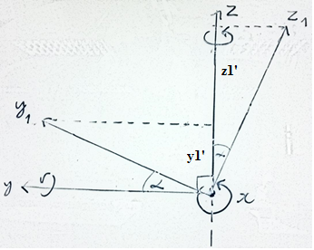

Figure 67 – Projection of 3 axes to gravity axis

From picture, we have projection of y1 on gravity axis is y1’ = sin()*g and projection of z1 on gravity axis z1’ = cos()*g with $α$ is angle when robot inclined.

$⟹ \frac{y_{1}'}{z_{1}'}$ = $\frac{\sin\left(α\right)*g}{\cos{(α)}*g}$ = $\tan{α}$

$⟹α$ = $\arctan\left(\frac{y_{1}'}{z_{1}'}\right)$

We use atan2 formula instead of atan formula to gather value with correct signs of the inputs in order to return the appropriate quadrant of the computed angle:

$$atan2\left(y,z\right)= \left\{\begin{aligned}\begin{matrix}\arctan\left(\frac{y}{z}\right) & z>0\end{matrix} \\ \begin{matrix}\arctan\left(\frac{y}{z}\right)+ π & y ≥0, z< 0\end{matrix} \\ \begin{matrix}\arctan\left(\frac{y}{z}\right)- π & y<0, z<0\end{matrix} \\ \begin{matrix}+ \frac{π}{2} & y>0, z=0\end{matrix} \\ - \begin{matrix}\frac{π}{2} & y<0, z=0\end{matrix} \\ \begin{matrix}undefined & y=0, z=0\end{matrix}\end{aligned}\right.$$

The final step to obtain the roll value is to convert the atan2 calculation result from radian to degree by multiplying it to the rad to deg constant ($\frac{180}{π}$)

##### Gyroscopes Reading

Computing orientation from the gyroscope sensor is different from accelerometer, since the gyroscope measures ***angular velocity*** (the rate of change in orientation angle), not angular orientation itself. To compute the orientation, we must first initialize the sensor position with a known value (possibly from the accelerometer), then measure the angular velocity (ω) around the X, Y and Z axes at measured intervals (Δt). Then ω × Δt = change in angle. The new orientation angle will be the original angle plus this change.

The problem with this approach is that we are integrating - adding up many small computed intervals - to find orientation. Repeatedly adding up increments of ω × Δt will result in small systematic errors becoming magnified over time. This is the cause of gyroscopic drift, and over long timescales the gyroscope data will become increasingly inaccurate.

The MPU-6050 datasheet shows that dividing the raw gyroscope values by 131 gives angular velocity in degrees per second, which multiplied by the time between sensor readings, gives the change in angular position. If we save the previous angular position, we simply add the computed change each time to find the new value.

##### Accelerometer and gyroscope data fusion (Filter)

It is important to note that the accelerometer results provide accurate orientation angles as long as gravity is the only force acting on the sensor. However, when moving and rotating the sensor, we are applying forces to it, which causes the measurements to fluctuate. The net result is that accelerometer data tends to be very noisy, with brief but significant perturbations.

Another problem occurs in gyroscope data. The gyroscope provides accurate data about changing orientation in the short term, but the necessary integration causes the results to drift over longer time scales.

The solution to these problems is to fuse the accelerometer and gyroscope data together in such a way that the errors cancel out. The standard method of combining these two inputs is with a Kalman Filter, which is quite a complex methodology. Fortunately, there is a simpler approximation for combining these two data types, called a **Complementary Filter**.

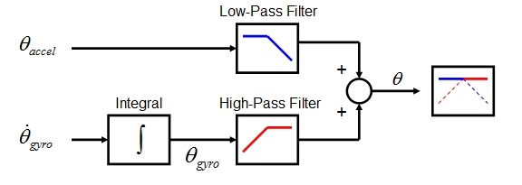

Figure 68 – Complementary Filter Diagram

**Filtered Angle =** α × (Gyroscope Angle) + (1 − α) × (Accelerometer Angle)

**Where:**

α = τ/(τ + Δt)

(Gyroscope Angle) = (Last Measured Filtered Angle) + ω×Δt

Δt = sampling rate,

τ = time constant greater than timescale of typical accelerometer noise

We had a sampling rate of about 0.09 seconds, giving α ≈ 0.98.

The **Filtered Angle** is the final input for the PID process.

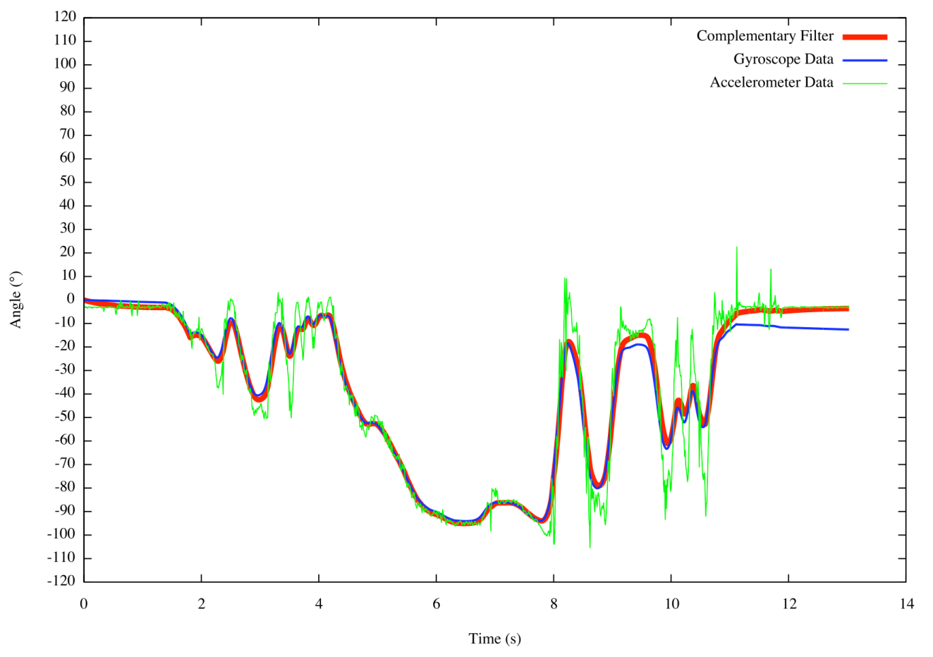

Figure 69 – Angle by time Graph

Look at the graph above, It's easily seen that the filter (red) follows the gyroscope (blue) for fast changes, but keeps following the mean value of the accelerometer (green) for slower changes, thus not feeling the noisy accelerometer data and not drifting away either.

#### PID (Proportional-Integral-Derivative) Algorithms

Proportional-Integral-Derivative (PID) control is the most common control algorithm used in industry and has been universally accepted in industrial control. The popularity of PID controllers can be attributed partly to their robust performance in a wide range of operating conditions and partly to their functional simplicity, which allows engineers to operate them in a simple, straightforward manner.

As the name suggests, PID algorithm consists of three basic coefficients; proportional, integral and derivative which are varied to get optimal response. Closed loop systems, the theory of classical PID and the effects of tuning a closed loop control system. What is closed loop systems; we shall see what a closed loop system is.

##### Closed loop system

In a typical control system, the process variable is the system parameter that needs to be controlled, such as temperature (ºC), pressure (psi), or flow rate (liters/minute). A sensor is used to measure the process variable and provide feedback to the control system. The **set point** is the desired or command value for the process variable, such as 100 degrees Celsius in the case of a temperature control system. At any given moment, the difference between the process variable and the set point is used by the control system algorithm (compensator), to determine the desired actuator output to drive the system (plant). For instance, if the measured temperature process variable is 100 ºC and the desired temperature set point is 120 ºC, then the actuator output specified by the control algorithm might be to drive a heater. Driving an actuator to turn on a heater causes the system to become warmer, and results in an increase in the temperature process variable.

This is called **a** **closed loop control system**, because the process of reading sensors to provide constant feedback and calculating the desired actuator output is repeated continuously and at a fixed loop rate as illustrated in picture below:

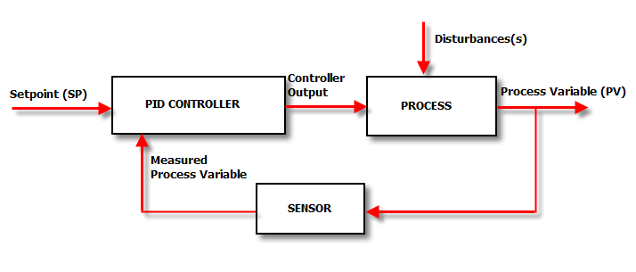

Figure 70 – Closed-loop system

In many cases, the actuator output is not the only signal that has an effect on the system. For instance, in a temperature chamber there might be a source of cool air that sometimes blows into the chamber and disturbs the temperature, such a term is referred to as **disturbance**. We usually try to design the control system to minimize the effect of disturbances on the process variable.

##### Theory of PID

The PID control scheme is named after its three correcting terms, whose sum constitutes the manipulated variable (MV). The proportional, integral, and derivative terms are summed to calculate the output of the PID controller. Defining u(t) as the controller output, the final form of the PID algorithm is:

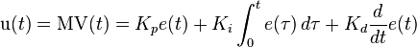  
 Proportional (P) Integral (I) Derivative (D)

**Kp**: Proportional gain, a tuning parameter

**Ki**: Integral gain, a tuning parameter

**Kd**: Derivative gain, a tuning parameter

**ℓ**: Error = Ideal value – measureable output

***t***: Time or instantaneous time (the present)

: Variable of integration; takes on values from time 0 to the present ***t***



##### Specific PID in two wheeled inverted balancing robot

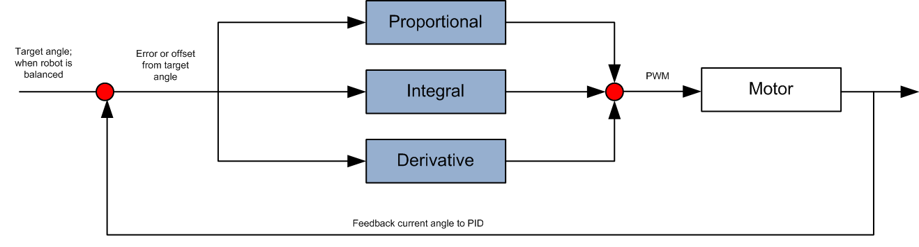

Figure 71 – PID for angle measurement

###### **Proportional**

**The proportional (P)** term of the PID is based on the current angle difference or error from Point Zero (where robot balances) multiplied by the P gain. The P gain is a number need to tweak to get the right amount of proportional control.

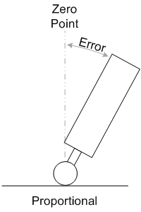

Figure 72 – Proportional term with balancing robot

$$P=K_{p}e(t)$$

**Where:**

$$K_{p}-Proportional gain, a tuning parameter$$

###### **Integral**

**The integral (I)** term of the PID is based on the current angle difference or error from Point Zero multiplied by the I gain, which is that accumulated over time. The integral control assists in balancing the robot if it is moving.

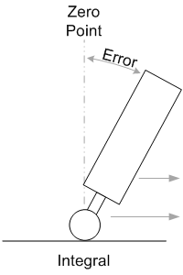

Figure 73 – Integral term with balancing robot

$$I=K_{i}\int_{0}^{t}{e\left(τ\right)dτ}$$

**Where:**

$$K_{i}-Integral gain, a tuning parameter$$

###### **Derivative**

**The derivative (D)** term of the PID is based on the current rate of rotation. It is used to dampen the response as the robot reaches Zero Point. Without the derivative control, the robot will overshoot and then start to oscillate.

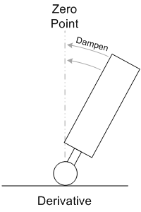

Figure 74 – Derivative term with balancing robot

$D=K_{d}\frac{d}{dt}e(t)$

**Where:**

$$K_{d}-Derivative gain, a tuning parameter$$

Finally, from P, I, D values, we have an output for our system:

$$output=P+I+D$$

The **output** value is limited from 0 to 2. Itwill be used to calculate the PWM value for the actuator reaction.

#### PWM Motor Control

**Pulse Width Modulation** is an electromagnetic wave or modulation thereof of brief duration to adjust to or keep in proper measure or proportion the width of the pulse with respect to the sequence of the wave.

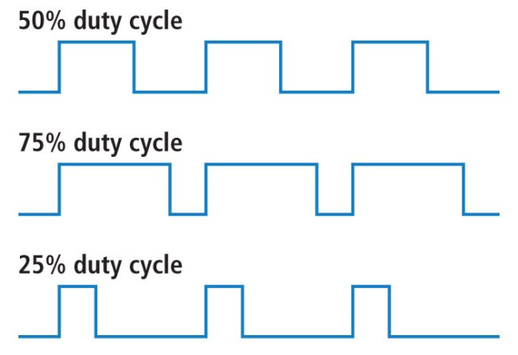

Figure 75 – PWM signal correspondant to duty cycle

**Advantages**

* The motor consumes less power
* Significantly less energy loss due to heat
* Allows finer motor control

**Disadvantages**

* Constantly supplying power to a device seems wasteful.
* Initial energy requirement depends on the size of the motor used.

**PWM Period:**

To calculate PWM period, we have to setting the PWM Time Base Period Register (PTPER) register sets the counting period for PWM. When the value in PWM Timer Count Value Register (PTMR) matches the value in PTPER, the time base will either reset to ‘0’ or reverse the count direction on the next clock input edge. The action taken depends on the operating mode of the time base.

The time base period is double buffered to allow on-the-fly period changes of the PWM signal without glitches. The PTPER register serves as a buffer register to the actual time base period register, which is not accessible by the user.

The value held in the PTPER register is automatically loaded into the time base period register when the PWM time base is disabled.

**PWM Period Calculation**

$$PTPER= \frac{F_{CY}}{F_{PWM}*\left(PTMR\right)*2}$$

**Where:**

$$F_{PWM}=144 Hz$$

$$PTMR=64 \\ F_{CY}=36864000 Hz$$

$$PTPER= \frac{36864000}{144*64*2}=2000$$

##### PWM Duty Cycle

The Motor control PWM module has four PWM generators. There are four 16 bit special function registers used to specify duty cycle values for the PWM generators:

* PDC1
* PDC2
* PDC3
* PDC4

**Duty Cycle Calculation for Up/Down Counting Modes**

$$Duty cycle= \frac{PDCx-DT}{\left(PTPER+1\right)*2}$$

Because the range of duty cycle is from 0 to 100%, and PTPER = 2000 so PDC will be set from 0 – 4000. For safe purpose, the PDC is set from **100 – 3900**

##### Dead Time Control

Dead time is a small period when both upper and lower switches in a phase leg are off. So that short circuit can be avoided and switches are not damaged due to high current

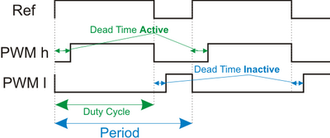

Figure 76 – Deadtime in Motor Control PWM

Dead time generation is automatically enabled when any of the PWM I/O pin pairs are operating in the Complementary Output mode. Because the power output devices cannot switch instantaneously, some amount of time must be provided between the turn-off event of one PWM output in a complementary pair and the turn-on event of the other transistor.

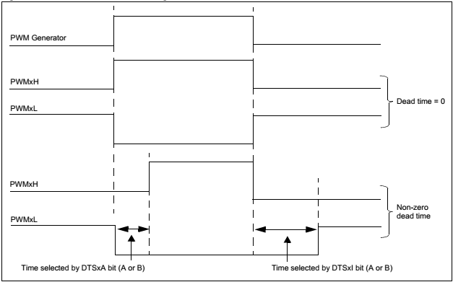

Figure 77 – Dead Time Insertion Diagram

##### Dead Time Ranges

Dead time A (active) and dead time B (inactive) are set by selecting an input clock prescaler value and a 6-bit unsigned dead time count value. Four input clock prescaler selections have been provided to allow a suitable range of dead times based on the device operating frequency. The clock prescaler option may be selected independently for each of the two dead time values. The following clock prescaler options may be selected for each of the dead time values:

* TCY
* 2 TCY
* 4 TCY
* 8 TCY

**Dead Time Calculation:**

$$Dead Time Register Value= \frac{Dead Time}{Prescaler Value*T_{CY}}$$

**Where:**

$$T_{cy}=\frac{1}{F_{CY}}=\frac{1}{36864000} (s)$$

$$Dead Time-desired dead time (s) \\ F_{CY}=36864000 Hz$$

##### Calculate actuator reaction for balancing process

The **output** valuecalculated in PID process will be used to calculate actuator reaction by following formula:

$$PDC =100+output*(1900)$$

$$output is from 0 to 2, so PDC value is from 100 to 3900$$

#### Quadrature Encoder Interface (QEI)

**Motor encoder** is an electromechanical device that provides an electrical signal that is used for speed and/or position control. Encoders turn mechanical motion into an electrical signal that is used by the control system to monitor specific parameters of the application and make adjustments if necessary to maintain the machine operating as desired.

**Quadrature encoder interface** (also known as incremental encoders or optical encoders) are used for position and speed detection of rotating motion systems. Quadrature encoders enable closed loop control of many motor control applications. The QEI module provides a simple interface to incremental optical encoders, which allows obtaining signed velocity and relative rotor position information from the motor or mechanical system.

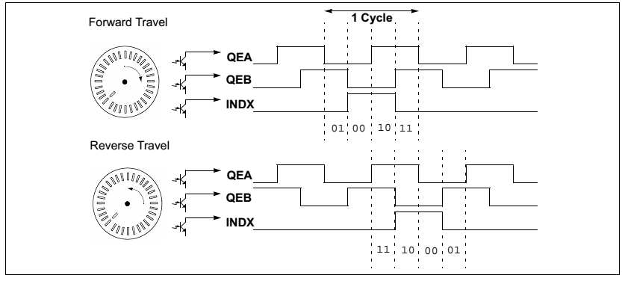

Figure 78 – Quadrature encoder interface signals

##### QEI Logic

A typical, incremental (a.k.a. optical) encoder has three outputs: Phase A, Phase B and an index pulse. The two channels, Phase A (QEA) and Phase B (QEB), have a unique relationship. If Phase A leads Phase B, then the direction (of the motor) is deemed positive or forward. If Phase A lags Phase B, then the direction (of the motor) is deemed negative or reverse. A third channel, termed index pulse, occurs once per revolution and is used as a reference to establish an absolute position. The index pulse coincides with Phase A and Phase B, both low.

##### QEI for Two-wheeled Inverted Balancing Robot

In Two-wheeled balancing robot, Encoders is used to calculate the current velocity and current position, so that the robot is able to improve its balancing performance. Moreover, encoders provide ability for the robot to move precisely with specific amount that user defined in their movement control commands.

## SYSTEM IMPLEMENTATION & TEST (SIT)

### Introduction

#### System Overview

In this section, there has all necessary information about test plan, test cases, test result, the environment for testing, test pass/fail criteria, risks estimations and a checklist to check when test this system.

#### Test Approach

* **Goal**: To test the whole system based on the core workflow.
* **Method**: Black-box Testing.

The purpose of this section is to verify and ensure that 2WR’s function meets its design specification and other requirements from user. The following part will describe which features to be tested.

#### Features to be tested

The features below will be focused and tested thoroughly during the test phase:

* **TWIBR** : Connect Bluetooth, Move on flat surface, Move on inclined surface
* **TWIBR Monitor**: Connect Bluetooth, Control robot movement, Activities Log, Settings PID values, Sequence Movement Control.

#### Test environment

* **Test tool**: A PC with Windows 7 Operating System and having Bluetooth module to connect to TWIBR.

### Test Case

#### Two wheeled inverted balancing robot (TWIBR) Test Cases

|  |  |  |  |  |  |  |  |  |  |
| --- | --- | --- | --- | --- | --- | --- | --- | --- | --- |
| No. | Function | | | Pre-condition | Step of testing | Expected result | Create by | Executed by | Result |
| Large function | Medium function | Small function |
| 1 | Robot | Connect Bluetooth device | Connect to laptop/PC that has Bluetooth | 1. Robot is turned on. | 1. Turn ON Bluetooth board on each device | 1. Light of Bluetooth is on. | BinhPNT | BinhPNT | Pass |
| 2 | Robot moves on flat surface | Robot stands on flat surface | N/A | 1. Turn on the robot | 1. State: balancing in 1 hours without falling | BinhPNT | BinhPNT | Pass |
| 3 | Go Forward | 1. Robot is turned on. 2. Robot and laptop/PC are connected | 1. In the Controls section of Beginner tab, click Forward arrow button, 2. After 5 seconds release the button | 1. Robot State : Move Forward without fall 2. After 5 seconds, robot stop moving and keep balancing | BinhPNT | BinhPNT | Pass |
| 4 | Go Backward | 1. Robot is turned on. 2. Robot and laptop/PC are connected | 1. In the Controls section of Beginner tab click Backward arrow button 2. After 5 seconds release the button | 1. Robot State : Move Backward without fall 2. After 5 seconds, robot stop moving and keep balancing | BinhPNT | BinhPNT | Pass |
| 5 | Turn right | 1. Robot is turned on. 2. Robot and laptop/PC are connected | 1. In the Controls section of Beginner tab click Right arrow button 2. After 5 seconds release the button | 1. Robot State : Turn right without fall 2. After 5 seconds, robot stop turning and keep balancing | BinhPNT | BinhPNT | Pass |
| 6 | Turn left | 1. Robot is turned on. 2. Robot and laptop/PC are connected | 1. In the Controls section of Beginner tab Click symbol Left arrow button | 1. Robot State : Turn left without fall 2. After 5 seconds, robot stop turning and keep balancing | BinhPNT | BinhPNT | Pass |
| 7 | Go forward command with specific distance | 1. Robot is turned on. 2. Robot and laptop/PC are connected | 1. Input 20 to the textbox of Forward button 2. Click Forward button | 1. Robot State : Move Forward without fall 2. The distance the robot moved is 20 mm | BinhPNT | BinhPNT | Pass |
| 8 | Go backward command with specific distance | 1. Robot is turned on. 2. Robot and laptop/PC are connected | 1. Input 20 to the textbox of Backward button 2. Click Backward button | 1. Robot State : Move Backward without fall 2. The distance the robot moved is 20 mm | BinhPNT | BinhPNT | Pass |
| 9 | Turn Right command with specific degrees | 1. Robot is turned on. 2. Robot and laptop/PC are connected | 1. Input 80 to the textbox of Right button 2. Click Right button | 1. Robot State : Turn Right without fall 2. The amount the robot turned is 80 degrees | BinhPNT | BinhPNT | Pass |
| 10 |  | Turn left command with degrees | 1. Robot is turned on. 2. Robot and laptop/PC are connected | 1. Input 80 to the textbox of Left button 2. Click Left button | 1. Robot State : Turn Left without fall 2. The amount the robot turned is 80 degrees | BinhPNT | BinhPNT | Pass |
| 11 | Robot move on 15 degree Inclined surface | Robot on 15 degree Inclined surface | N/A | 1. Turn on the robot on inclined surface | 1. Robot State : Balancing in 1 hours | BinhPNT | BinhPNT | Pass |
| 12 | Go Forward on 15 degree Inclined surface | 1. Robot is turned on. 2. Robot and laptop/PC are connected | 1. In the Controls section of Beginner tab Click Forward arrow button | 1. Robot State : Move Forward without fall 2. After 5 seconds, robot stop moving and keep balancing | BinhPNT | BinhPNT | Pass |
| 13 | Go Backward on 15 degree Inclined surface | 1. Robot is turned on. 2. Robot and laptop/PC are connected | 1. In the Controls section of Beginner tab Click symbol Backward button | 1. Robot State : Move Backward without fall 2. After 5 seconds, robot stop moving and keep balancing | BinhPNT | BinhPNT | Pass |

Table 31 – Test case for TWIBR

#### TWIBR Monitor windows application Test Cases

|  |  |  |  |  |  |  |  |  |  |
| --- | --- | --- | --- | --- | --- | --- | --- | --- | --- |
| No. | Function | | | Pre-condition | Step of testing | Expected result | Create by | Executed by | Result |
| Large function | Medium function | Small function |
| 1 | Welcome window | Welcome window | Load window |  | 1. Open the program | 1. Welcome screen is shown 2. “Start now” button was show | SinhTL | SinhTL | Pass |
| 2 | Bluetooth Connection | Connect to robot | First time connect to robot from welcome screen | 1. Program was loaded 2. Robot has turn on 3. Program show welcome screen | 1. Click Start Now button 2. Click connect button | 1. Connection status changes from disconnected to connected 2. Setting panel is closed 3. Control feature in beginner tab and advanced tab are shown 4. Connect button change to disconnect button | SinhTL | SinhTL | Pass |
| 3 | Disconnect Bluetooth | 1. Bluetooth is connected | 1. Click Settings button on the left of window 2. Click disconnect button | 1. Control feature in beginner tab and advanced tab are disabled 2. Close setting panel | SinhTL | SinhTL | Pass |
| 4 | Reconnect after disconnect Bluetooth | 1. Bluetooth on robot has turn on 2. Program show beginner tab and advanced tab with feature are disable | 1. Select port and baud rate 2. Click connect button | 1. Connect button change to disconnect button 2. Control feature in beginner tab and advanced tab are enabled 3. Close setting panel | SinhTL | SinhTL | Pass |
| 5 | Beginner tab | Movement Control | Go forward | 1. Bluetooth was connected 2. User is now in Beginner tab | 1. Press and hold down forward button in 3s | 1. Robot moves forward in 3s 2. “Robot has moved forward …mm” message appears in activities log | SinhTL | SinhTL | Pass |
| 6 | Go backward | 1. Bluetooth was connected 2. User is now in Beginner tab | 1. Press and hold down backward button in 3s | 1. Robot go backward in 3s 2. “Robot has moved backward …mm” message appears in activities log | SinhTL | SinhTL | Pass |
| 7 | Turn right | 1. Bluetooth was connected 2. User is now in Beginner tab | 1. Press and hold down turn right button in 3s | 1. Robot turn right in 3s 2. “Robot has turned right …degrees” message appears in activities log | SinhTL | SinhTL | Pass |
| 8 | Turn left | 1. Bluetooth was connected 2. User is now in Beginner tab | 1. Press and hold down turn left button in 3s | 1. Robot turn left in 3s 2. “Robot has turned left …degrees” message appears in activities log | SinhTL | SinhTL | Pass |
| 9 | Go Forward command with specific distance | 1. Bluetooth was connected 2. User is now in Beginner tab | 1. Enter 200 to forward textbox 2. Click forward button | 1. Robot go forward 200 mm with error is 5mm 2. “Robot has moved forward …mm” message appears in activities log | SinhTL | SinhTL | Pass |
| 10 | Go backward command with specific distance | 1. Bluetooth was connected 2. User is now in Beginner tab | 1. Enter 200 to backward textbox 2. Click backward button | 1. Robot go backward 200 mm with error is 5mm 2. “Robot has moved backward …mm” message appears in activities log | SinhTL | SinhTL | Pass |
| 11 | Turn right command with specific angle | 1. Bluetooth was connected 2. User is now in Beginner tab | 1. Enter 90 to turn right textbox 2. Click right button | 1. Robot turn right 90 with error is 2. “Robot has turned right …mm” message appears in activities log | SinhTL | SinhTL | Pass |
| 12 | Turn left command with specific angle | 1. Bluetooth was connected 2. User is now in Beginner tab | 1. Enter 90 to turn left textbox 2. Click left button | 1. Robot turn left 90 with error is 2. “Robot has turned left …mm” message appears in activities log | SinhTL | SinhTL | Pass |
| 13 | Control robot in advanced tab | Setting PID | Get current PID’s value | 1. Bluetooth was connected 2. User is now in Advanced tab | 1. Clear P,I,D textboxes 2. Click Get PID values button | 1. Program shows received PID values in 3 textboxes (Proportional, Integral and Derivative text box) | SinhTL | SinhTL | Pass |
| 14 | Set PID’s value for robot | 1. Bluetooth was connected 2. User is now in Advanced tab | 1. Set Proportional textbox equals 0 2. Set Integral textbox equals 0 3. Set Derivative textbox equals 0 4. Click Set PID values button | 1. Robot falls immediately | SinhTL | SinhTL | Pass |
| 15 | Data graph angle | Data graph about robot’s angle | 1. Bluetooth was connected 2. User is now in Advanced tab |  | 1. Data graph must update new robot’s angle in real time | SinhTL | SinhTL | Pass |
| 16 | Sequence Command Control | Import file control | 1. Bluetooth was connected 2. User is now in Advanced tab | 1. Click import file button 2. Select one text file with only one line “F10” in this file | 1. Sequence command log writes out load file success 2. The Sequence List has only 1 item: “Forward – 10mm “ | SinhTL | SinhTL | Pass |
| 17 | Export file control | 1. Bluetooth was connected 2. User is now in Advanced tab | 1. Sequence List has 1 item “Forward – 10mm” 2. Click export file button 3. Write file name and click save button | 1. The saved file contains only 1 line : “F10” | SinhTL | SinhTL | Pass |
| 18 | Execute Sequence Movement | 1. Bluetooth was connected 2. User is now in Advanced tab | 1. Sequence List is now has 1 item :”Forward 10mm” 2. Click execute button | 1. The movement color changes from Green to Orange 2. Robot moves forward 10mm then stops 3. The movement color changes from Orange to Black | SinhTL | SinhTL | Pass |
| 19 |  | Pause when Sequence command list is in executing status | 1. Bluetooth was connected to robot 2. Sequence list contains 2 item, the first movement is executing, the second one is pending | 1. Click pause button | 1. The status of the second movement is remaining pending after the first movement has executed. 2. Pause and Stop button is hided and Execute button is shown | SinhTL | SinhTL | Pass |
| 20 | Stop when Sequence command list is in executing status | 1. Bluetooth was connected to robot 2. Sequence list contains 2 item, the first movement is executing, the second one is pending | 1. Click Stop button | 1. The status of 2 movements is all pending 2. Pause and Stop button is hided and Execute button is shown | SinhTL | SinhTL | Pass |

Table 32 – TWIBR Monitor Test Cases

## SYSTEM USER’S MANUAL (SUM)

### System Requirement

|  |  |
| --- | --- |
| **CPU:** | Intel Pentium 4 2.4GHz or higher |

|  |  |
| --- | --- |
| **RAM:** | 512MB or higher |

|  |  |
| --- | --- |
| **OS:** | 32 bit or 64bit - Windows 8/Windows 7 / Vista / Vista 64 |
| **Software** | Microsoft .NET Framework 4 Client Profile or higher |

|  |  |
| --- | --- |
| **Communication:** | Bluetooth-Serial Module |

|  |  |
| --- | --- |
| **Free Disk Space:** | 15MB |

Table 33 – System Requirement Description

### Install/Uninstall Control Program

#### Install

Run file “setup.exe” in folder “Install”:

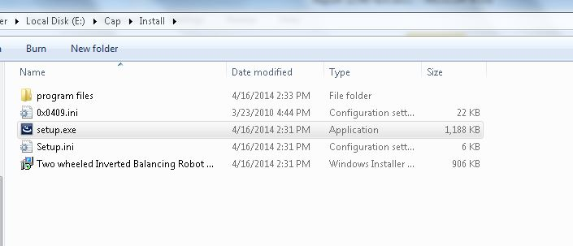

Figure 79 – Install folder

Click “Next” to continue

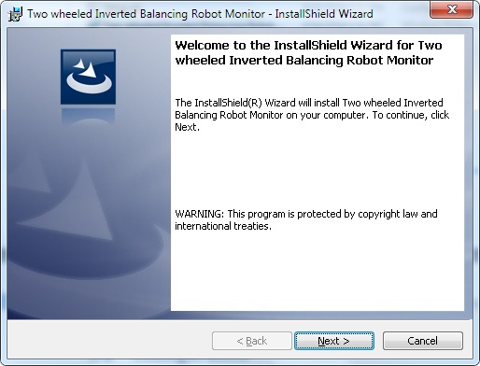

Figure 80 – Installation - Step 1

Read and accept the license agreement by select the line “I accept the terms in the license agreement” (1). After that, click “Next” to continue

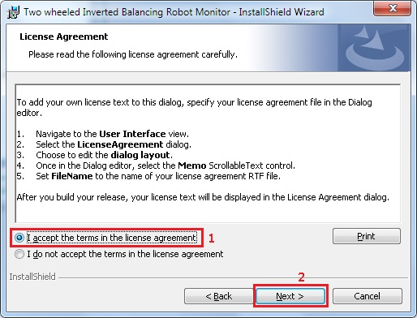

Figure 81 – Installation - Step 2

User can select folder to install by click “Change” button and select where to install or use default location to install. Click “Next” to continue.

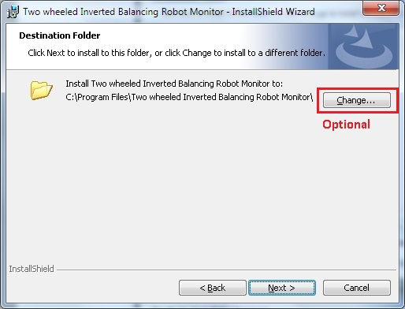

Figure 82 – Installation - Step 3

Finally, click “Install” and wait for install complete.

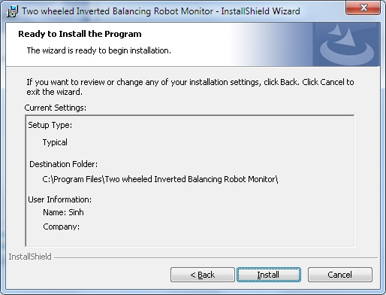

Figure 83 – Installation - Step 4

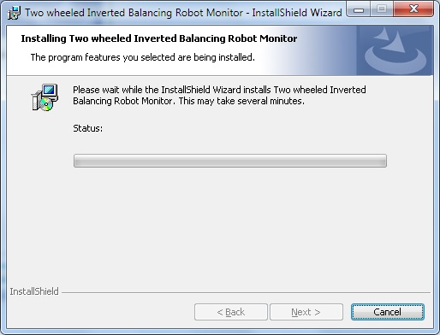

Figure 84 – Installation - Step 5

After installed, click “Finish” to exit the install wizard.

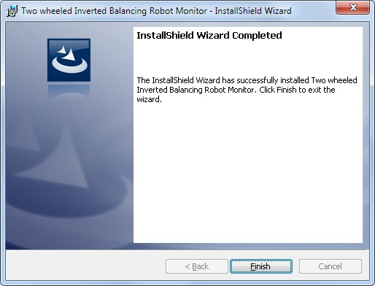

Figure 85 – Finish Installation

#### Uninstall

To remove program:

* Go to “Control Panel” -> “Programs”-> “Programs and Features”.

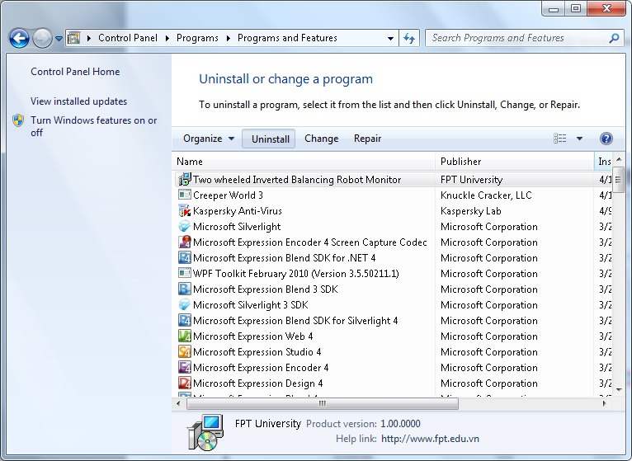

Figure 86 – Programs and Features Dialog

* Select “Two wheeled Inverted Balancing Robot Monitor” (1) and click “Uninstall” (2).

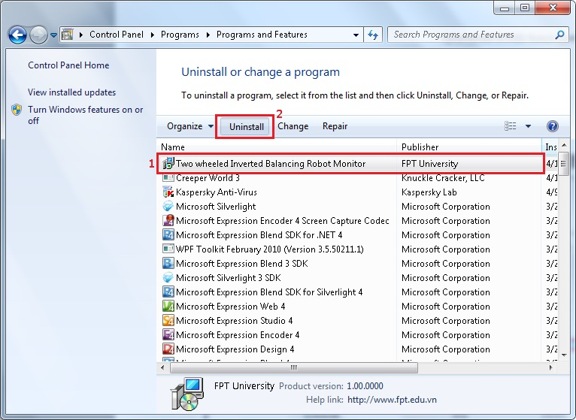

Figure 87 – Uninstall TWIBR Monitor application

Click “Yes” if a dialog appears.

### Configuration

#### Settings Bluetooth

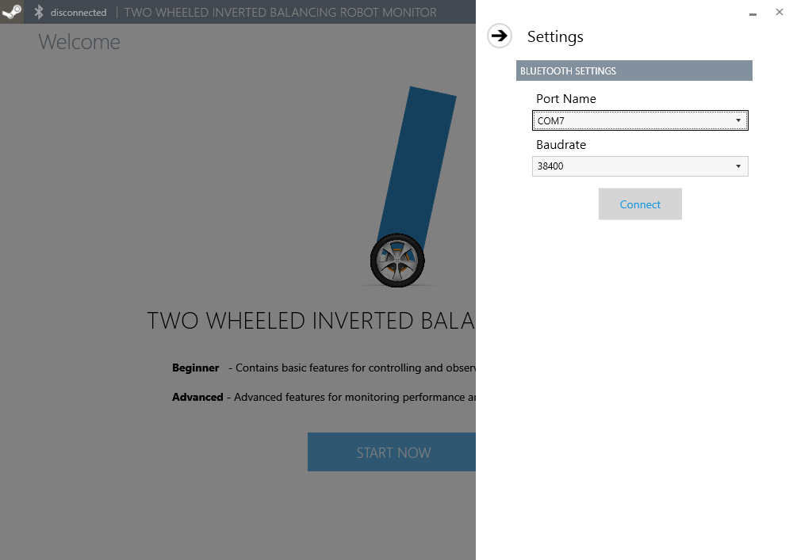

Figure 88 – Bluetooth is required

Before using Two-wheeled inverted balancing robot Monitor application, user need to configure Bluetooth setting to connect bluetooth between PC and the robot. Select Portname and Baudrate of bluetooth to connect. Then click on “Connect” button to connect bluetooth.

##### Add Bluetooth device

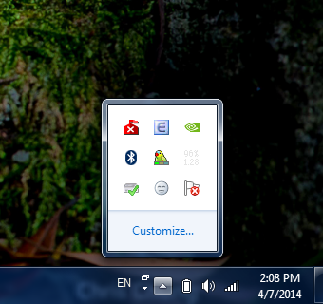

Figure 89 – Bluetooth Icon on Tray bar

**Step 1:** we need to check your bluetooth is available or not by to see the icon  in taskbar of windows.

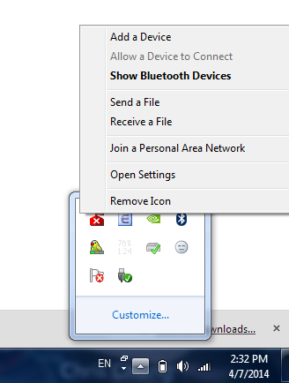

Figure 90 – Add a Device option

**Step 2:** Right click on icon to show Bluetooth Settings, then click “Add a Device”.

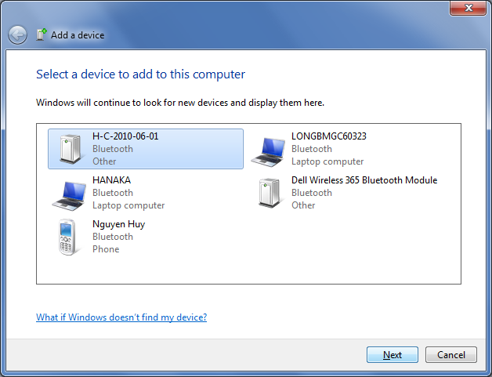

Figure 91 – Add a device dialog (1)

**Step 3:** A list of Bluetooth device show all Bluetooth around your Bluetooth. Click choose Bluetooth H-C-2010-06-01, then click Next to get connect Bluetooth Device.

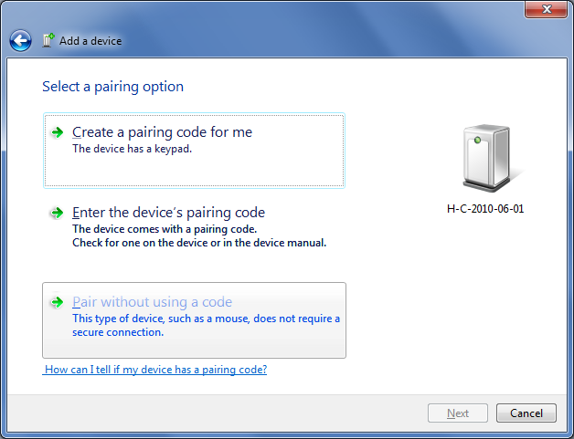

Figure 92 – Add a device dialog (2)

**Step 4:** In the next windows, click choose Pair without using a code to Select a pairing option.

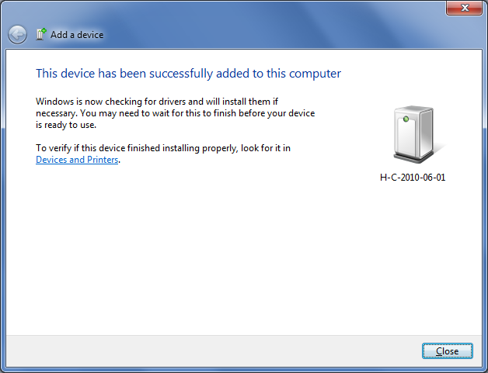

Figure 93 – Add a device dialog (3) – Successfully added a device

The above dialog is showed after we connect Bluetooth device successfully, this window will show device connect successfully.

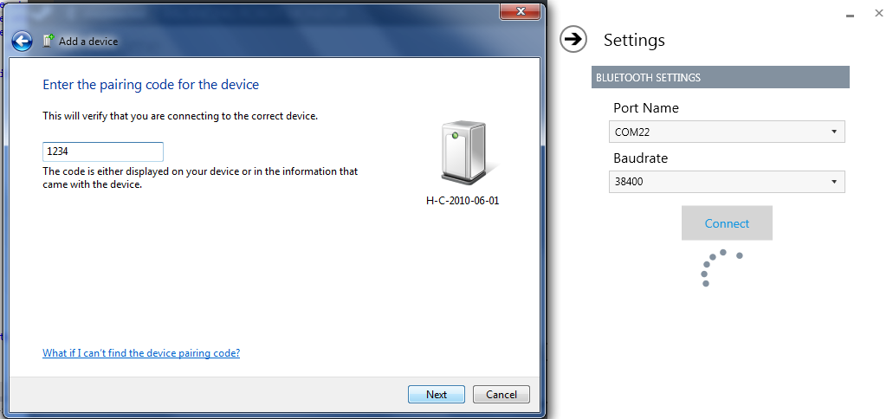

Figure 94 – Enter pairing code for the first time.

**Notice**: In the first time using, you need to enter the password to pairing with the Bluetooth device. The default password is “1234”.

##### Know port name of the robot



Figure 95 – Bluetooth icon on Tray Bar

**Step 1:** We need to check your Bluetooth is available or not by to see the icon  in taskbar of windows.

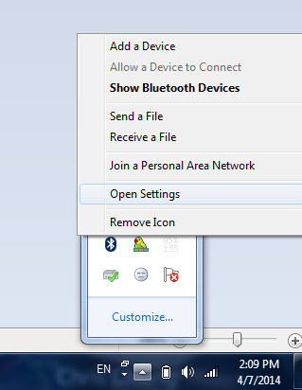

Figure 96 – Open Settings option

**Step 2:** Right click on icon to show Bluetooth Settings, then click “Open Settings”.

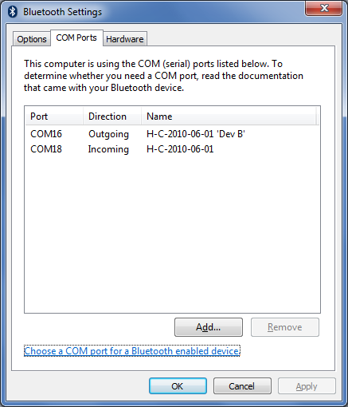

Figure 97 –Port name of the robot

**Step 3:** Choose the COM Port tab in the next windows. As you can see, there a list of COM port using for the Bluetooth, the right port for selecting in the Configuration is the one with “Outgoing” direction. In this case, the right COM port is COM16.

##### How to know Baud rate?

The default Baud rate is 38400. It was set in Bluetooth HC-05.

### Normal Control

#### Beginner Tab

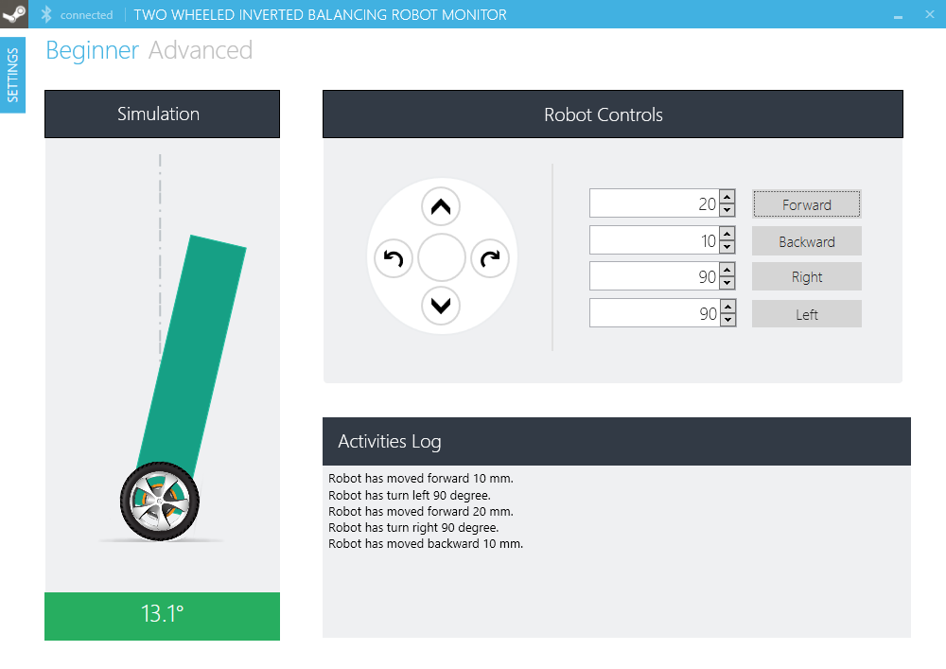

Figure 98 – Beginner Tab GUI

##### Free Moving Mode

User can make robot follow move actives by click and keep hold ( ) () () () buttons.



Figure 99 – Robot Movement Control section

##### Presice Moving Mode

User can fix the number how far robot will move by enter the number in textbox or you can click on the  buttons to increase or decrease number, then click () () () () buttons.

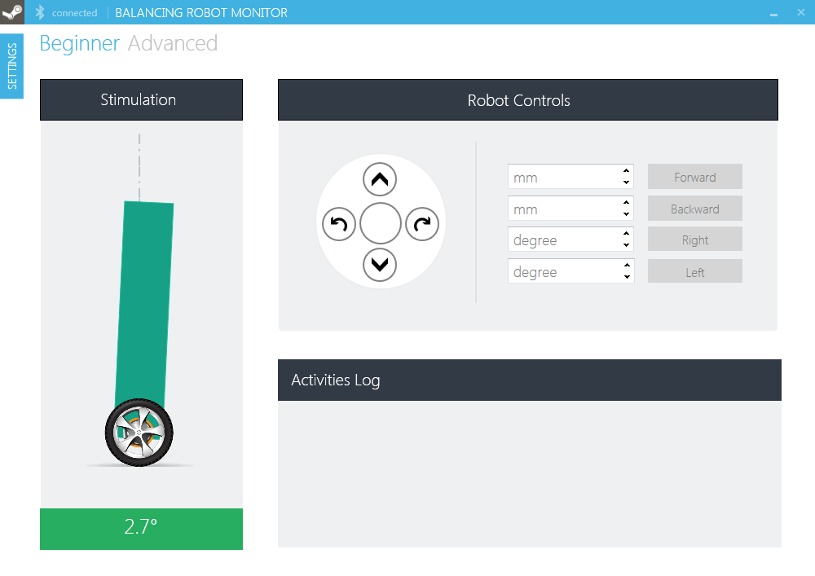

Figure 100 – Precise Mode Movement Control

##### Control Log

User can also see what robot has done by see it view in Activities Log.



Figure 101 – Activites Log

#### Advanced Tab

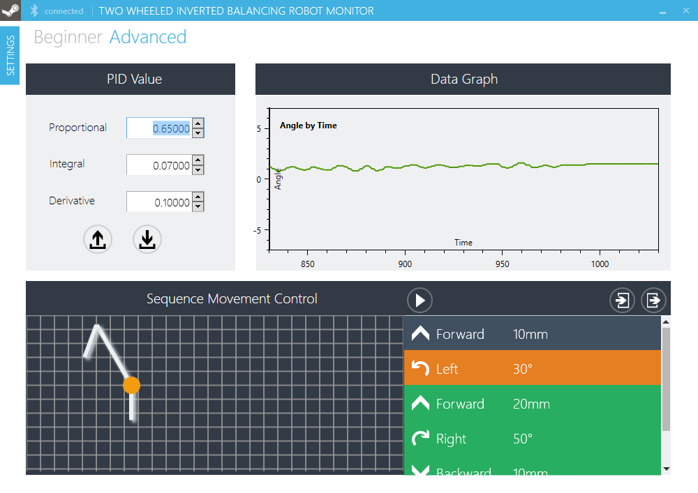

Figure 102 – Advanced Tab GUI

##### Update New PID Value



Figure 103 – PID Value section

User enters the new value of P, I, and D value in the textbox, then click on button 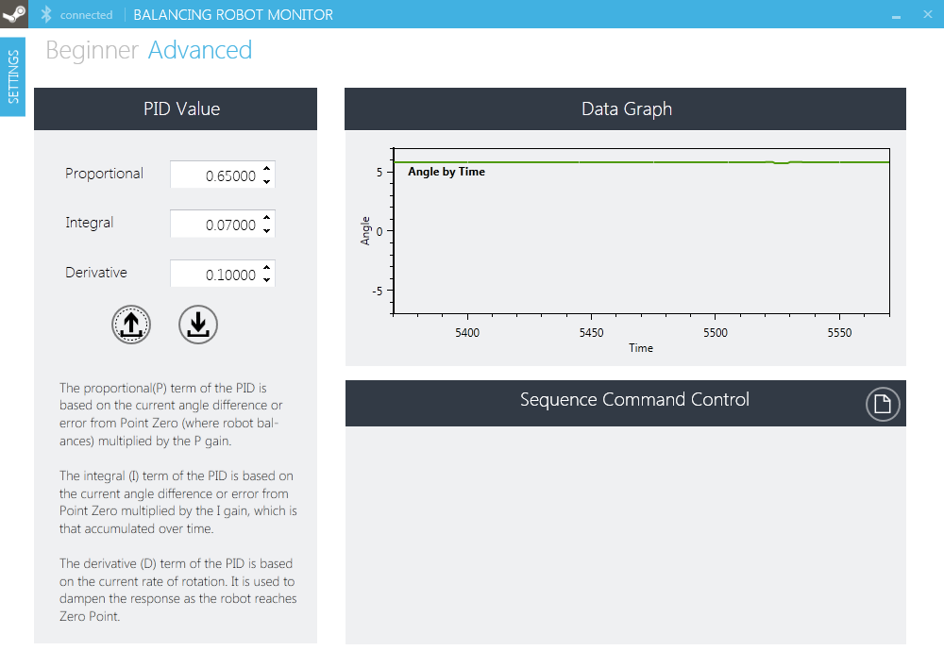 to update the new PID value.

##### Get Current PID Value



Figure 104 – Get PID values button

For getting the current PID value, user can click on button  to get the current PID value.

### Sequence Movement Control

#### Add new movement

Follow 2 steps below to create new movement and add to movement list:

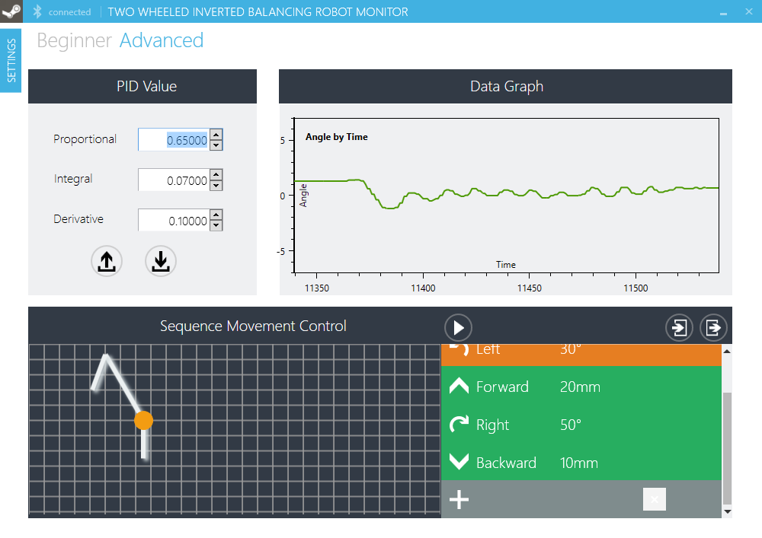

Figure 105 – New Movement Row

**Step 1:** Move cursor to below latest line and new line with gray color appear.



Figure 106 – Add new Movement to Sequence List

**Step 2:** Double click white cross  to add new command.

After step 2, new movement will create with default setting (Forward, 0mm)

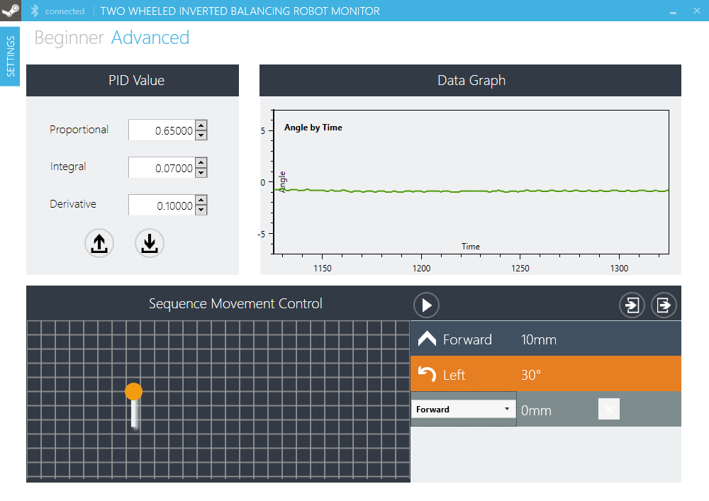

Figure 107 – Update a Movement

#### Edit movement command

##### Edit type of movement

To edit type of movement, follow 3 steps:

**Step1:** double click to name of type in line that you want to edit



Figure 108 – Direction combo box

After first step, a combo box will replace type of movement.

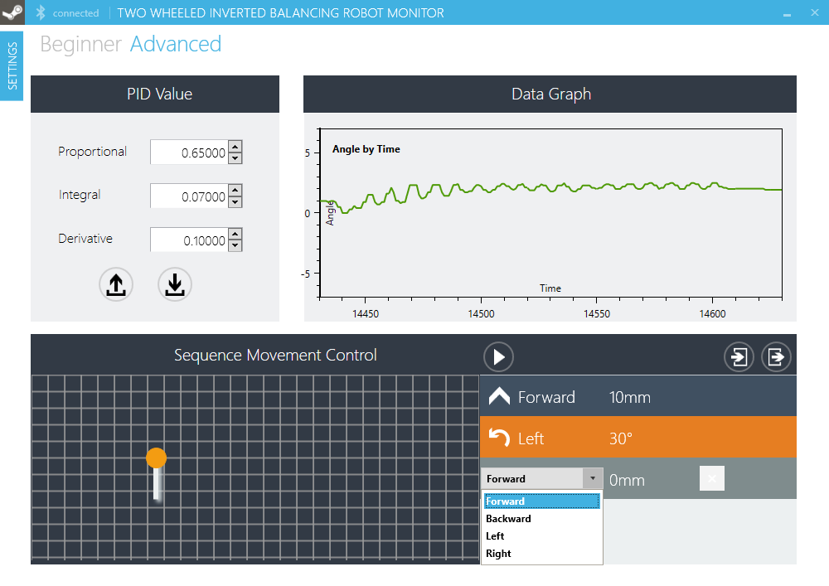

Figure 109 – Select direction

**Step 2:** Click on combo box, list of all type movement will appear. Select new type movement for this line command

**Step 3:** Press “Enter” or Click on another arena in program to complete editing.

##### Edit value of movement

To edit value of each movement, follow 3 steps:

**Step 1:** Double click to this movement’s value and a text box will appear.

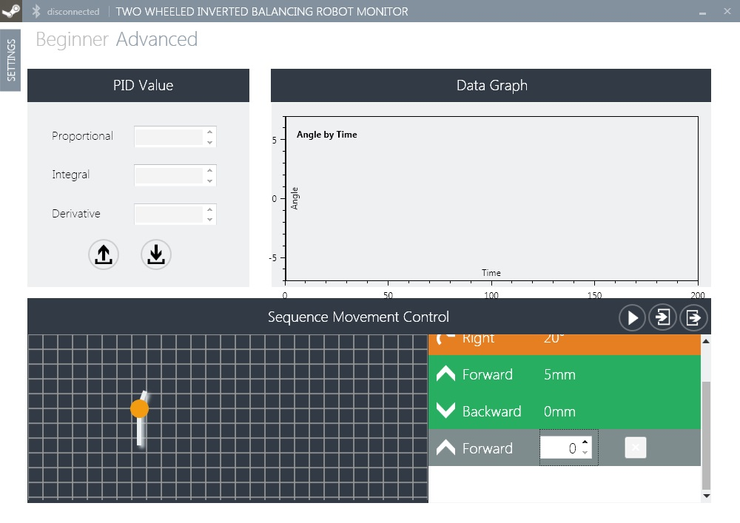

Figure 110 – Amount combo box

**Step 2:** Edit number in text box.

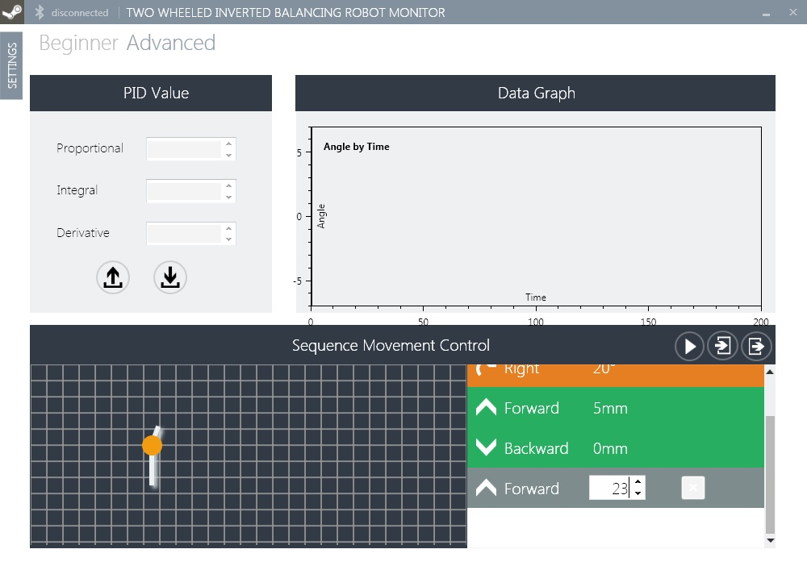

Figure 111 – Edit amount

**Step 3:** Click on another arena in program to complete edit.

#### Delete movement command

To delete movement command, follow 2 steps:

**Step 1:** Click to select the line which will delete. A button to delete will appear.

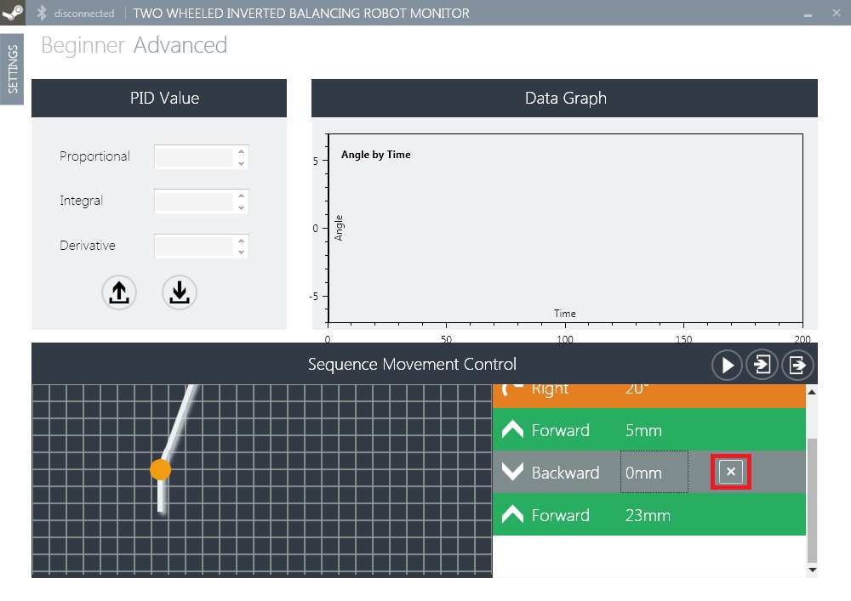

Figure 112 – Remove button of Movement

**Step 2:** Click on “X” button () to delete.

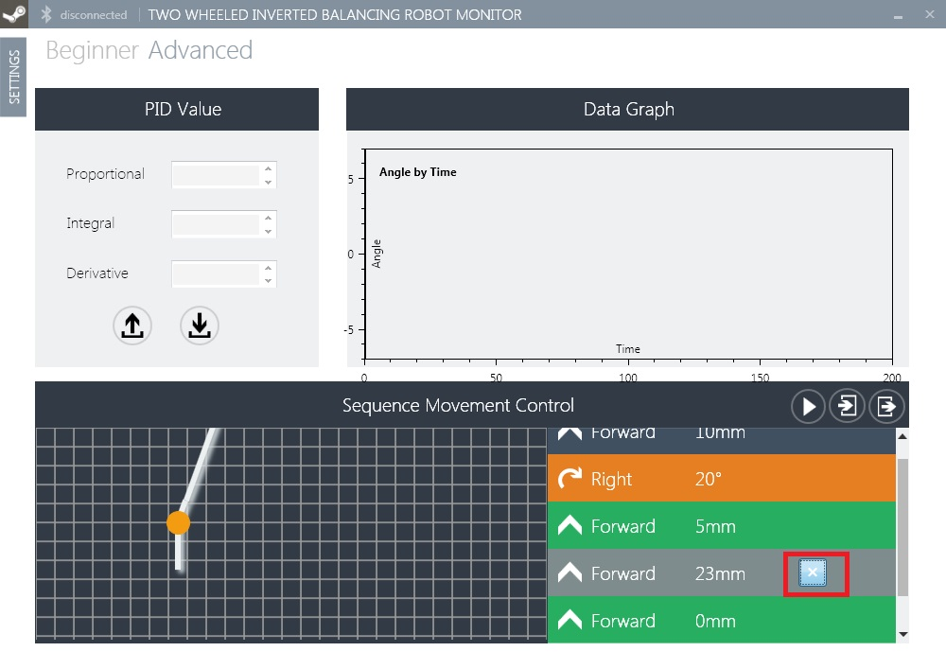

Figure 113 – Click on “X” button Remove a movement

#### Export all movement command to file

To save all movement command, use export button.

In advanced tab, click export button ():

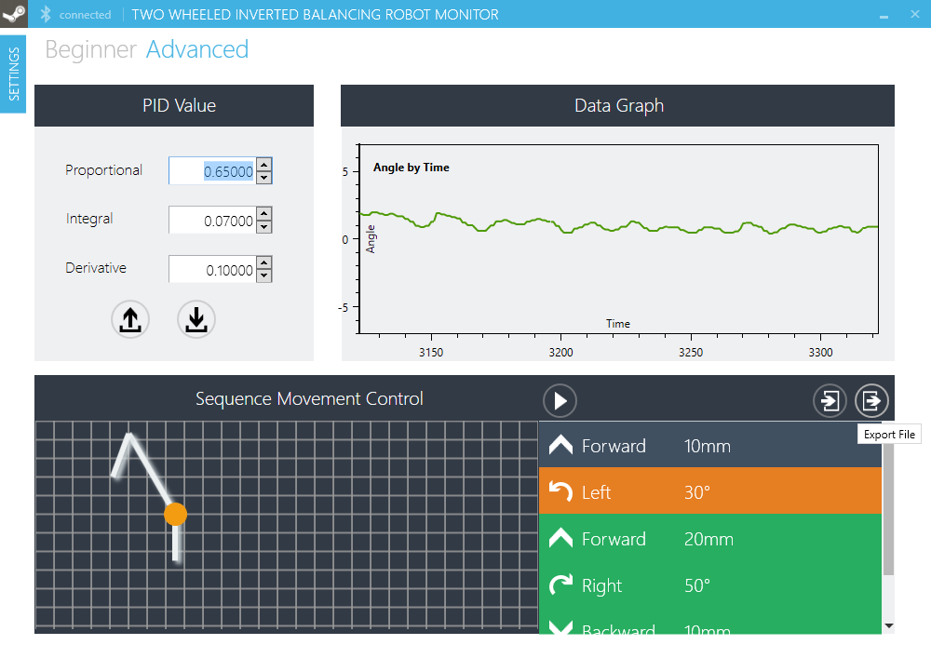

Figure 114 – Export Movement button

After that, “Save” dialog appear. Write file name and click save button.

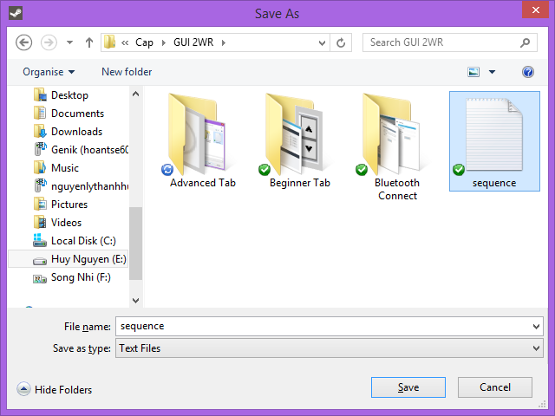

Figure 115 – Save File Dialog

#### Import all movement command from file

To load all movement command in a file, use export button.

In advanced tab, click import button ():

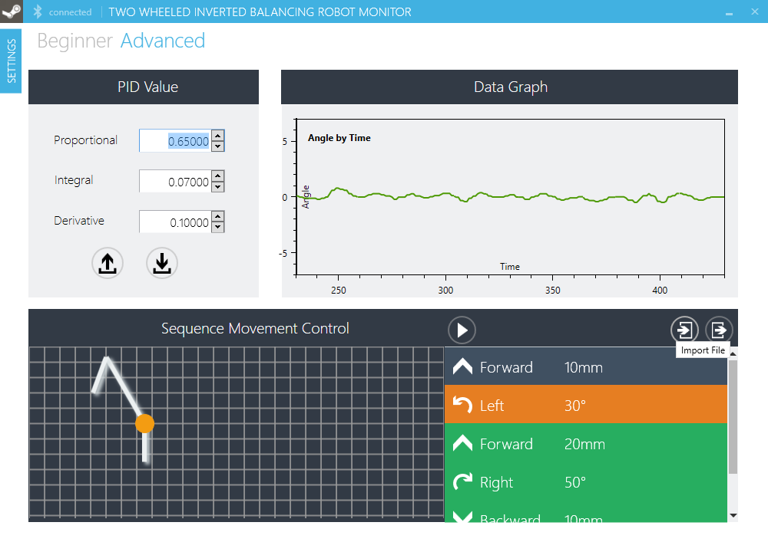

Figure 116 – Import Sequence File button

After click on import button, “Open” dialog will appear. Select text file or *.dat file. Click open.

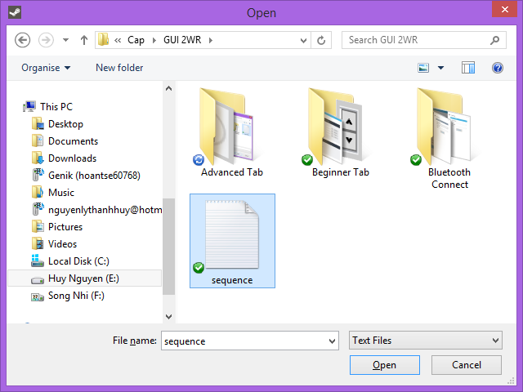

Figure 117 – Open File Dialog

#### Execute/Continue

While robot in “Stop” static, click on  button will make Sequence movement control start send command in movement command list.



Figure 118 – Execute button

While robot in “Pause” status, click on  button will make Sequence movement control continue send command from pause point.

#### Pause

While Sequence movement control sending command to robot, click “Pause” button will make Sequence pause send command and set pause point.

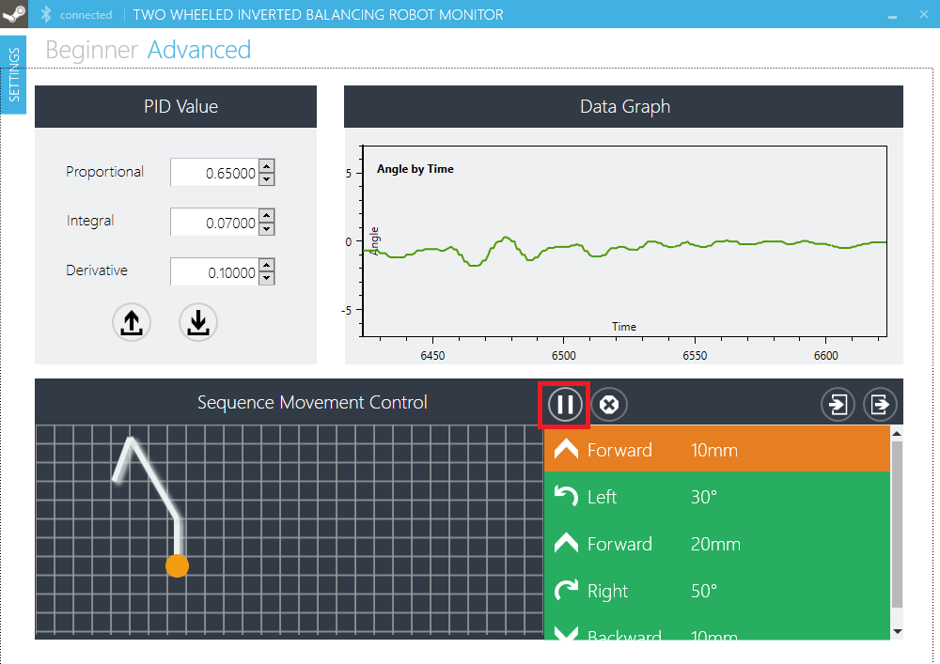

Figure 119 – Pause button

#### Stop

While Sequence movement control sending command to robot, click “Stop” button will make Sequence stop sending command and set pause point to start point.

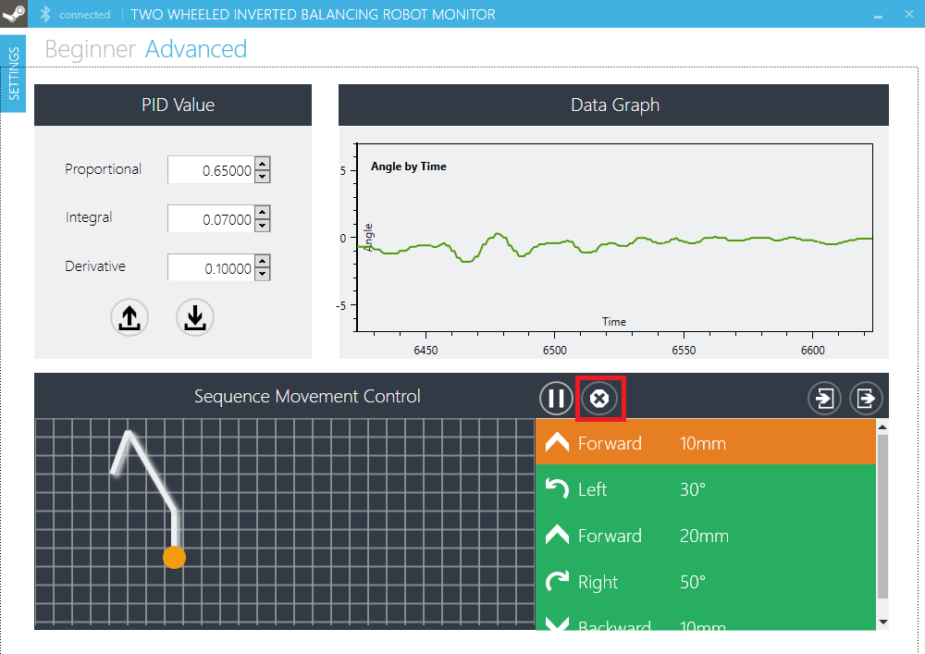

Figure 120 – Stop button

## REFERENCES

* Microchip website, version dated (2014/4/18), url https://www.microchip.com/
* H.Ferdinando, H.Khoswanto, S.Tjokro, March. 2011, Design and evaluation of two-wheeled balancing robot chassis, Communications, Computing and Control Applications (CCCA), 2011 International Conference on , vol., no., pp.1-6
* Rich Chi Ooi, 2003. Balancing a two-wheeled autonomous robot, Final year thesis, The university of western Australia, Australia.
* Liu Kun, Bai Ming, Ni Yuhua , Sept. 2011, Two-wheel self-balanced car based on Kalman filtering and PID algorithm, Industrial Engineering and Engineering Management (IE&EM), 2011 IEEE 18Th International Conference on, vol.Part 1, no., pp.281-285.
* Liang Sun, Jiafei Gan , May. 2010, Researching of Two-Wheeled Self-Balancing Robot Base on LQR Combined with PID, Intelligent Systems and Applications (ISA), 2010 2nd International Workshop on , vol., no., pp.1-5.
* M.Yukitomo, T.Shigemasa, Y.Baba, F.Kojima, July. 2004, A two degrees of freedom PID control system, its features and applications, Control Conference, 2004. 5th Asian , vol.1, no., pp.456-459.